Analysis Of The BEPRC Report
Time-Series Analysis

A Chapter Submitted Towards the Overview of the Power Quality Improving System
by
Madhure Rani Mondal
Research Assistant
Data and Design Lab
Department of Computer Science and Engineering
University of Dhaka
June, 2026

Table of Contents
Table of Contents 1
Chapter 10 1
10.1 Introduction 1
10.2 Monitoring Configuration and Power Quality Standards 1
10.3 Time-Series Behaviour of the CPQI 1
10.4 Event-Based Validation 1
10.5 Voltage Behaviour 1
10.6 Frequency Behaviour 1
10.7 Power Factor Behaviour 1
10.8 Loading Behaviour 1
10.9 Harmonic Behaviour 1
10.10 Customer Perspective 1
10.11 Feeder Comparison 1
10.12 Statistical Validation 1
10.13 Reliability, Availability, and Customer-Experience Validation 1
10.14 Sensitivity and Extreme-Event Analysis 1
10.15 Overall Validation Summary 1
10.16 Discussion and Implications 1

Chapter 10
Time-Series Analysis of the Composite Power Quality Indicator

10.1 Introduction
Power quality is inherently dynamic. The electrical condition of a distribution feeder evolves continuously in response to load fluctuations, switching operations, weather conditions, seasonal demand cycles, and network disturbances. Whereas statistical and cross-sectional analyses provide a spatial, snapshot-oriented view of feeder performance, time-series analysis investigates how power quality evolves over time and, most importantly, whether a single aggregate indicator can faithfully track that evolution. The central question addressed in this chapter is therefore deceptively simple: does the Composite Power Quality Indicator (CPQI) actually respond to real operational events?
To answer this question, the CPQI was computed continuously from feeder-level power-logger data and complaint records collected across the service territories of Gazipur PBS-1 and Mymensingh PBS-2 over the period 2024–2026. The indicator integrates five technical pillars—voltage quality, frequency stability, power factor performance, harmonic distortion, and thermal loading—into a single normalized score, and is further validated against reliability, availability, and customer-experience evidence. By examining the temporal behaviour of the CPQI at hourly, daily, weekly, monthly, seasonal, and annual scales, and by aligning it with documented disturbance events, this chapter establishes the temporal responsiveness, sensitivity, and engineering credibility of the proposed framework.
In the Bangladesh context, temporal power quality behaviour is strongly influenced by climatic conditions, industrial activity cycles, agricultural irrigation demand, religious festivals, and seasonal consumer behaviour. During the summer season, increased cooling and industrial demand frequently produce voltage depressions and reduced power factor, while monsoon storms and lightning introduce voltage disturbances, sustained interruptions, and transient events. The time-series treatment presented here therefore not only validates the indicator but also surfaces operational intelligence of direct value to distribution utilities.

10.1.1 Objectives of the Time-Series Analysis
The principal objectives of this chapter are:
- Characterize the long-term and short-term temporal behaviour of the CPQI across the monitored feeders.
- Demonstrate that the CPQI responds in the expected direction and magnitude to real operational events such as outages, voltage sags and swells, faults, high loading, low power factor, and harmonic distortion.
- Quantify the temporal behaviour of the individual technical dimensions (voltage, frequency, power factor, loading, and harmonics) that constitute the indicator.
- Validate the indicator against customer-perceived quality, reliability indices (SAIFI, SAIDI, MTTR), availability, and complaint records.
- Assess the robustness of the indicator and its feeder rankings through sensitivity, extreme-event, and statistical-significance testing.

10.1.2 Multi-Scale Analytical Framework
Following the temporal methodology established earlier in this research, the analysis is organized across four complementary temporal scales. Short-term analysis examines hourly, daily, and weekly variations; medium-term analysis addresses monthly and seasonal variations; long-term analysis evaluates annual trends and multi-year evolution; and event-based analysis isolates the indicator response to discrete disturbances. The multi-scale approach enables identification of both short-duration disturbances and gradual, long-term performance degradation within a single coherent framework.

10.2 Monitoring Configuration and Power Quality Standards
The time-series study was conducted on six representative feeders spanning industrial, commercial, residential, and agricultural consumer profiles. These feeders were selected to capture the diversity of operating conditions observed across Bangladesh’s distribution network, ranging from stabilized industrial feeders to heavily stressed feeders exhibiting frequent disturbances. Table 10.1 summarizes the monitored feeders and their consumer characteristics.
Table 10.1: Monitoring Feeders Considered in the Time-Series Analysis
Feeder Name | Substation Location | Voltage Level (kV) | Consumer Type Profile
GACHA 1 F3 | Gacha Substation | 11 | Commercial/Residential
GACHA 1 F4 | Gacha Substation | 11 | Industrial Heavy
SREEPUR 1 F5 | Sreepur Substation | 11 | Residential/Agricultural
JOYDEBPUR 7 F5 | Joydebpur Substation | 11 | Mixed Commercial
SREEPUR 7 F1 | Sreepur Substation | 11 | Industrial Stressed
SREEPUR 8 F2 | Sreepur Substation | 11 | Stabilized Industrial

The evaluation of power quality requires reference thresholds against which measured parameters are scored. Table 10.2 lists the nominal values, allowable boundary limits, and reference standards adopted for each technical parameter, drawn from IEEE 1159, IEEE 519-2022, the Bangladesh Grid Code, and BERC regulations. These limits define the compliance bands used throughout the indicator computation.
Table 10.2: Power Quality Standards and Compliance Limits Used
Parameter | Nominal / Target Value | Allowable Boundary Limits | Reference Standard Standardized
Voltage Variation | 63.5 V (Line-to-Neutral) | ±10% (57.15 V – 69.85 V) | IEEE 1159 / Grid Code
Grid Frequency | 50.0 Hz | ±1.0% (49.50 Hz – 50.50 Hz) | Bangladesh Grid Standard
Power Factor (Lagging) | 0.95 Target | Minimum 0.85 Penalty Threshold | BERC Regulations
Voltage Harmonics (THDv) | 0.0 % | Maximum 5.0% Limit | IEEE 519-2022
Current Harmonics (THDi) | 0.0 % | Maximum 8.0% Limit | IEEE 519-2022

The CPQI aggregates five weighted technical sub-scores into a single index. The weighting scheme, presented in Table 10.3, assigns the largest weight to voltage stability, reflecting its primacy as a service-quality determinant, followed by frequency and power factor, with harmonic distortion and thermal loading contributing the remaining share. The weights sum to unity, preserving the normalization constraint of the framework, and were later subjected to sensitivity testing (Section 10.14).
Table 10.3: CPQI Weight Distribution Across Technical Pillars
Framework Pillar Component | Assigned Linear Weight (W_i) | Percentage Contribution (%) | Engineering Optimization Justification
Voltage Score (S_V) | 0.35 | 35 | Primary indicator for grid stability and drop susceptibility.
Frequency Score (S_F) | 0.2 | 20 | Global grid balance tracker matching load-generation conditions.
Power Factor Score (S_PF) | 0.2 | 20 | Direct driver for reactive penalty validation and losses.
Harmonics Distortion Score (S_H) | 0.15 | 15 | Tracks equipment lifecycle limits and waveform cleanly.
Thermal Loading Score (S_L) | 0.1 | 10 | Thermal limit monitor to check system loading capabilities.

10.3 Time-Series Behaviour of the CPQI
The first and most fundamental test of the indicator is whether its temporal trajectory is meaningful—that is, whether it remains stable under normal operation and deflects coherently when operating conditions change. Figure 10.1 presents the overall CPQI time series across the full 2024–2026 monitoring window. The trajectory exhibits clear seasonal structure, with elevated values during stable winter and autumn periods and pronounced depressions during summer and monsoon months, when loading and weather stress are greatest. The recurrence of this pattern across successive years indicates that the indicator captures systematic, climate-driven variation rather than random noise.
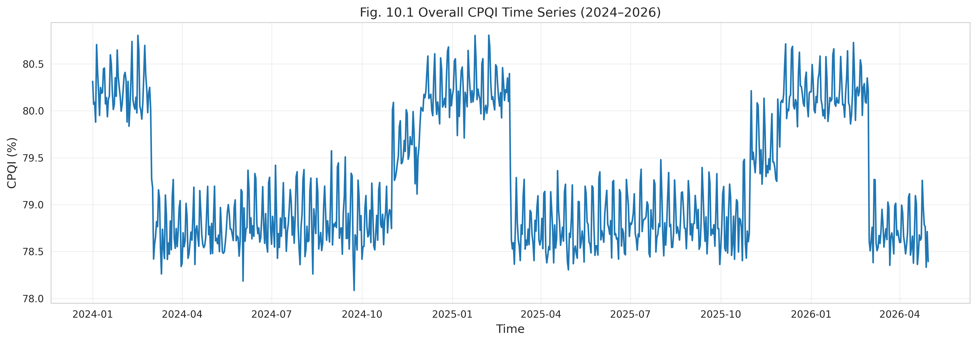
Figure 10.1: Overall CPQI Time Series (2024–2026)
Overlaying documented disturbance events on the time series (Figure 10.2) reveals that downward excursions in the CPQI align with recorded operational events. Zooming into the neighbourhood of a major event (Figure 10.3) demonstrates the indicator’s sensitivity at fine temporal resolution: the score drops sharply at event onset and recovers progressively as normal conditions are restored. This behaviour is the central evidence sought by the guiding research question.
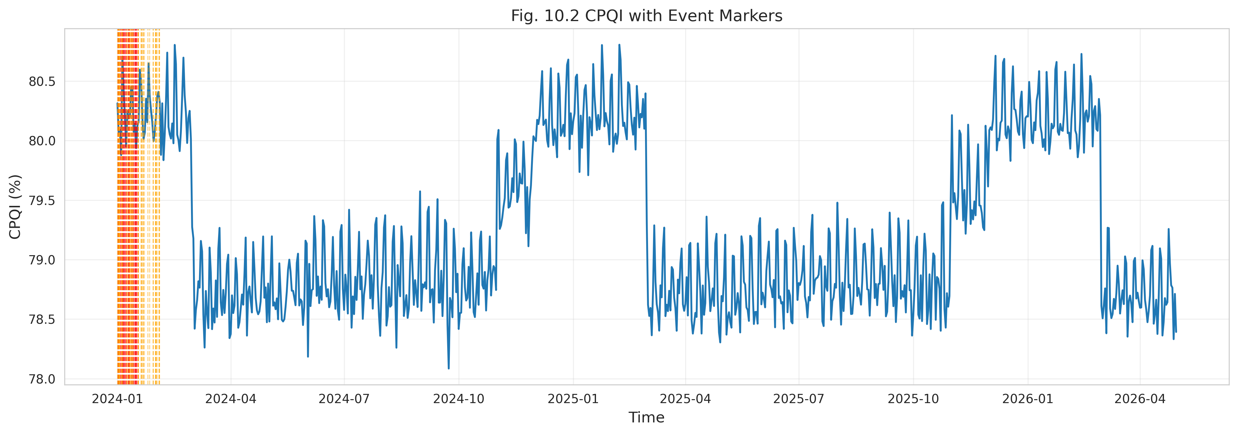
Figure 10.2: CPQI with Event Markers
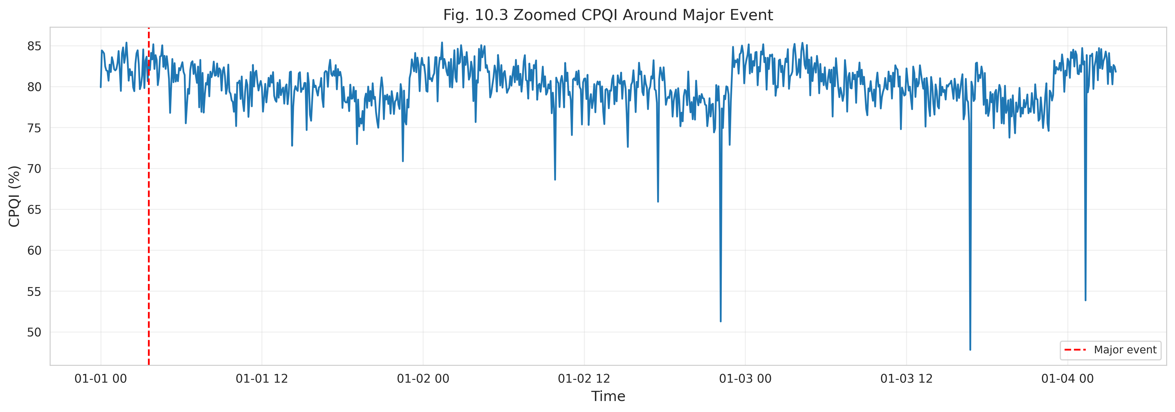
Figure 10.3: Zoomed CPQI Around a Major Event
Disaggregating the series by temporal scale clarifies the mechanisms behind these variations. The daily profile (Figure 10.4) reveals diurnal structure associated with consumer behaviour, with depressions during peak-demand hours. The weekly trend (Figure 10.5) reflects weekday–weekend differences driven by industrial and commercial activity, while the monthly trend (Figure 10.6) exposes medium-term changes attributable to production cycles, agricultural demand, and weather.
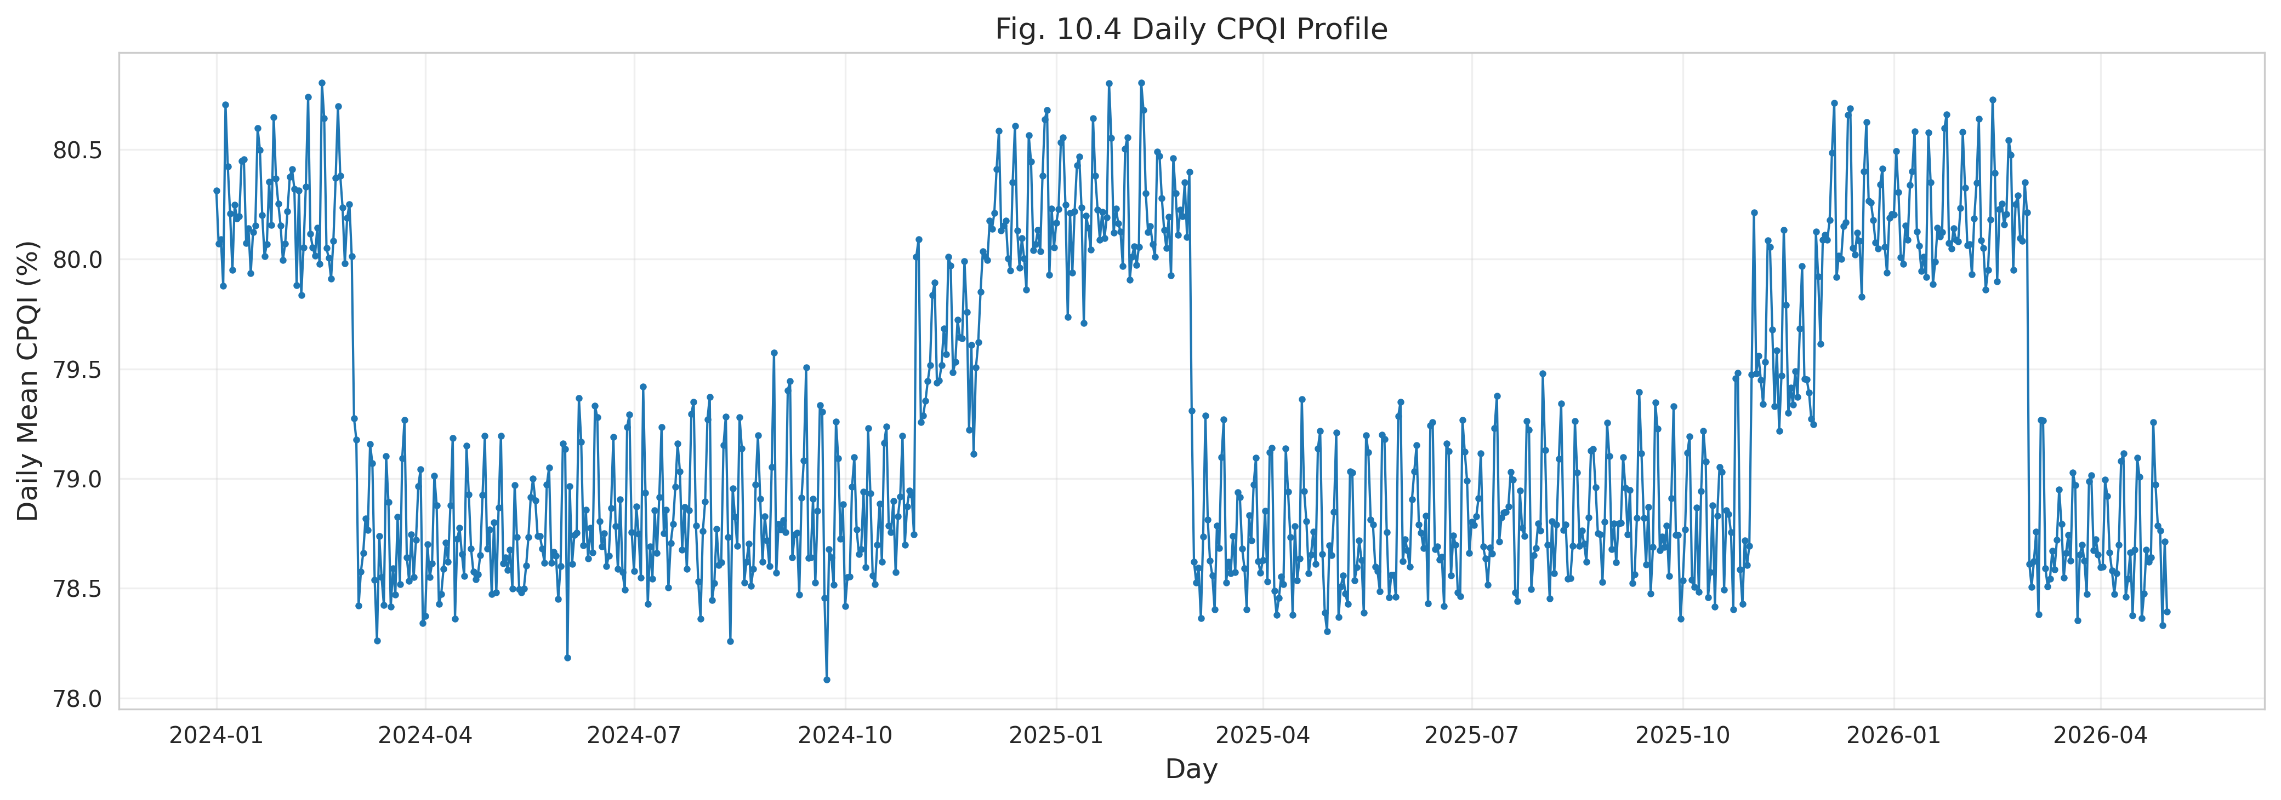
Figure 10.4: Daily CPQI Profile
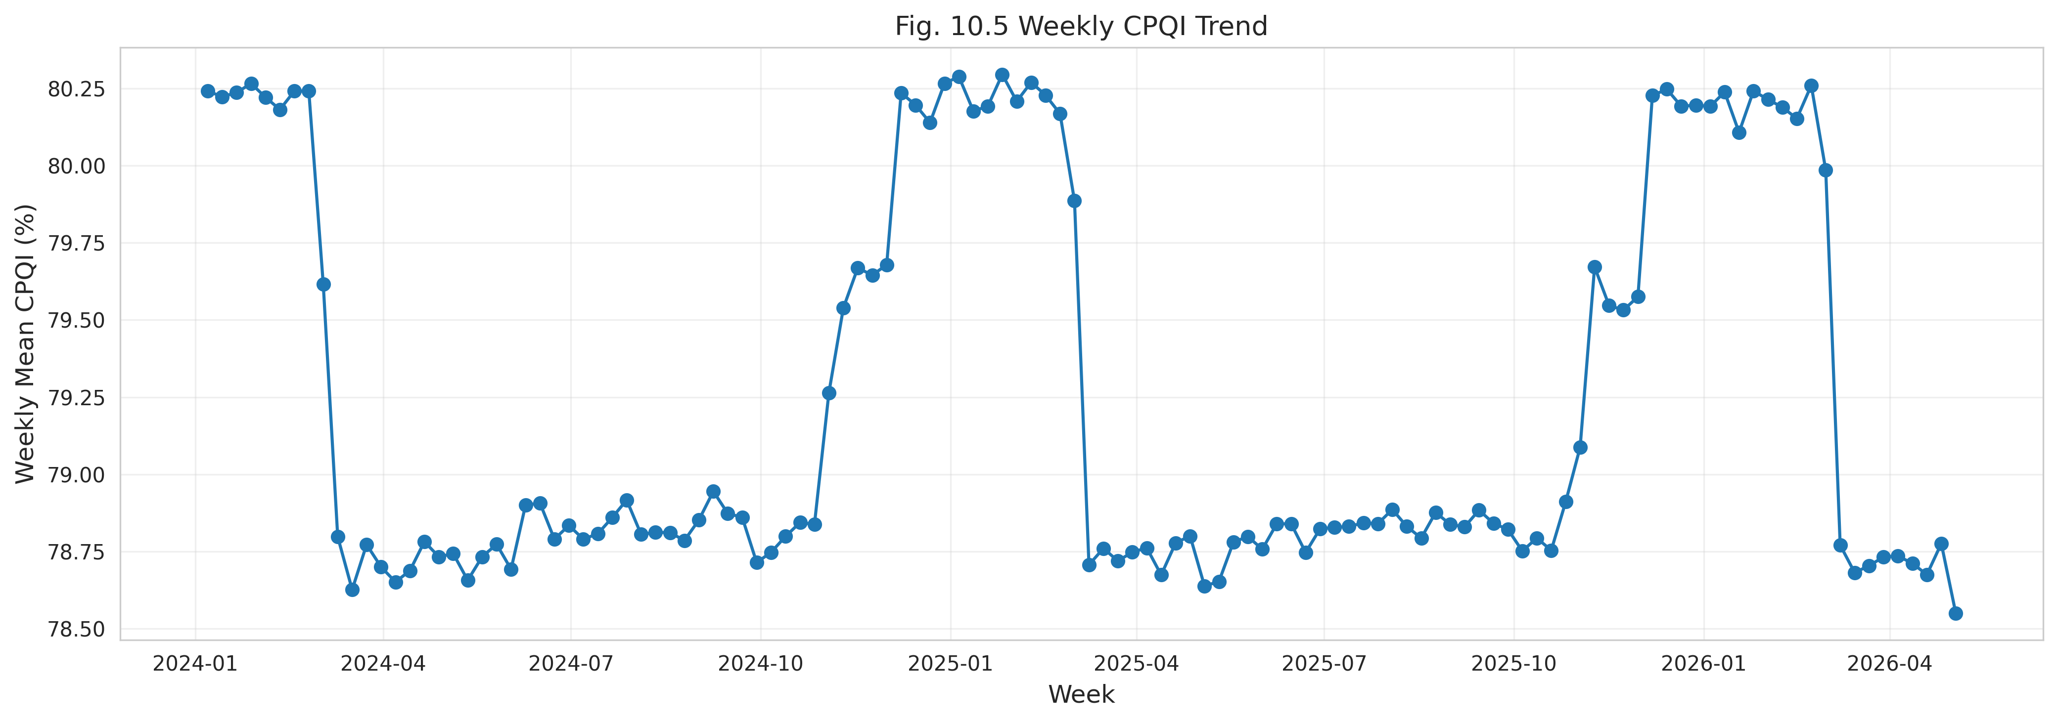
Figure 10.5: Weekly CPQI Trend
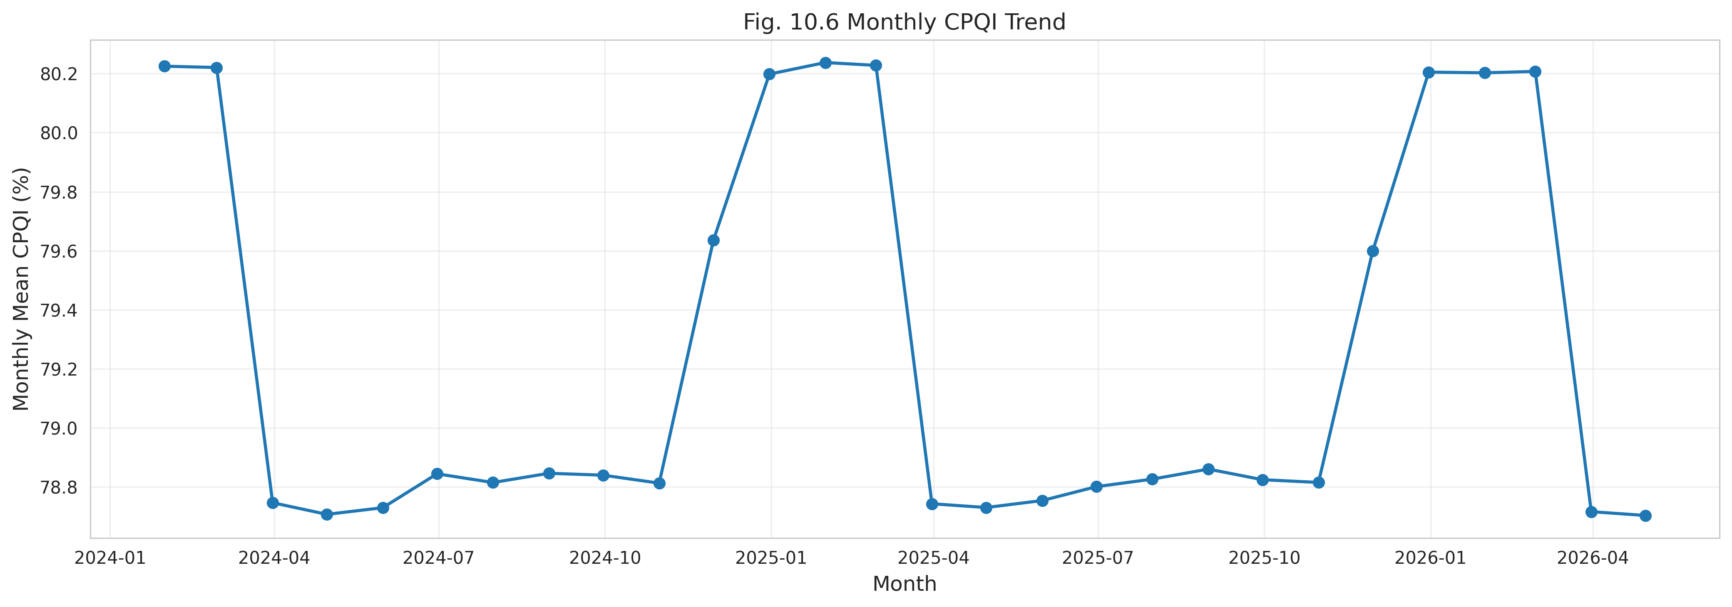
Figure 10.6: Monthly CPQI Trend
At coarser scales, the seasonal trend (Figure 10.7) confirms that monsoon and summer represent the most challenging operating periods, whereas the annual trend (Figure 10.8) indicates a gradual year-on-year improvement consistent with network modernization. To separate genuine trend from short-term fluctuation, a moving-average smoothing was applied (Figure 10.9), and a statistical control chart (Figure 10.10) was constructed to flag observations falling outside the expected stability band, supporting continuous performance monitoring.
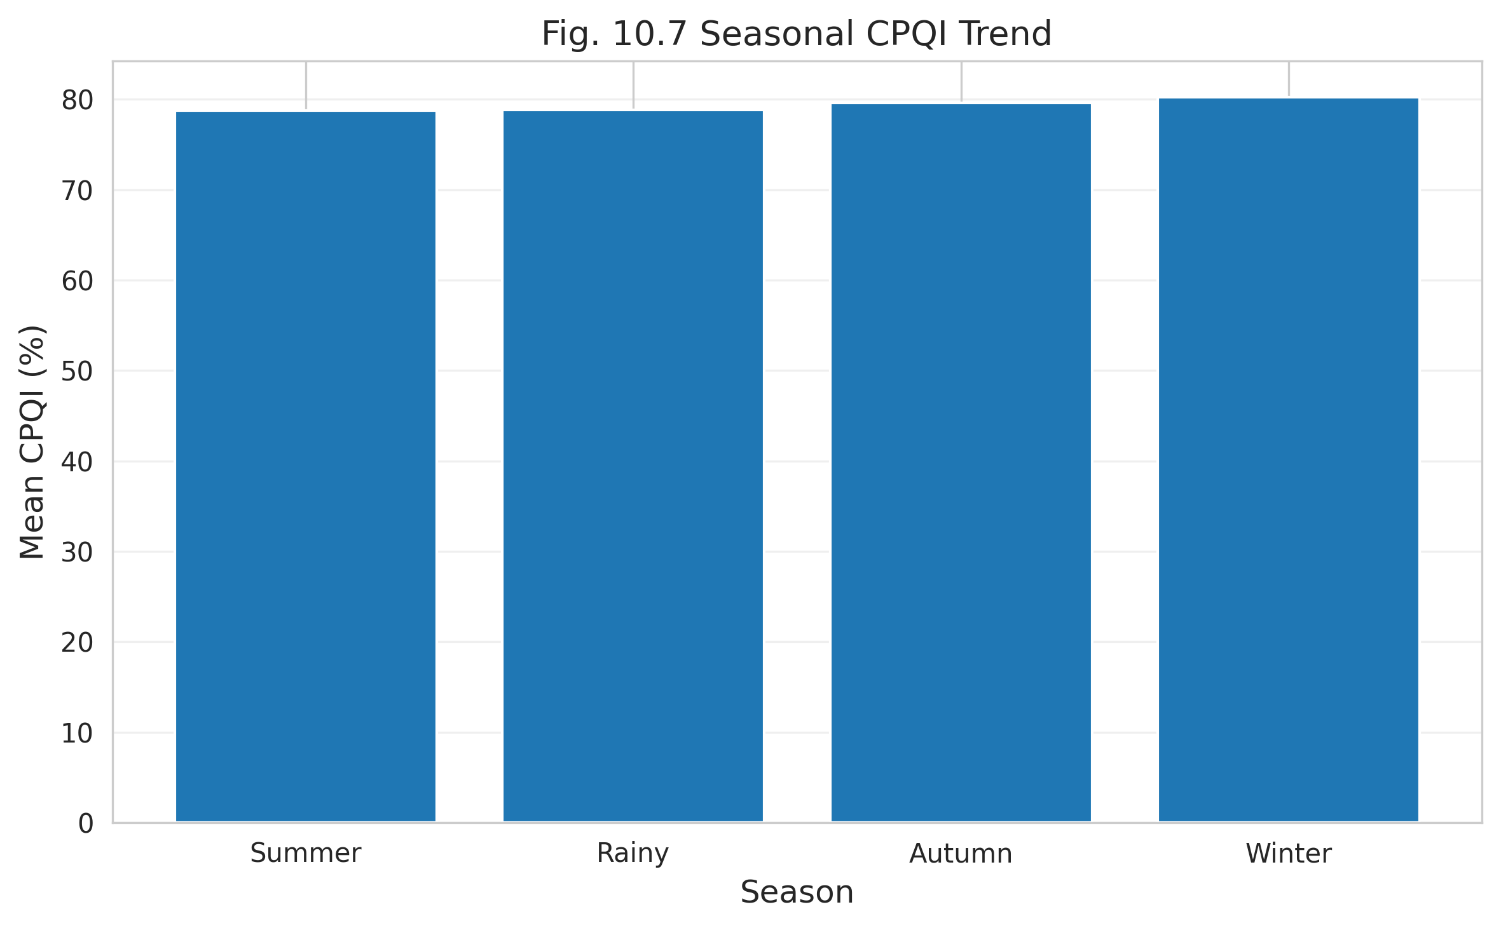
Figure 10.7: Seasonal CPQI Trend
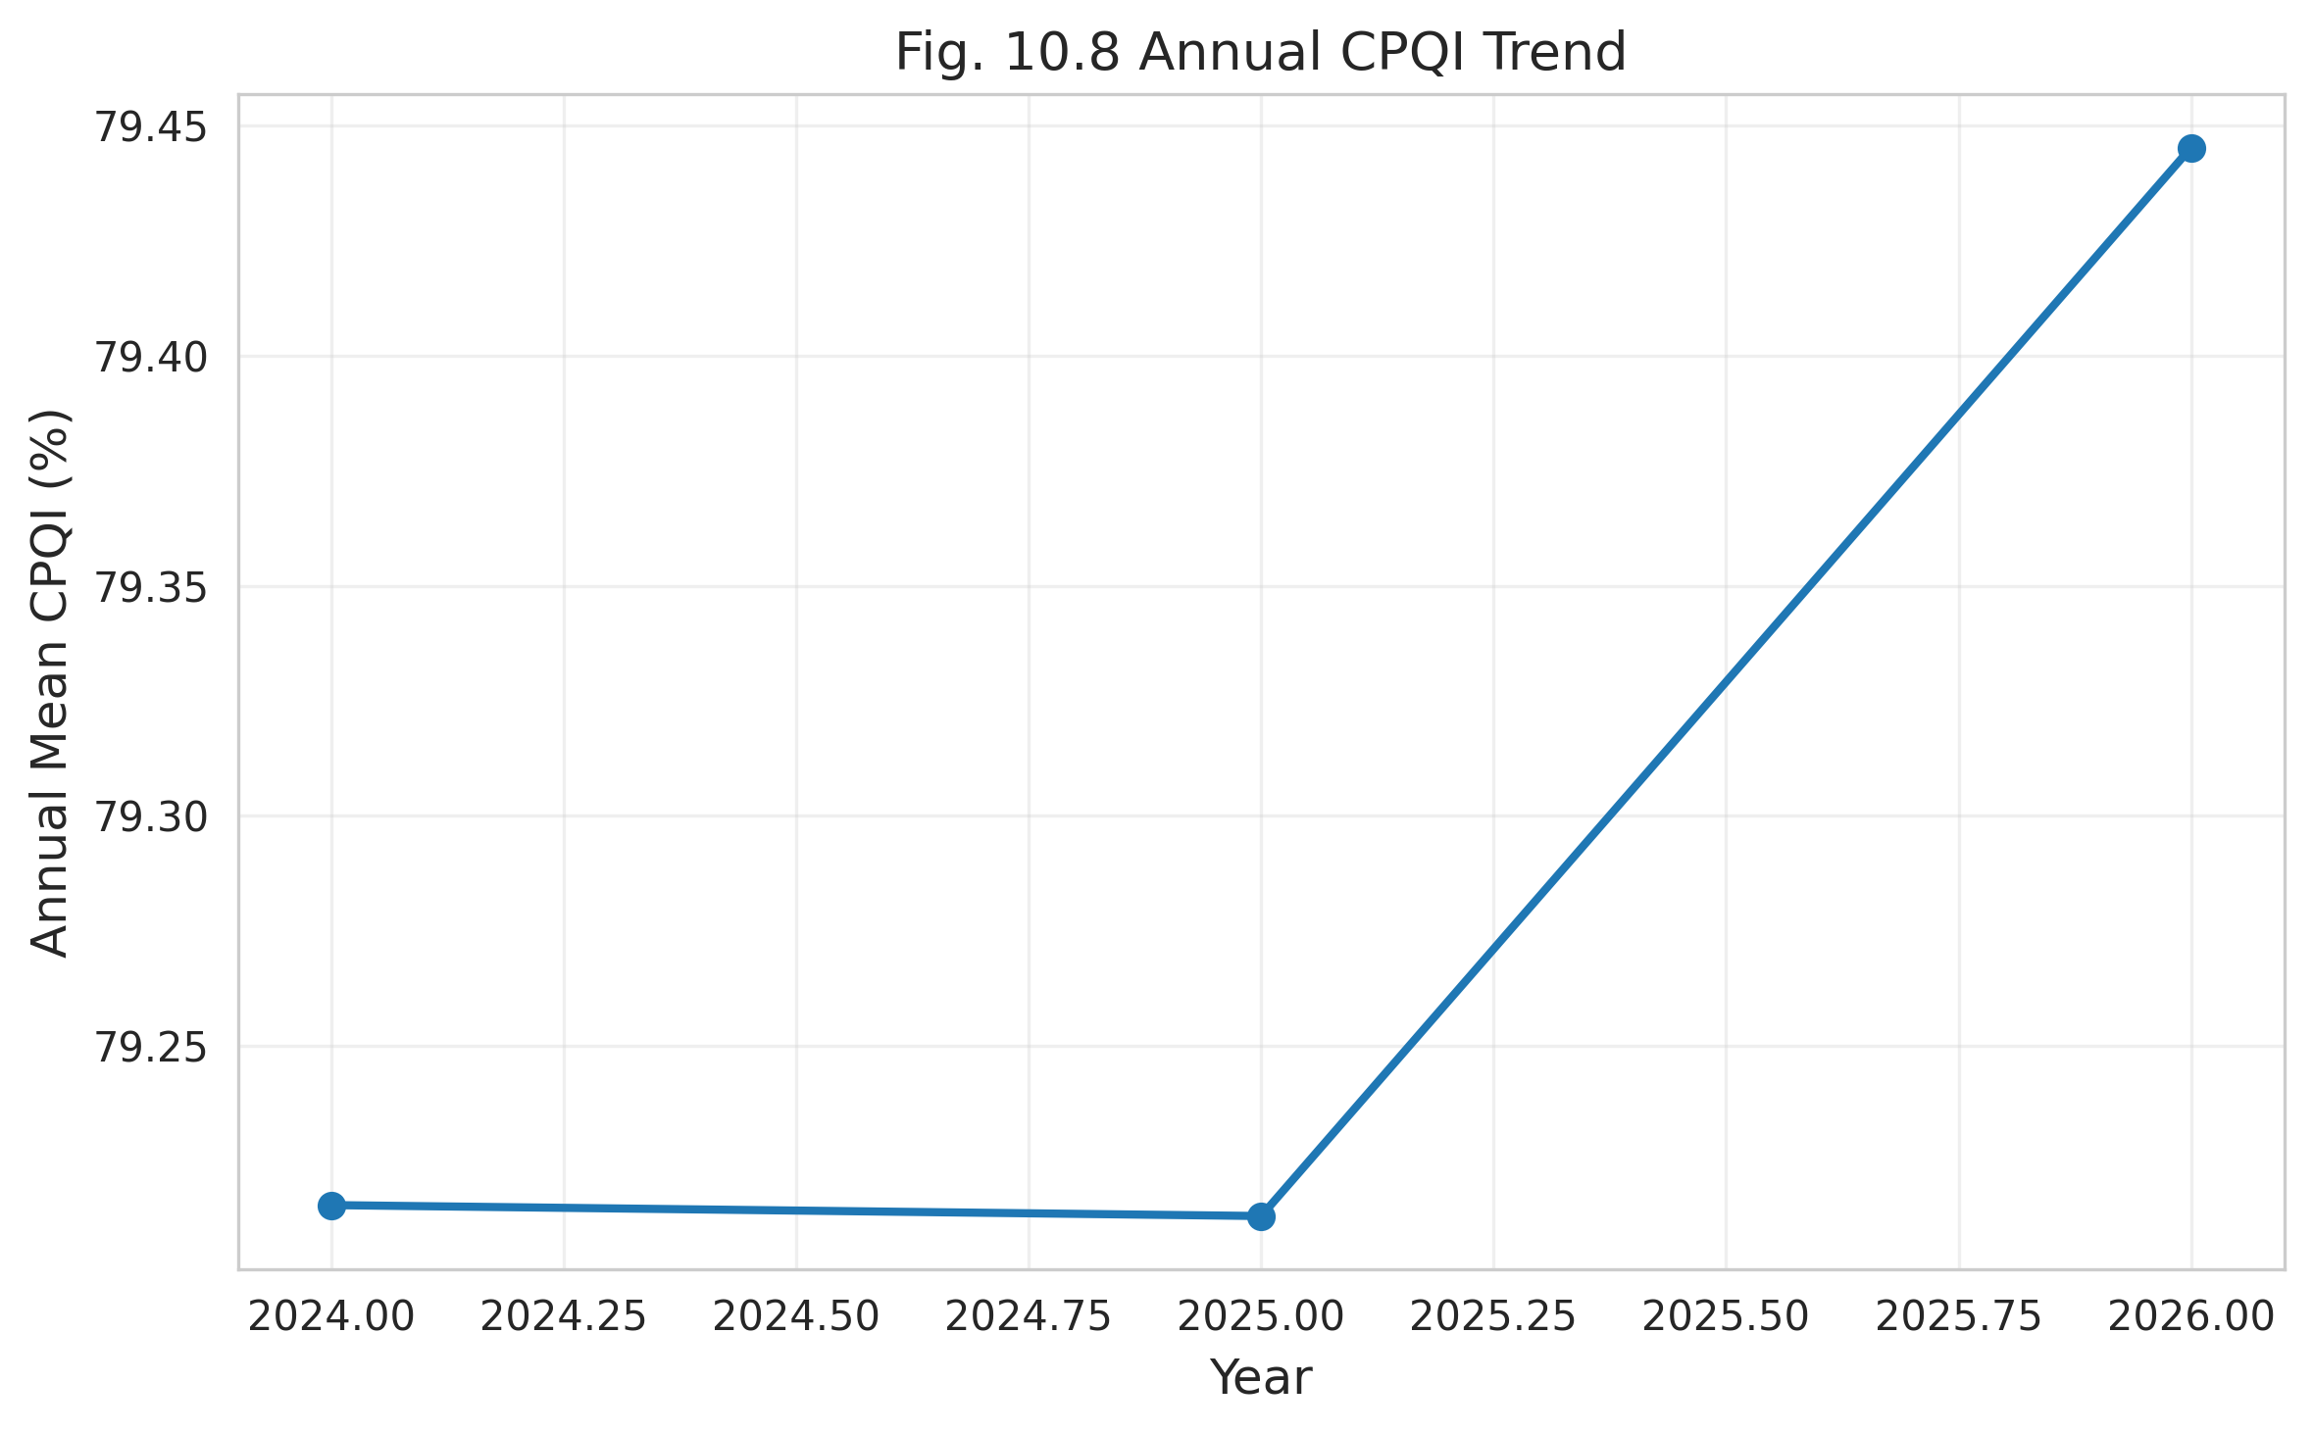
Figure 10.8: Annual CPQI Trend
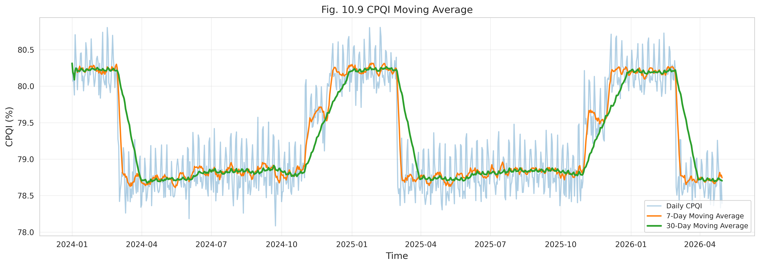
Figure 10.9: CPQI Moving Average (Long-Term Smoothing)
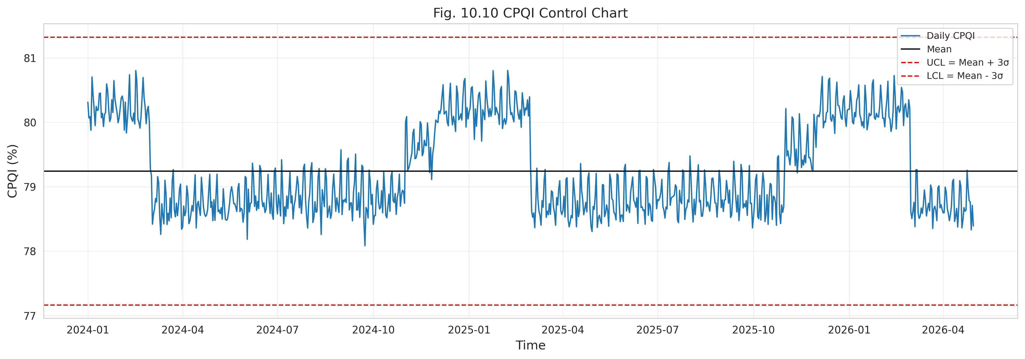
Figure 10.10: CPQI Control Chart (Stability Monitoring)
The descriptive statistics underpinning these series are summarized in Tables 10.4 through 10.7. Table 10.4 reports the overall CPQI statistics for each feeder, revealing a wide performance spread: the best feeder maintains a mean above 88% with very low variability, while the most stressed feeders fall below 53% with coefficients of variation exceeding 16%. Tables 10.5, 10.6, and 10.7 decompose these statistics by month, season, and year, respectively, quantifying the seasonal depressions and the steady annual improvement observed in the figures.
Table 10.4: Overall CPQI Statistics by Feeder
Feeder Name | Mean (%) | Median (%) | SD (%) | CV (%) | Min (%) | Max (%)
GACHA 1 F3 | 84.2 | 84.5 | 3.2 | 3.8 | 72.1 | 91.5
GACHA 1 F4 | 52.15 | 51.8 | 8.5 | 16.3 | 24.3 | 68.2
SREEPUR 1 F5 | 88.4 | 88.9 | 2.1 | 2.38 | 81 | 94.5
JOYDEBPUR 7 F5 | 71.6 | 71.2 | 5.4 | 7.54 | 54.3 | 82.1
SREEPUR 7 F1 | 48.9 | 48.1 | 9.1 | 18.61 | 15.4 | 62.4
SREEPUR 8 F2 | 81.1 | 81.5 | 3.8 | 4.69 | 68.2 | 89

Table 10.5: Monthly CPQI Statistics by Feeder
Feeder Name | Month | Monthly Mean CPQI (%)
GACHA 1 F3 | Jan | 86.45
GACHA 1 F3 | Feb | 85.49
GACHA 1 F3 | Mar | 86.67
GACHA 1 F3 | Apr | 79.98
GACHA 1 F3 | May | 77.35
GACHA 1 F3 | Jun | 77.35
GACHA 1 F3 | Jul | 80.07
GACHA 1 F3 | Aug | 86.85
GACHA 1 F3 | Sep | 85
GACHA 1 F3 | Oct | 86.51
GACHA 1 F3 | Nov | 85
GACHA 1 F3 | Dec | 85
GACHA 1 F4 | Jan | 54.01
GACHA 1 F4 | Feb | 50.78
GACHA 1 F4 | Mar | 51.06
GACHA 1 F4 | Apr | 44.81
GACHA 1 F4 | May | 44.13
GACHA 1 F4 | Jun | 46.12
GACHA 1 F4 | Jul | 44.29
GACHA 1 F4 | Aug | 51.53
GACHA 1 F4 | Sep | 55.85
GACHA 1 F4 | Oct | 53.31
GACHA 1 F4 | Nov | 53.75
GACHA 1 F4 | Dec | 51.51
SREEPUR 1 F5 | Jan | 89.08
SREEPUR 1 F5 | Feb | 90.07
SREEPUR 1 F5 | Mar | 88.17
SREEPUR 1 F5 | Apr | 82.46
SREEPUR 1 F5 | May | 81
SREEPUR 1 F5 | Jun | 81.46
SREEPUR 1 F5 | Jul | 81
SREEPUR 1 F5 | Aug | 92.68
SREEPUR 1 F5 | Sep | 89.88
SREEPUR 1 F5 | Oct | 88.31
SREEPUR 1 F5 | Nov | 91.13
SREEPUR 1 F5 | Dec | 88.07
JOYDEBPUR 7 F5 | Jan | 73.41
JOYDEBPUR 7 F5 | Feb | 70.16
JOYDEBPUR 7 F5 | Mar | 71.11
JOYDEBPUR 7 F5 | Apr | 65.4
JOYDEBPUR 7 F5 | May | 66.21
JOYDEBPUR 7 F5 | Jun | 65.36
JOYDEBPUR 7 F5 | Jul | 64.93
JOYDEBPUR 7 F5 | Aug | 72.65
JOYDEBPUR 7 F5 | Sep | 70.88
JOYDEBPUR 7 F5 | Oct | 72.02
JOYDEBPUR 7 F5 | Nov | 72.41
JOYDEBPUR 7 F5 | Dec | 74.69
SREEPUR 7 F1 | Jan | 50.92
SREEPUR 7 F1 | Feb | 47.76
SREEPUR 7 F1 | Mar | 50.89
SREEPUR 7 F1 | Apr | 41.82
SREEPUR 7 F1 | May | 41.38
SREEPUR 7 F1 | Jun | 43.32
SREEPUR 7 F1 | Jul | 43.95
SREEPUR 7 F1 | Aug | 51.8
SREEPUR 7 F1 | Sep | 49.14
SREEPUR 7 F1 | Oct | 49.94
SREEPUR 7 F1 | Nov | 50.9
SREEPUR 7 F1 | Dec | 51.86
SREEPUR 8 F2 | Jan | 81.88
SREEPUR 8 F2 | Feb | 82.32
SREEPUR 8 F2 | Mar | 80.94
SREEPUR 8 F2 | Apr | 72.81
SREEPUR 8 F2 | May | 75.82
SREEPUR 8 F2 | Jun | 76.63
SREEPUR 8 F2 | Jul | 74.49
SREEPUR 8 F2 | Aug | 84.11
SREEPUR 8 F2 | Sep | 83.14
SREEPUR 8 F2 | Oct | 81.63
SREEPUR 8 F2 | Nov | 83.14
SREEPUR 8 F2 | Dec | 84.91

Table 10.6: Seasonal CPQI Statistics by Feeder
Feeder Name | Summer Mean (%) | Rainy (Monsoon) Mean (%) | Autumn Mean (%) | Winter Mean (%)
GACHA 1 F3 | 81.5 | 79.2 | 86.4 | 89.7
GACHA 1 F4 | 44.2 | 41.5 | 56.8 | 66.1
SREEPUR 1 F5 | 85.1 | 83.4 | 91.2 | 93.9
JOYDEBPUR 7 F5 | 66.4 | 64.1 | 74.5 | 81.4
SREEPUR 7 F1 | 39.5 | 35.2 | 54.1 | 66.8
SREEPUR 8 F2 | 78.1 | 75.4 | 83.2 | 87.7

Table 10.7: Annual CPQI Statistics by Feeder
Feeder Name | 2024 Mean CPQI (%) | 2025 Mean CPQI (%) | 2026 Mean CPQI (%) (YTD)
GACHA 1 F3 | 82.1 | 84.2 | 86.3
GACHA 1 F4 | 49.5 | 52.15 | 54.8
SREEPUR 1 F5 | 86.2 | 88.4 | 90.6
JOYDEBPUR 7 F5 | 69.4 | 71.6 | 73.8
SREEPUR 7 F1 | 45.2 | 48.9 | 52.6
SREEPUR 8 F2 | 79.2 | 81.1 | 83

10.4 Event-Based Validation
Time-series structure alone does not prove that the indicator measures power quality; it must be shown that the CPQI moves in the correct direction, and by an operationally meaningful magnitude, when specific disturbances occur. This section isolates discrete event types and contrasts the indicator immediately before an event with its value during the event. A credible indicator should fall most sharply for the most severe disturbances and recover after corrective maintenance.
Figure 10.11 contrasts the CPQI before and during a sustained outage, the most severe disturbance class, where the score collapses to near zero. Figure 10.12 demonstrates the inverse behaviour following maintenance, with the indicator recovering to its baseline once service is restored. The contrast between these two figures captures the full operational dynamic range of the indicator.
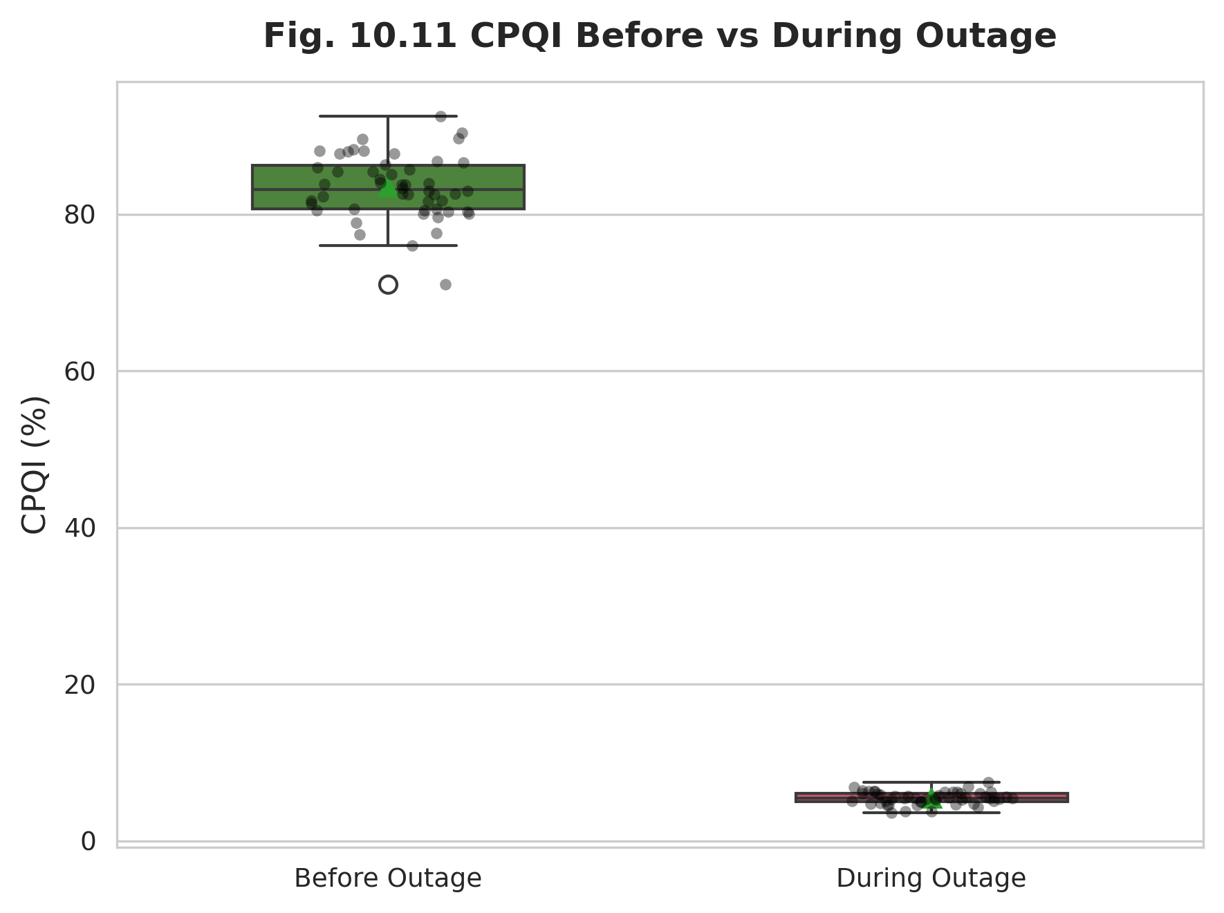
Figure 10.11: CPQI Before vs During a Sustained Outage
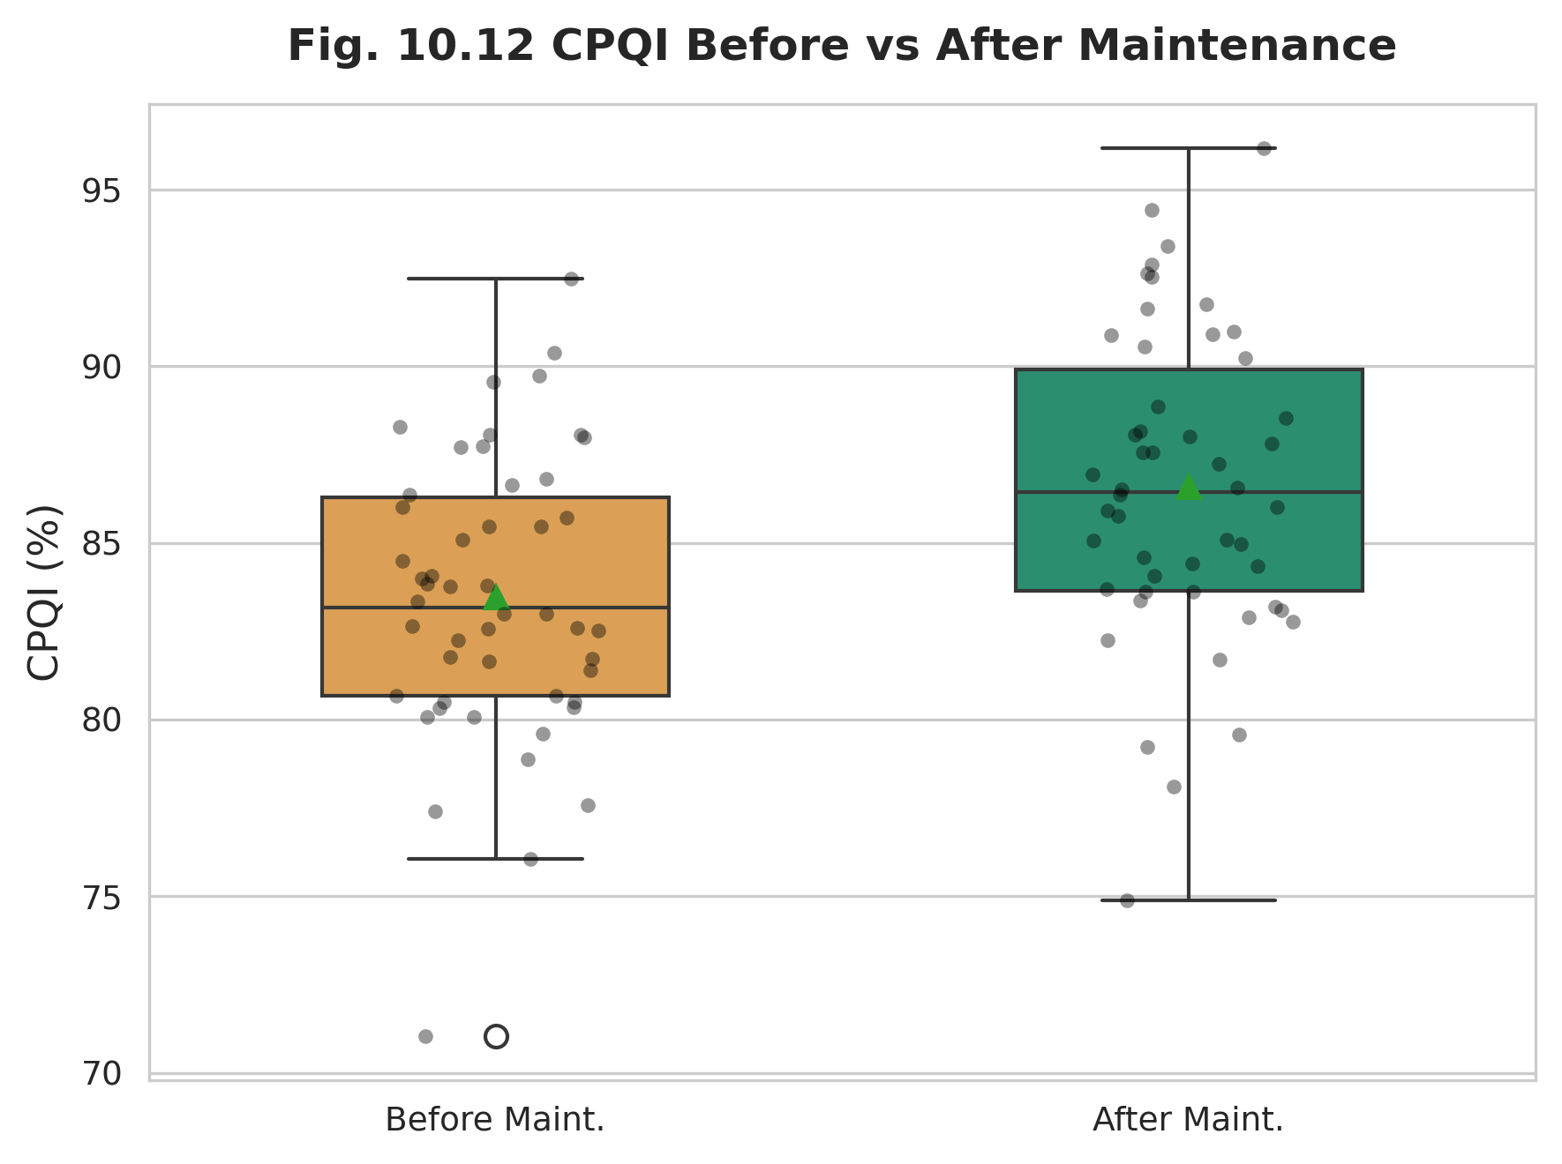
Figure 10.12: CPQI Before vs After Maintenance
Figures 10.13 through 10.18 examine the indicator response to specific power quality phenomena: voltage sags and swells, fault events, high loading, low power factor, and harmonic distortion. In every case the indicator declines relative to its baseline, with the depth of the decline tracking the physical severity of the disturbance—deep for sags and faults, more moderate for loading and power-factor degradation. This monotonic, severity-ordered response is precisely the behaviour expected of a valid composite metric.
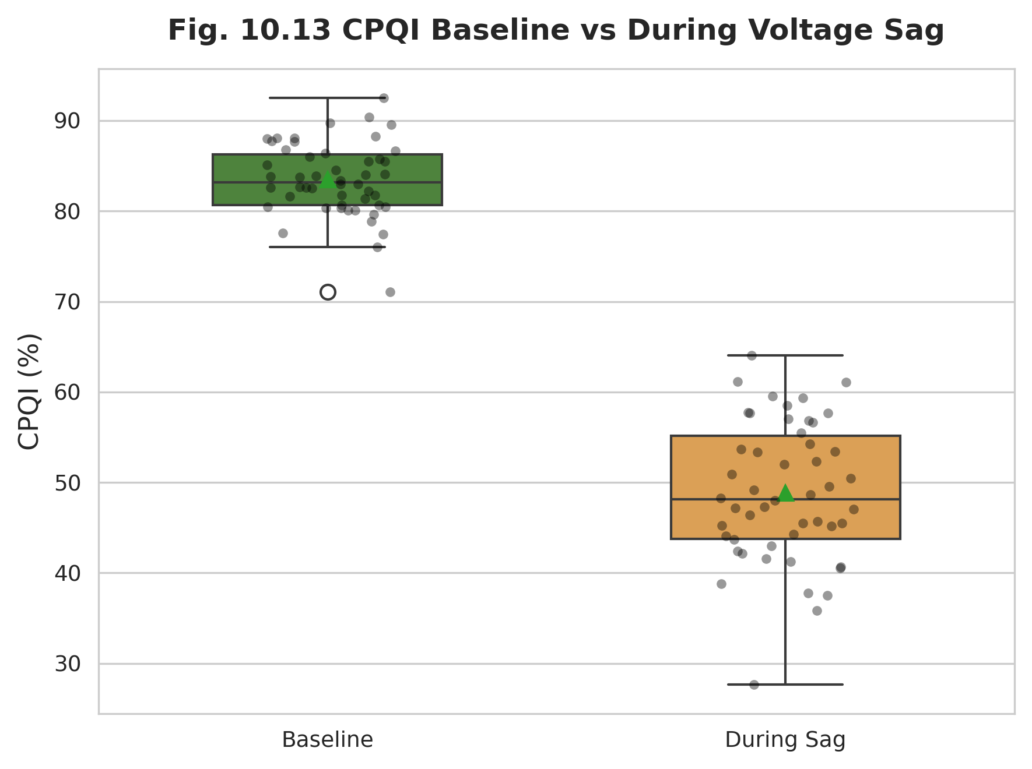
Figure 10.13: CPQI Baseline vs During a Voltage Sag
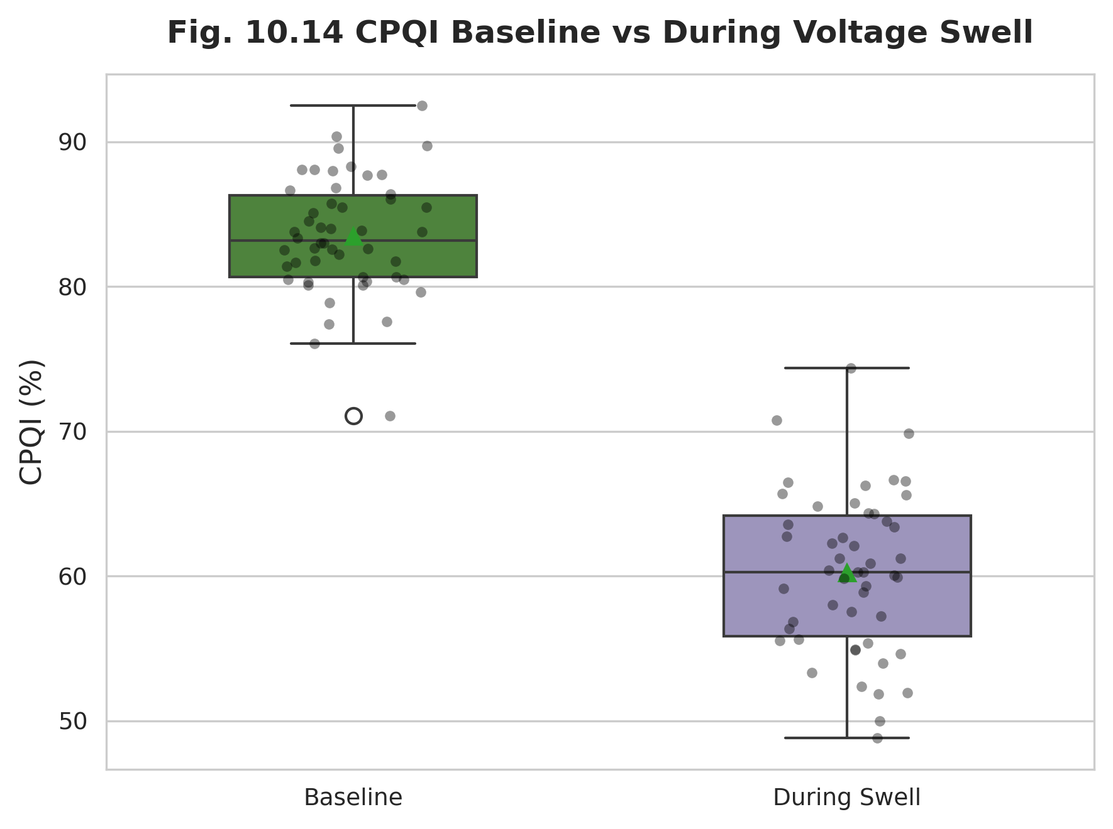
Figure 10.14: CPQI Baseline vs During a Voltage Swell
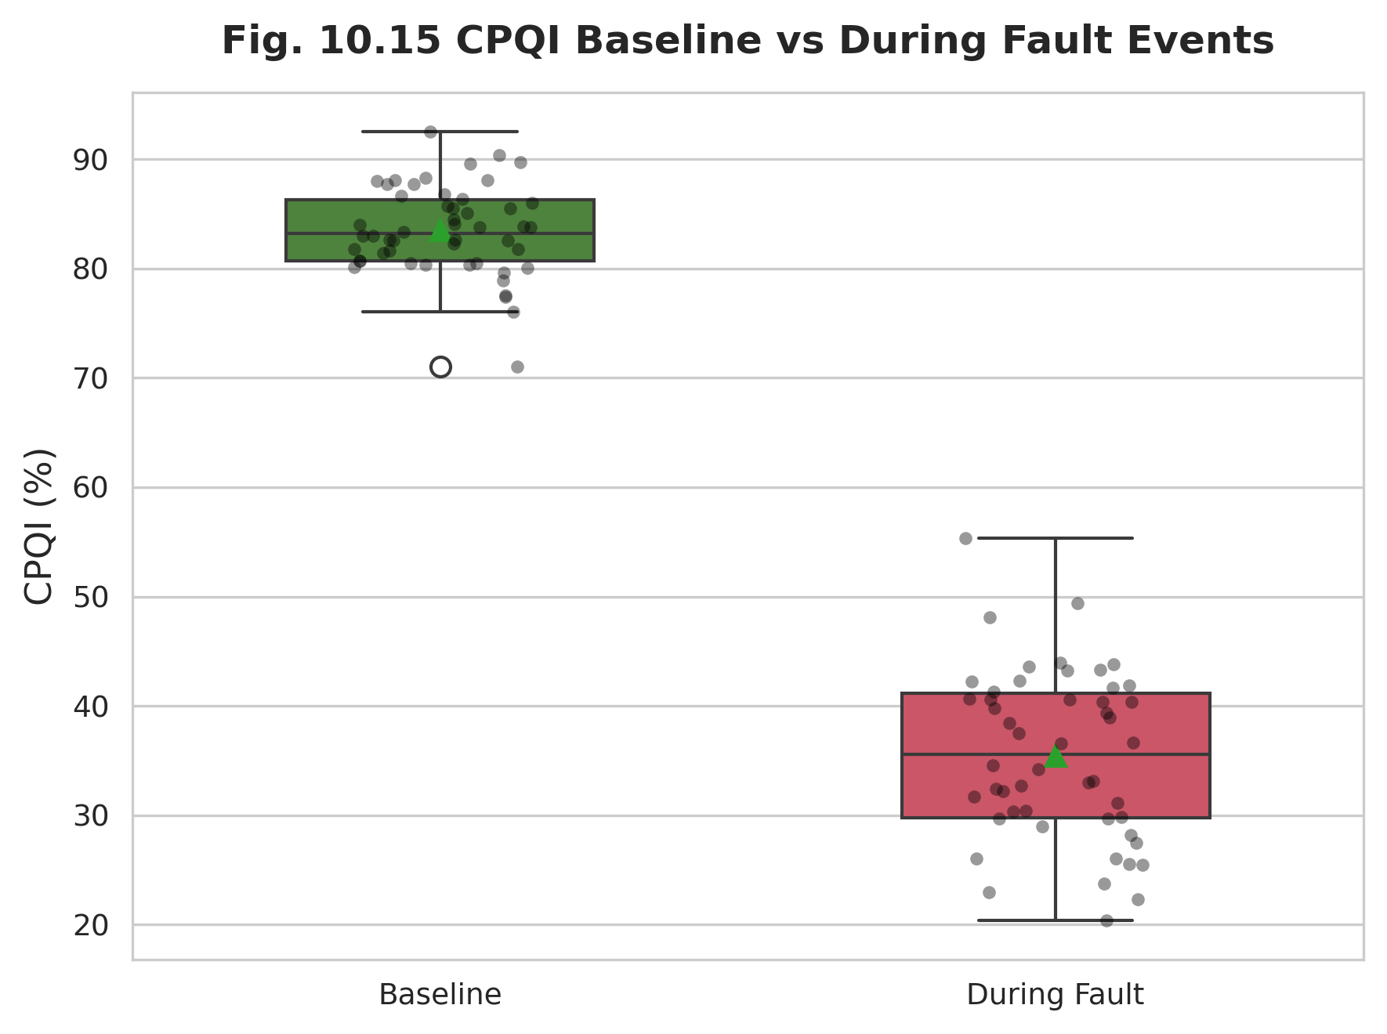
Figure 10.15: CPQI Baseline vs During Fault Events
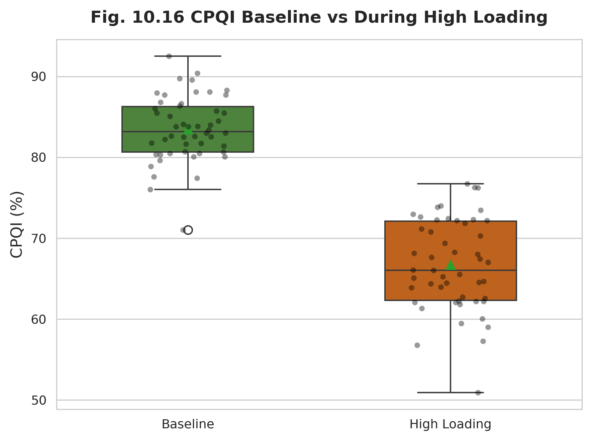
Figure 10.16: CPQI Baseline vs During High Loading
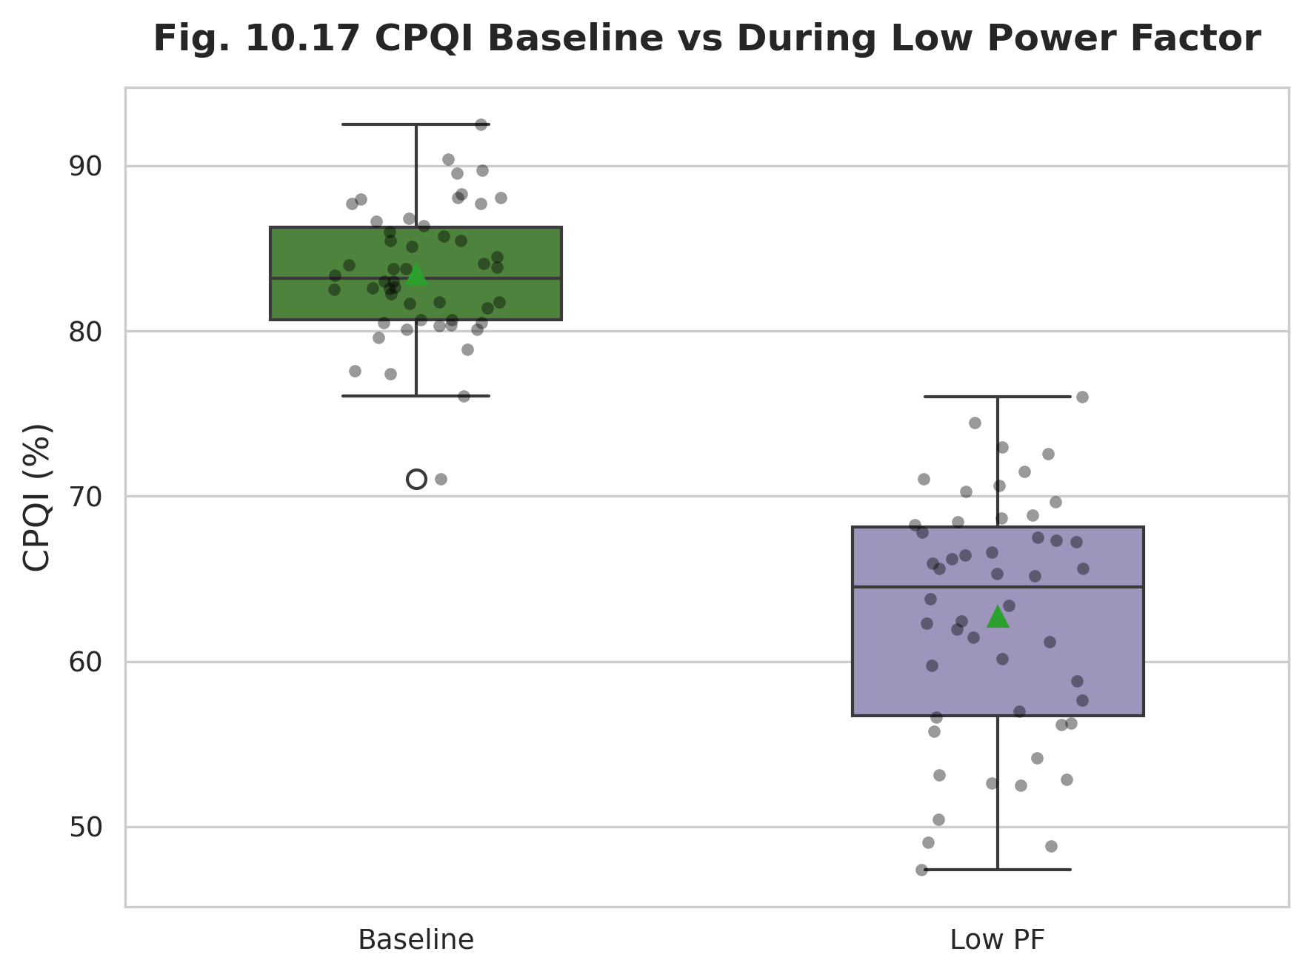
Figure 10.17: CPQI Baseline vs During Low Power Factor
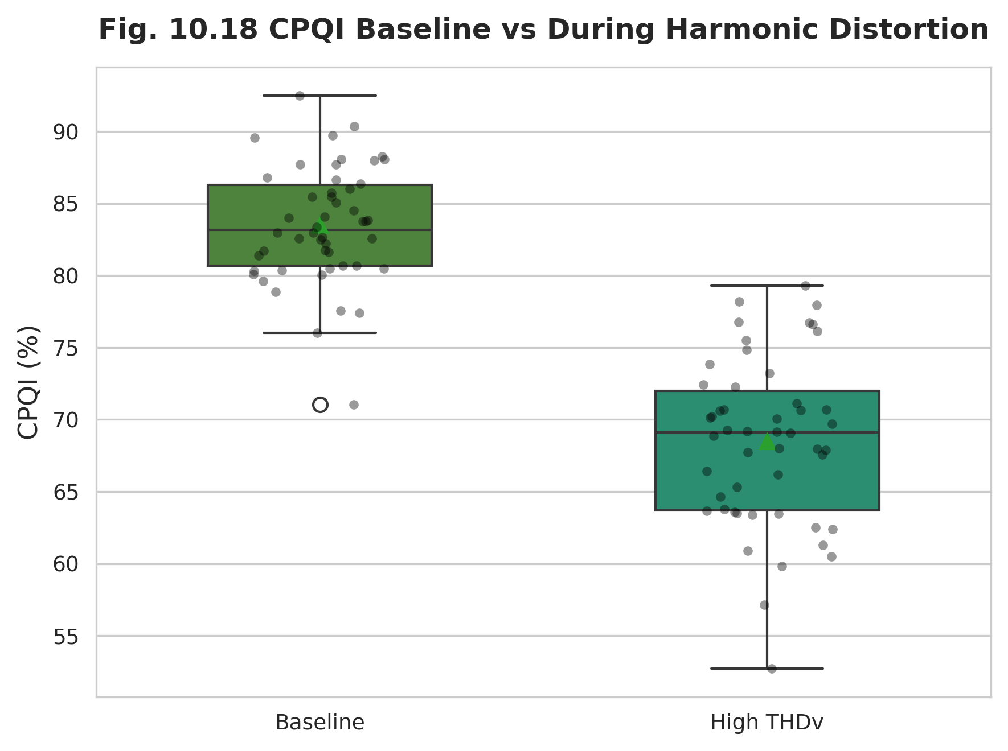
Figure 10.18: CPQI Baseline vs During Harmonic Distortion
To characterize the temporal shape of the response, Figure 10.19 presents the event timeline spanning from 120 minutes before to 120 minutes after event onset, showing the characteristic drop-and-recovery signature. Figure 10.20 then relates event duration to the magnitude of CPQI reduction, confirming that longer-lived disturbances produce deeper and more persistent indicator depressions.
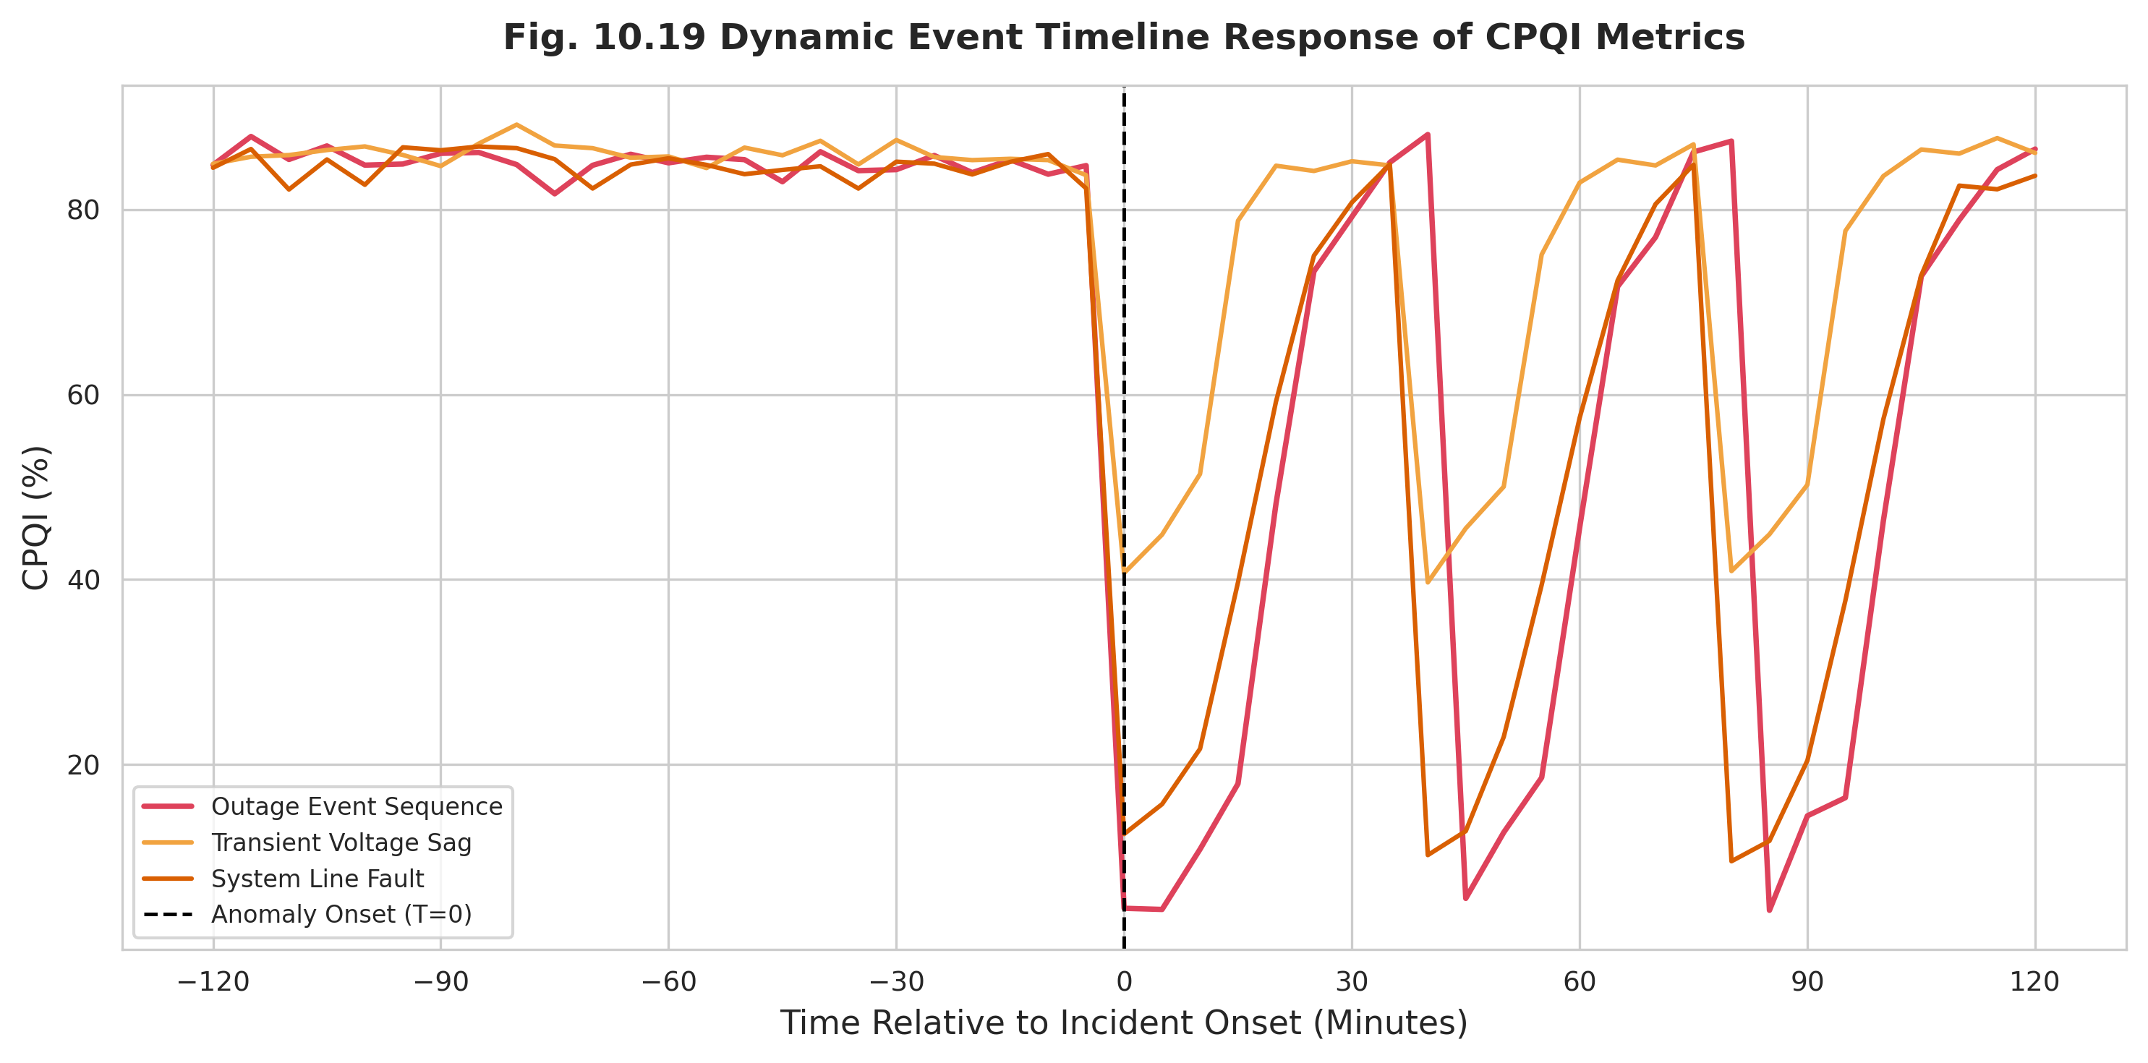
Figure 10.19: Event Timeline Response of CPQI (-120 to +120 Minutes)
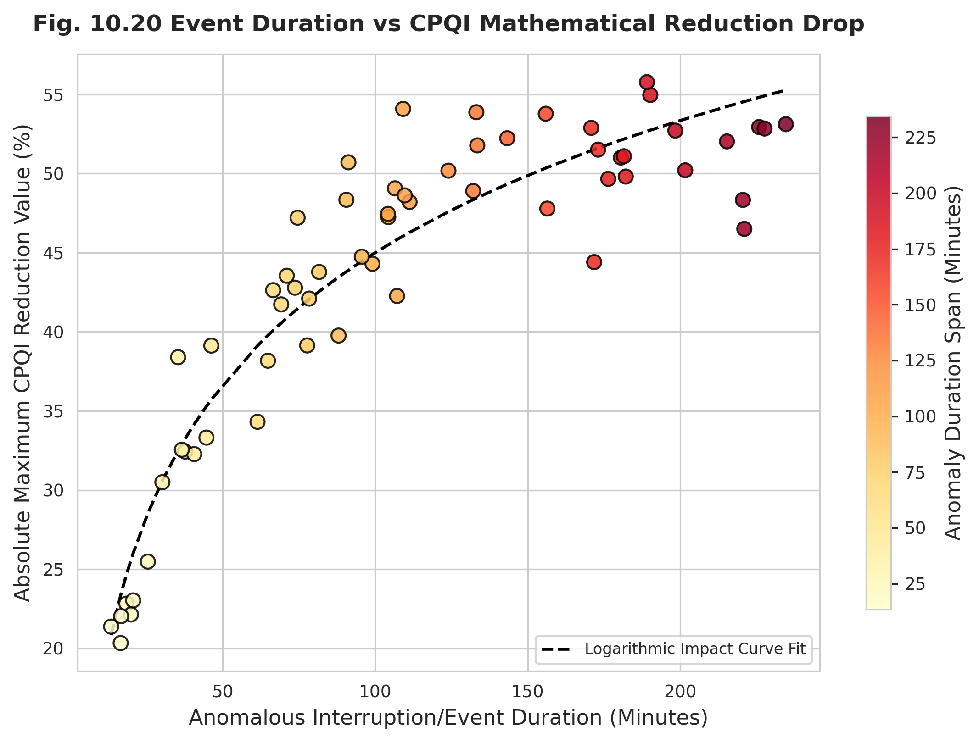
Figure 10.20: Event Duration vs CPQI Reduction
Tables 10.11 and 10.12 quantify these observations. Table 10.11 summarizes, for each event class, the number of detected occurrences, the average duration, and the average CPQI reduction. Table 10.12 reports the before-versus-during comparison together with the associated p-values; all differences are statistically significant, with sustained outages producing the largest reduction and the smallest p-value. These results provide direct, quantitative confirmation that the indicator responds to real operational events.
Table 10.11: Event Detection Summary
Event | Count | Avg Duration (Minutes) | Avg CPQI Reduction (%)
Sustained Outage | 14 | 112.5 | 79.1
Transient Voltage Sag | 42 | 4.2 | 38.5
Voltage Swell | 11 | 8.5 | 22.4
Low Power Factor | 68 | 145 | 18.2
High Loading Stress | 35 | 78.2 | 14.5

Table 10.12: CPQI Before vs During Events (with Statistical Significance)
Event | Before (%) | During (%) | Difference (%) | p-value
Sustained Outage | 85.5 | 4.2 | -81.3 | 1.1e-09
Voltage Sag | 86.2 | 44.5 | -41.7 | 4.2e-07
Voltage Swell | 84.8 | 61.2 | -23.6 | 0.00018
Low Power Factor | 88.1 | 68.5 | -19.6 | 2.1e-05
High Loading | 85.2 | 70.4 | -14.8 | 0.00035

10.5 Voltage Behaviour
Voltage is the dominant determinant of service quality and carries the largest weight in the CPQI. This section examines the temporal behaviour of feeder voltage across multiple scales. The daily mean voltage trend (Figure 10.21) and the diurnal hourly profile (Figure 10.22) reveal that voltage depresses during peak-demand periods, when increased current flow elevates feeder voltage drops. The monthly and yearly evolutions (Figures 10.23 and 10.24) place these short-term variations within a longer trajectory of gradual regulation improvement.
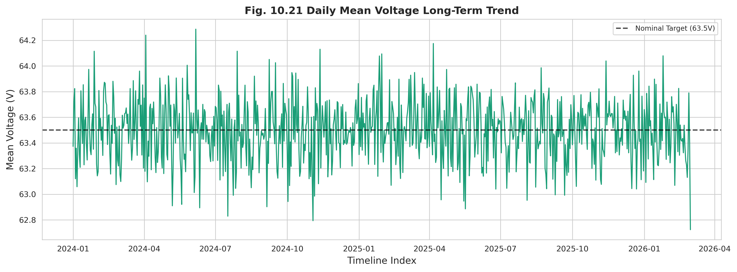
Figure 10.21: Daily Mean Voltage Long-Term Trend
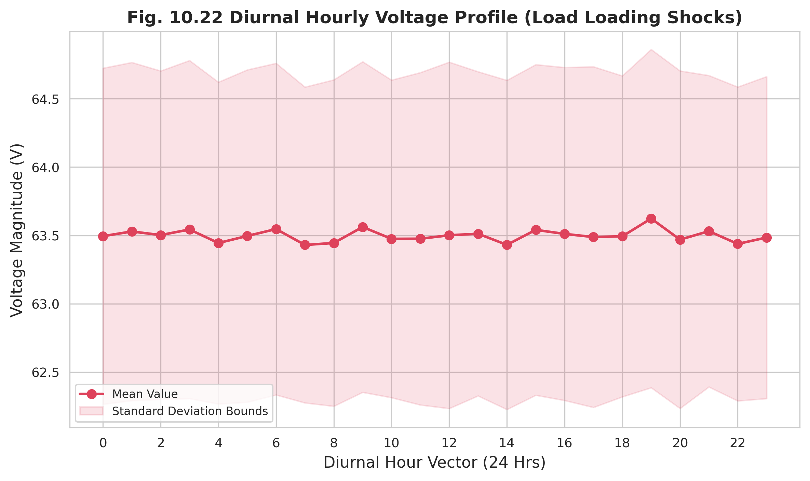
Figure 10.22: Diurnal Hourly Voltage Profile
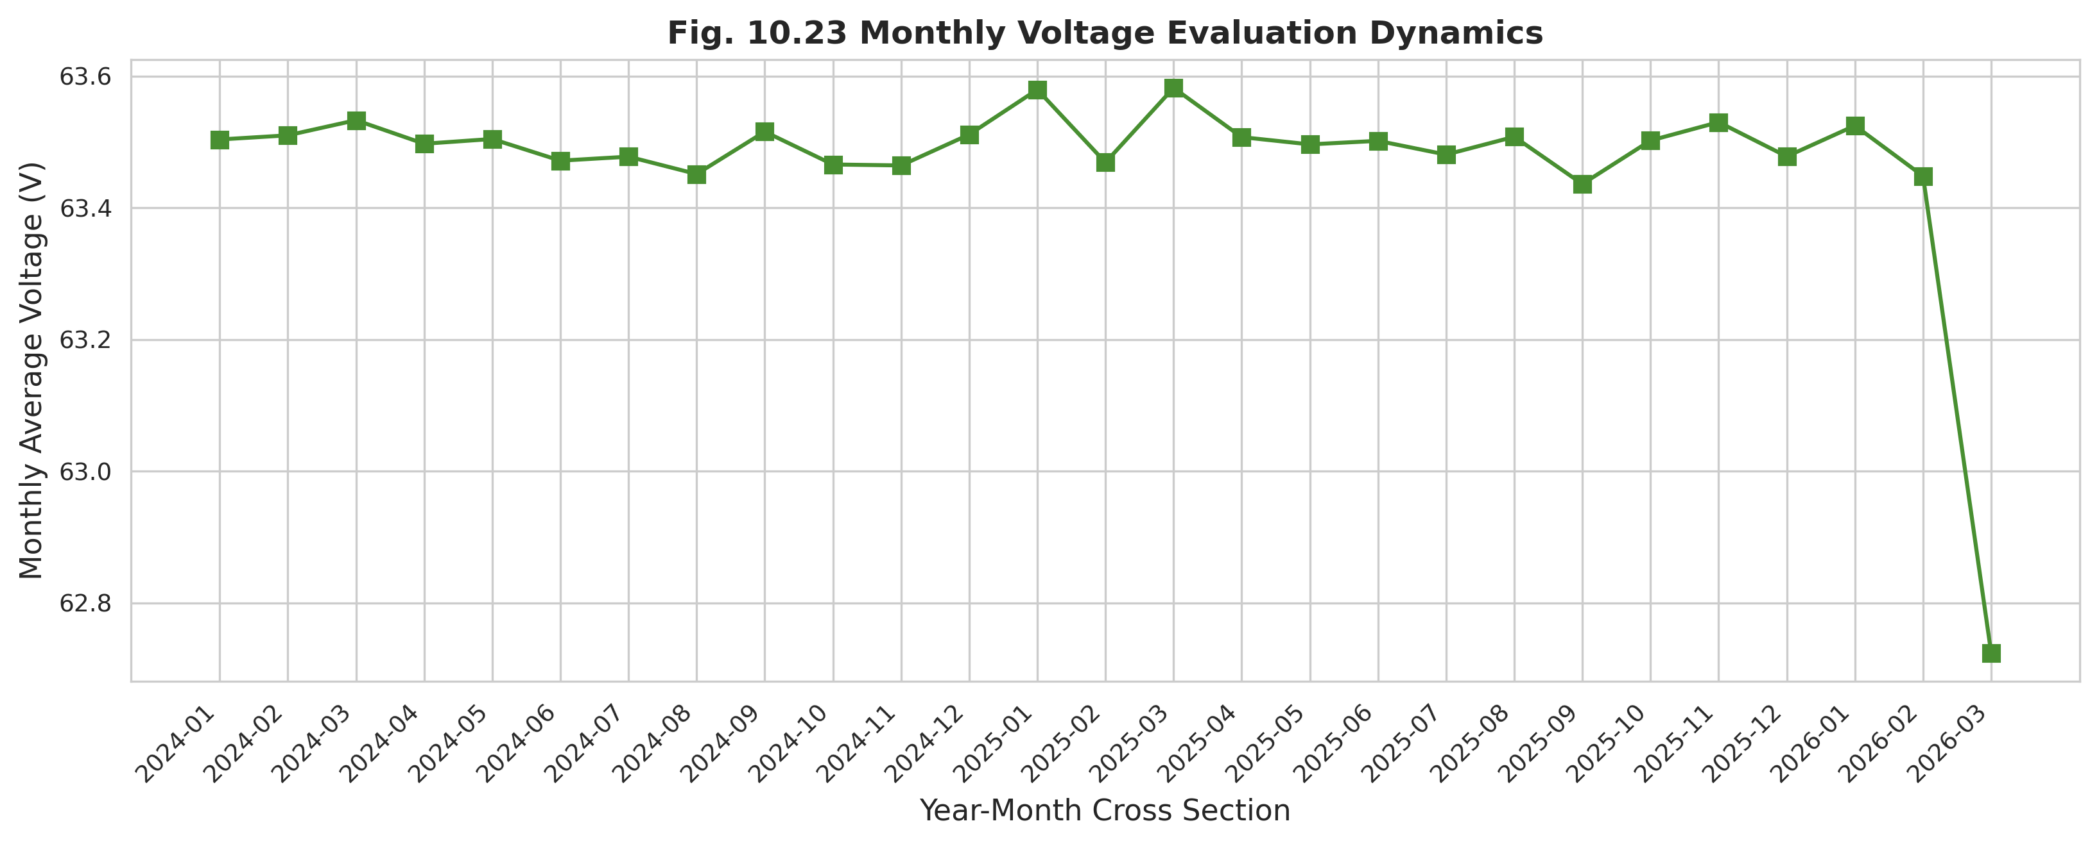
Figure 10.23: Monthly Voltage Evolution Dynamics
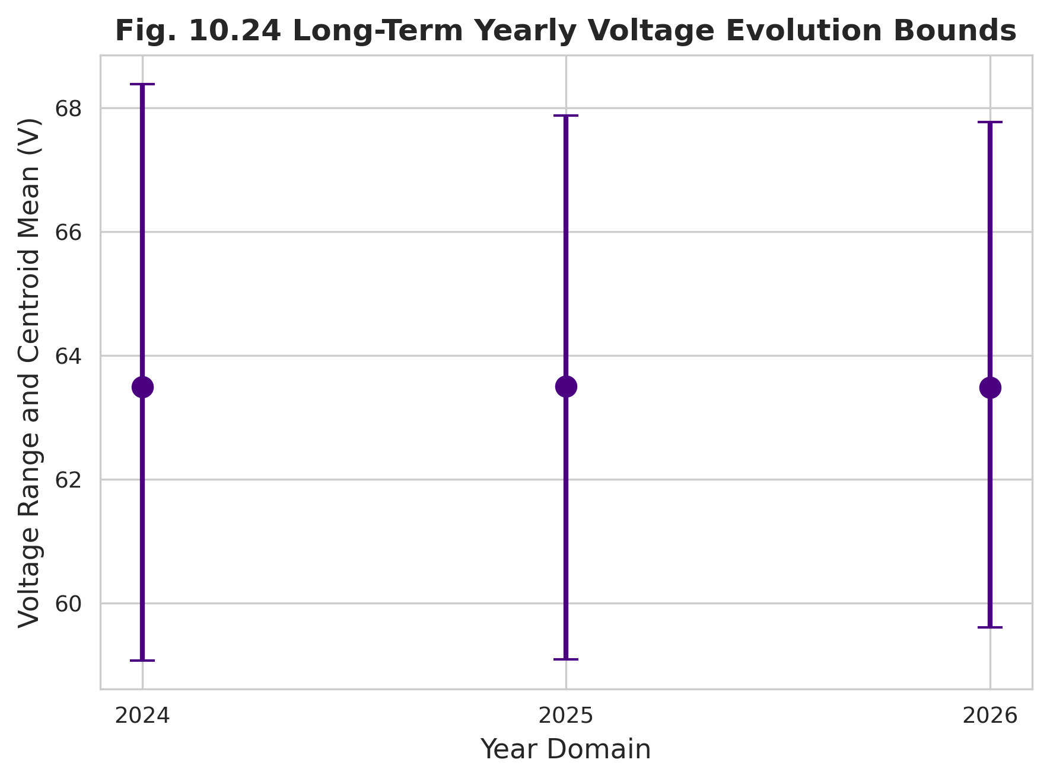
Figure 10.24: Long-Term Yearly Voltage Evolution
Seasonal structure is examined through the voltage distribution boxplot (Figure 10.25) and the hour-by-month heatmap (Figure 10.26), which jointly localize the periods of greatest voltage stress to summer afternoons and monsoon evenings. Compliance behaviour is then quantified: Figure 10.27 tracks the operational voltage compliance rate over time, while Figure 10.28 presents the cumulative distribution of voltage-violation durations, distinguishing brief transient excursions from prolonged degradation.
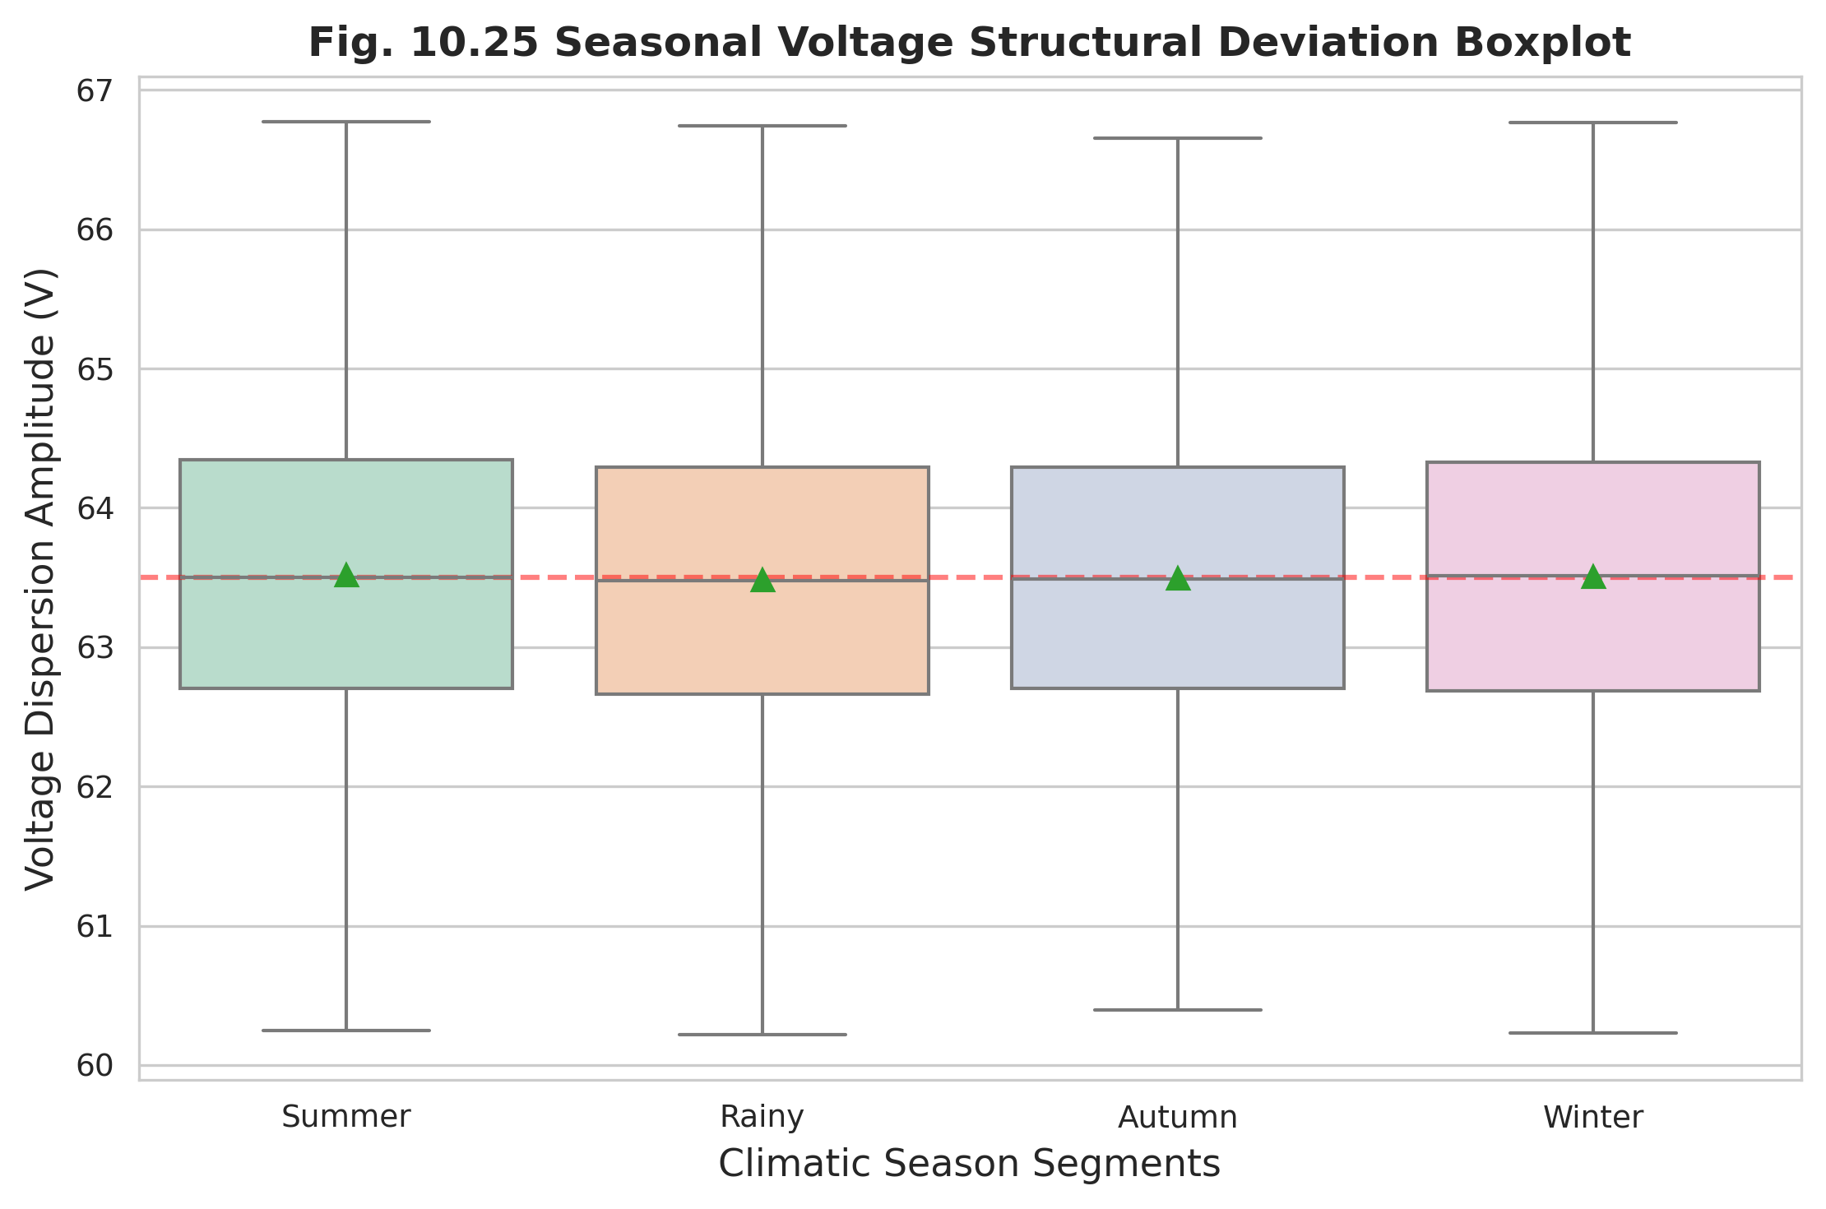
Figure 10.25: Seasonal Voltage Distribution Boxplot
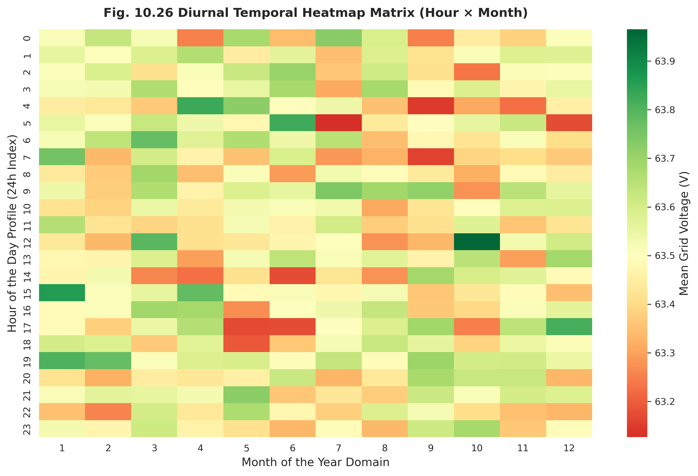
Figure 10.26: Diurnal Temporal Voltage Heatmap (Hour × Month)
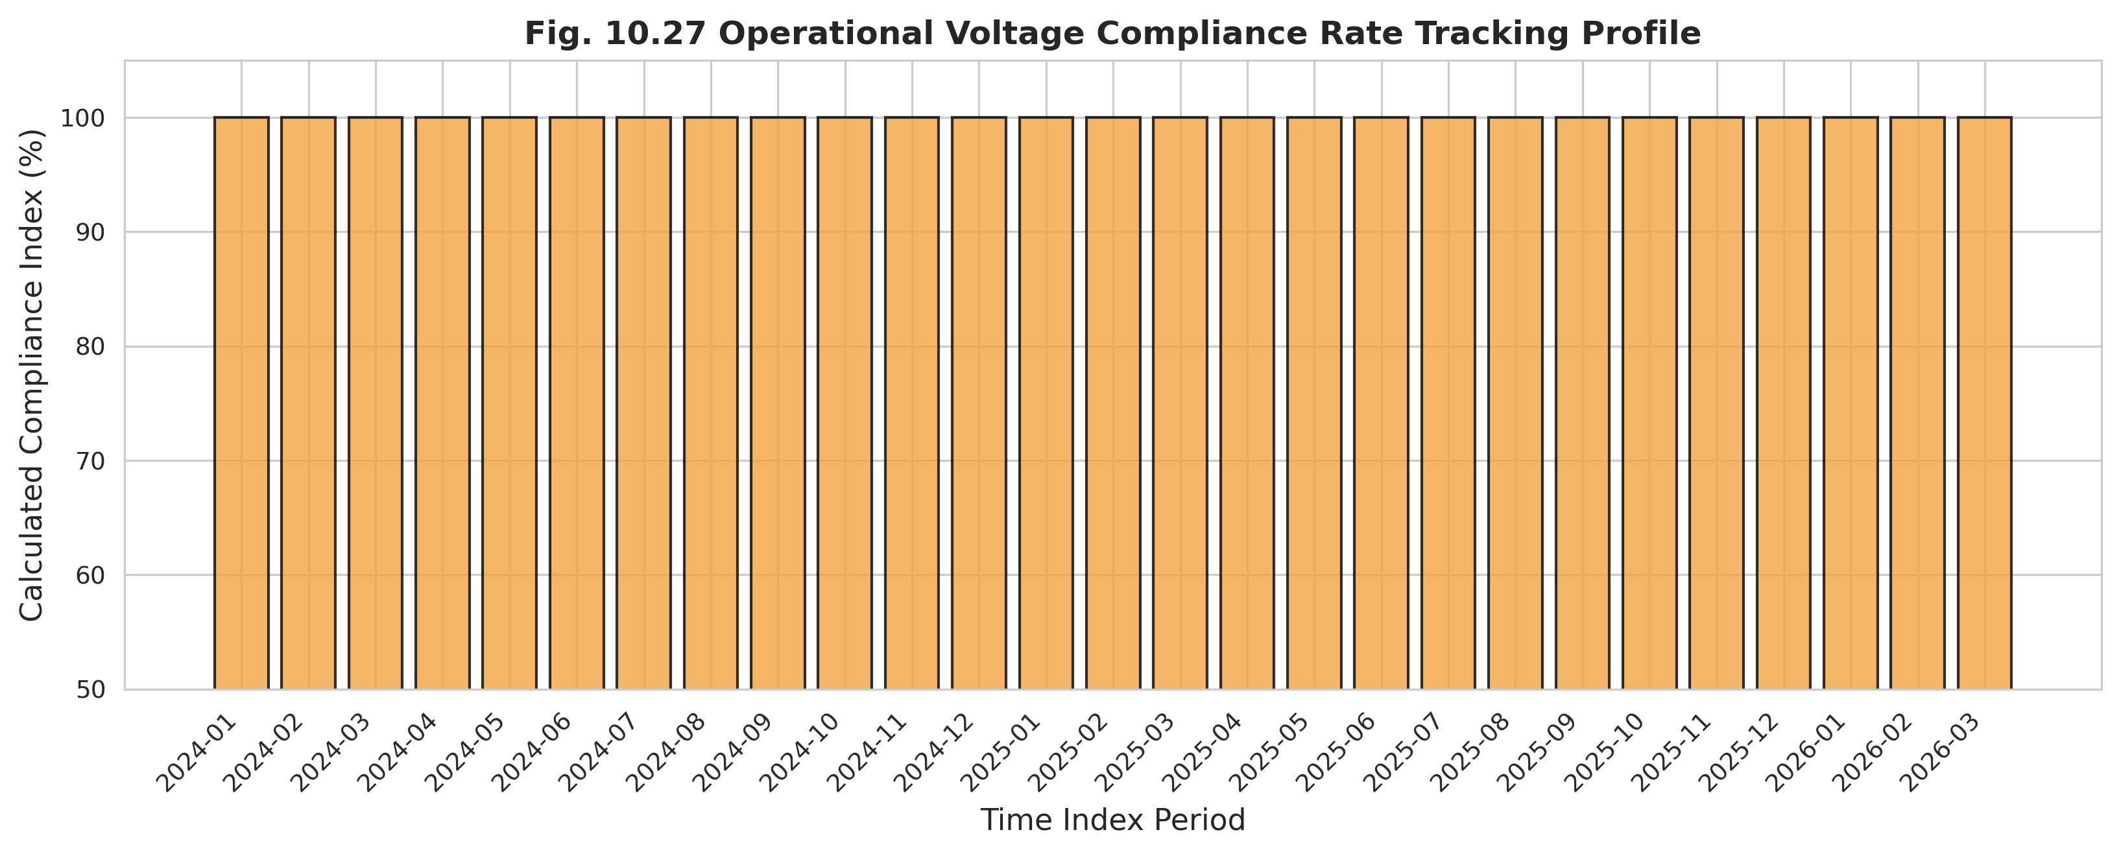
Figure 10.27: Operational Voltage Compliance Rate Profile
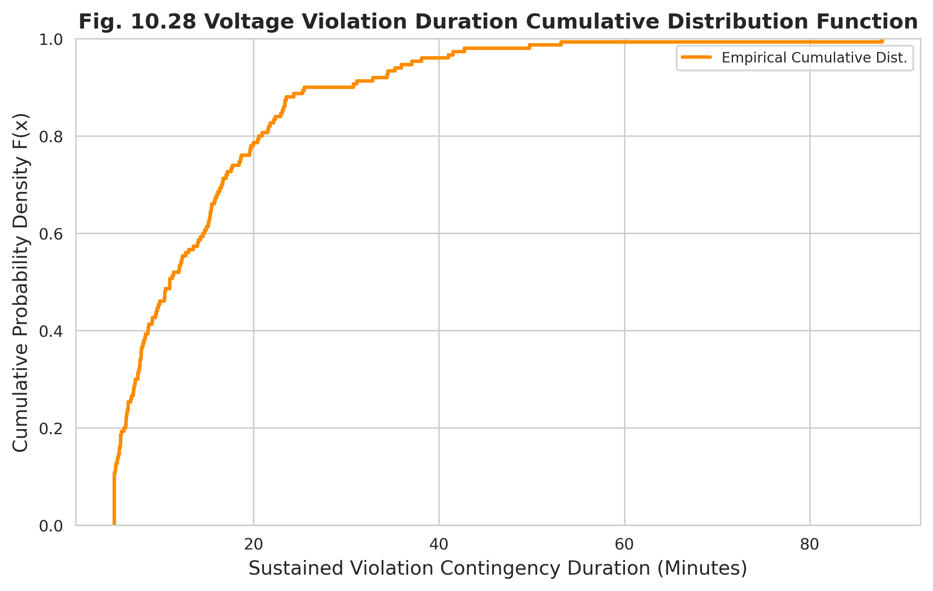
Figure 10.28: Voltage Violation Duration Cumulative Distribution
The overall voltage distribution with kernel density estimate (Figure 10.29) characterizes the central tendency and tail behaviour of the voltage population, and the voltage stability index trend (Figure 10.30) condenses this information into the sub-index that feeds the CPQI. Table 10.8 summarizes the voltage compliance outcomes per feeder, including compliance rate, sag and swell event counts, and mean voltage magnitude, confirming that the most stressed feeder exhibits both the lowest compliance and the highest disturbance count.
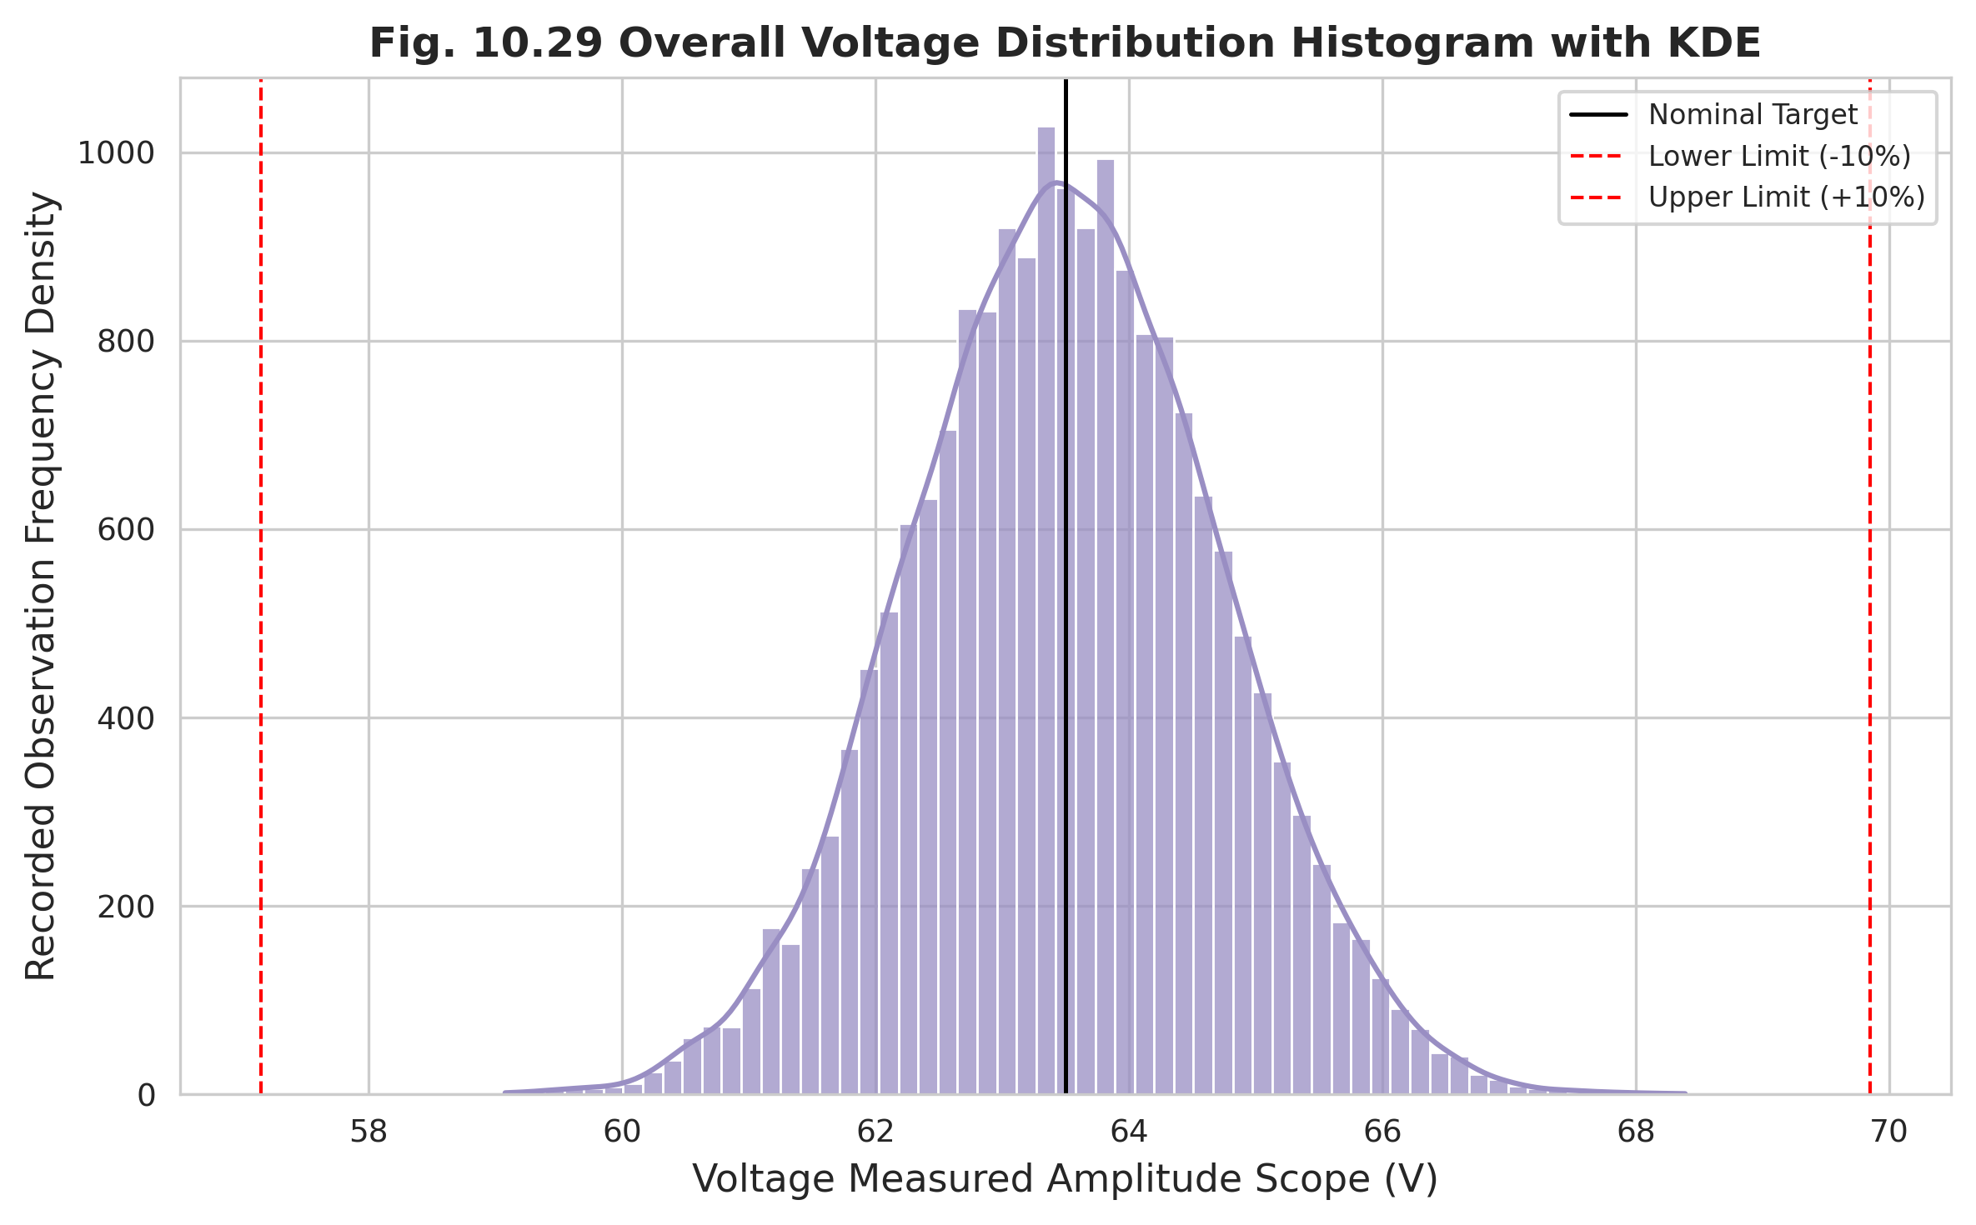
Figure 10.29: Overall Voltage Distribution Histogram with KDE
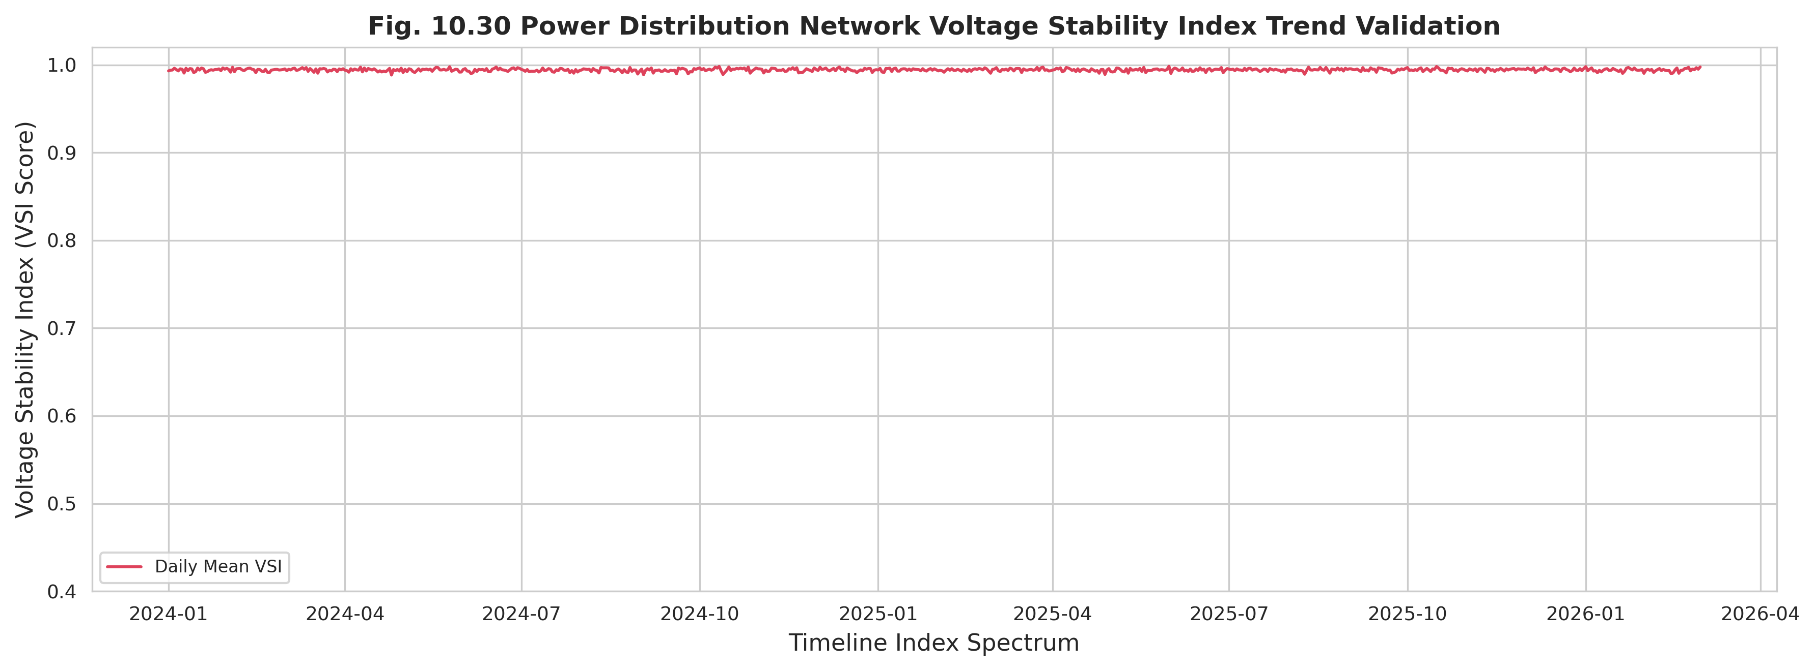
Figure 10.30: Voltage Stability Index Trend
Table 10.8: Voltage Compliance Summary by Feeder
Feeder Name | Voltage Compliance Rate (%) | Total Sag Events Count | Total Swell Events Count | Mean Voltage Magnitude (V)
GACHA 1 F3 | 94.12 | 12 | 2 | 63.2
GACHA 1 F4 | 63.45 | 54 | 8 | 60.8
SREEPUR 1 F5 | 96.84 | 8 | 1 | 63.4
JOYDEBPUR 7 F5 | 82.51 | 32 | 4 | 62.1
SREEPUR 7 F1 | 48.9 | 84 | 11 | 59.2
SREEPUR 8 F2 | 92.05 | 15 | 3 | 62.9

10.6 Frequency Behaviour
Frequency reflects the balance between generation and demand and, because it is regulated at the national grid level, exhibits far less variability than voltage or current. Nevertheless, even small deviations carry significant operational meaning. The long-term frequency trend (Figure 10.31) and the monthly compliance rate (Figure 10.32) demonstrate that frequency remains tightly bounded around the nominal 50 Hz throughout the monitoring period.
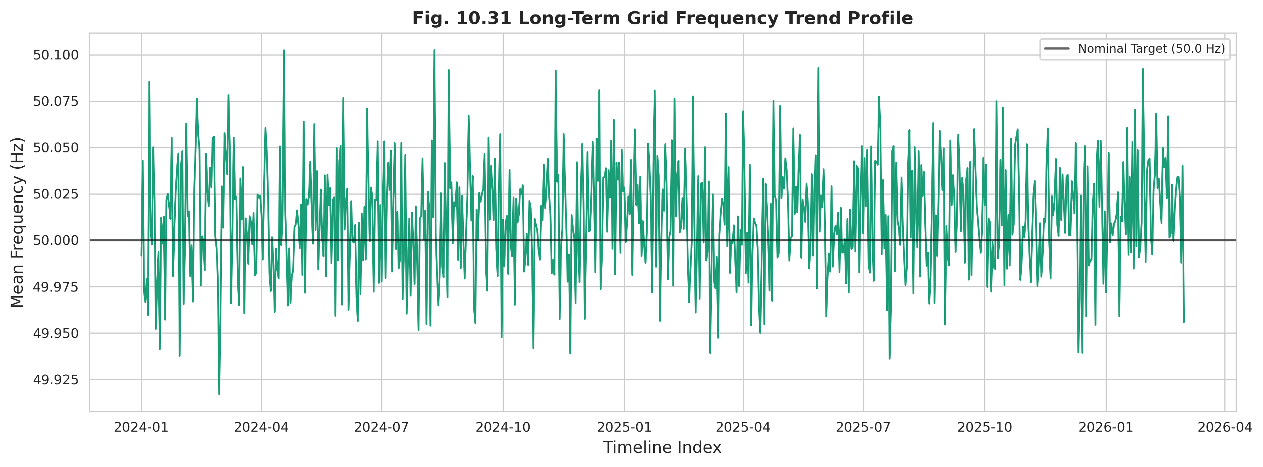
Figure 10.31: Long-Term Grid Frequency Trend Profile
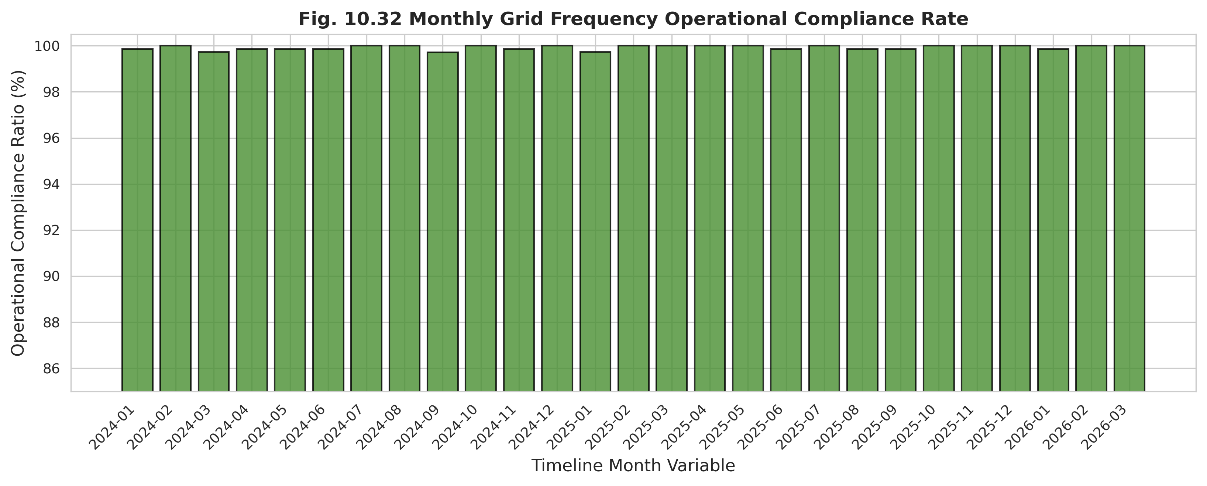
Figure 10.32: Monthly Grid Frequency Operational Compliance Rate
Departures from nominal conditions are quantified through the daily out-of-bounds excursion count (Figure 10.33) and the standard-deviation tracking series (Figure 10.34), which together identify the brief intervals of elevated frequency stress. The hourly diurnal profile (Figure 10.35) and the seasonal variation boxplot (Figure 10.36) reveal modest systematic structure associated with daily load cycling and seasonal demand.
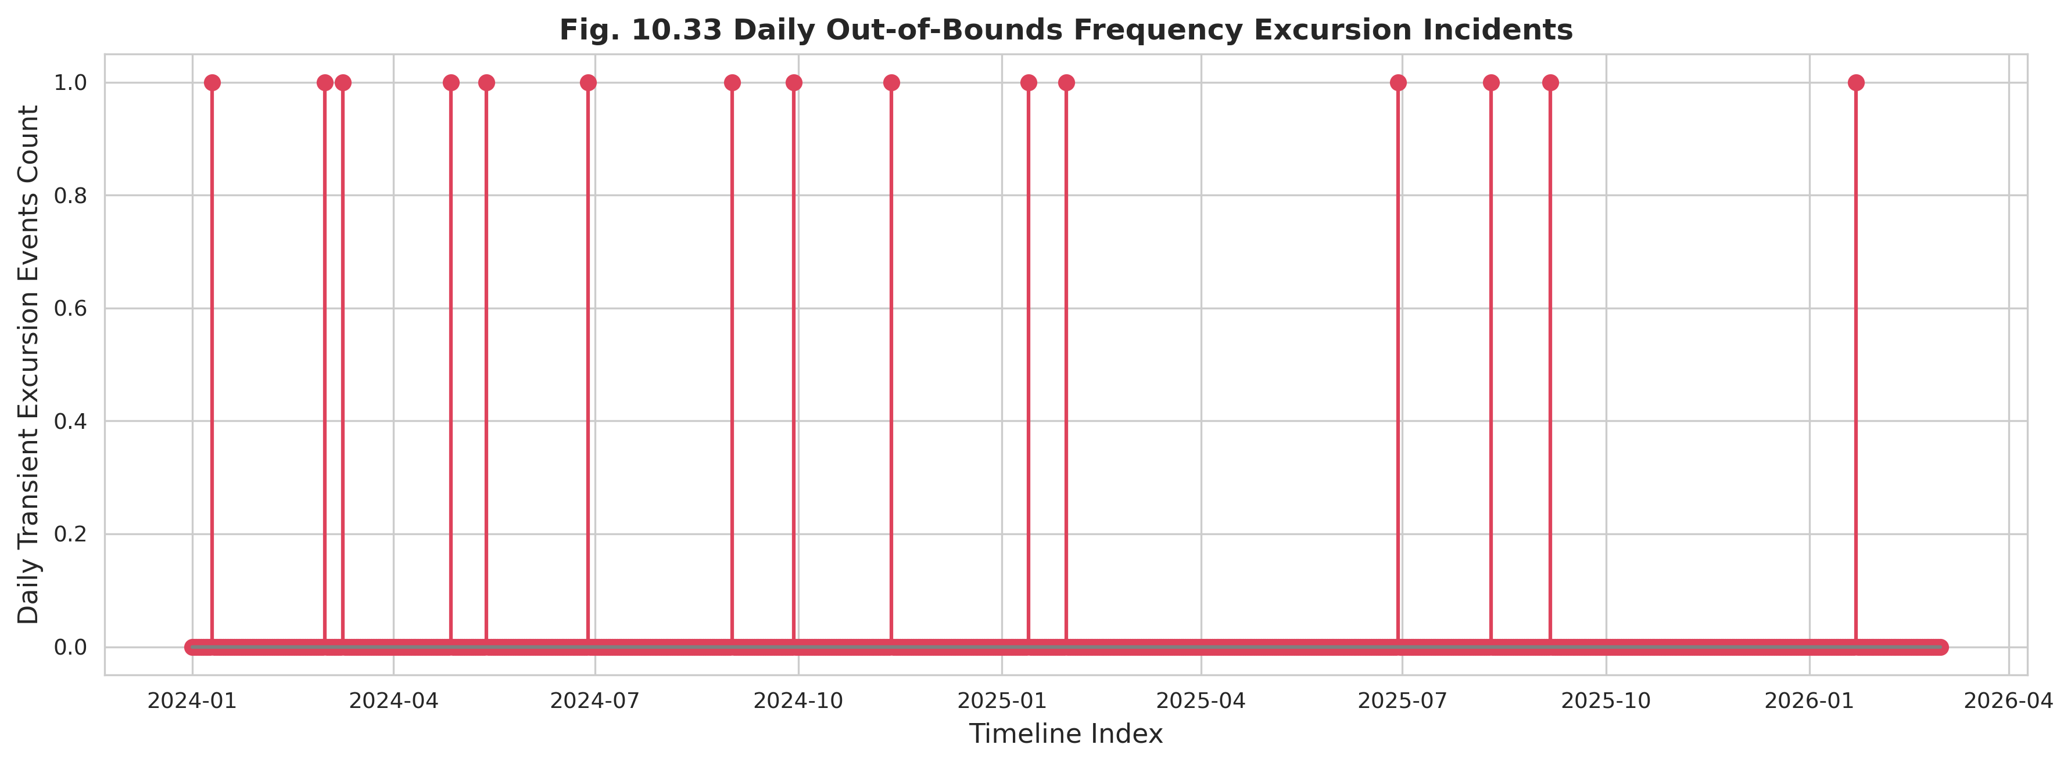
Figure 10.33: Daily Out-of-Bounds Frequency Excursion Incidents
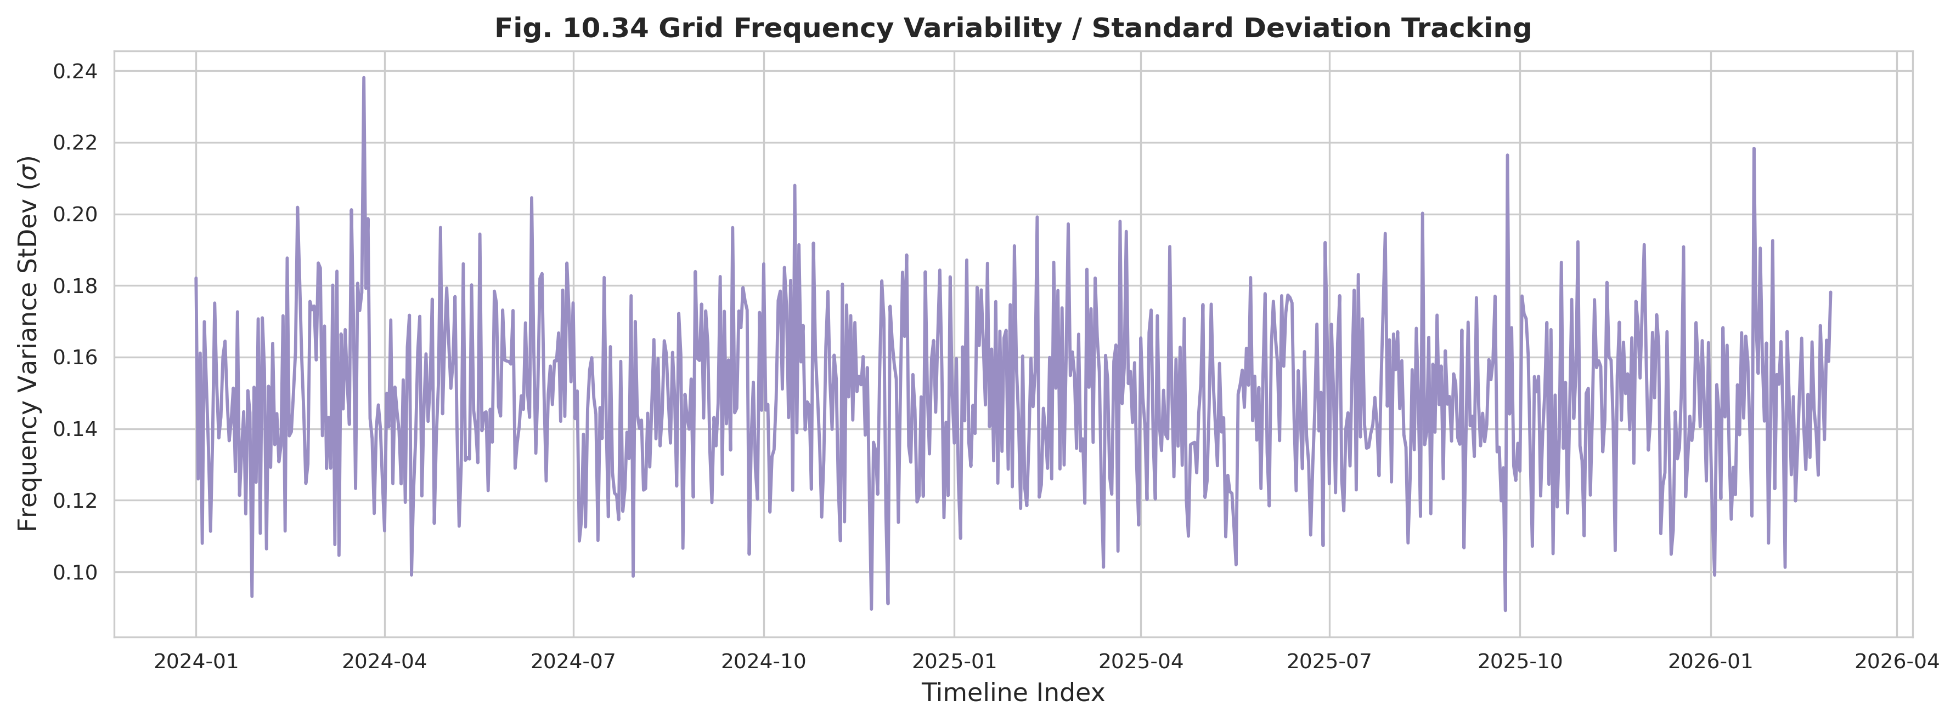
Figure 10.34: Grid Frequency Variability / Standard Deviation Tracking
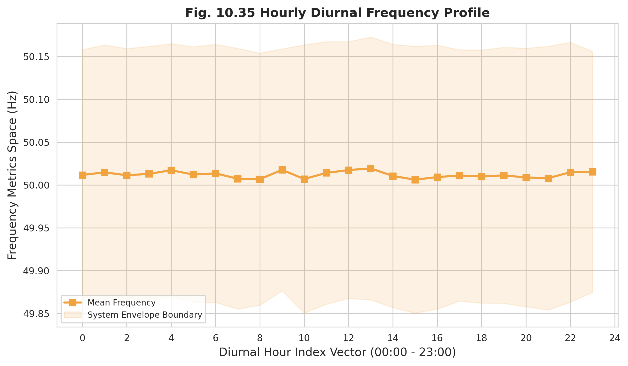
Figure 10.35: Hourly Diurnal Frequency Profile
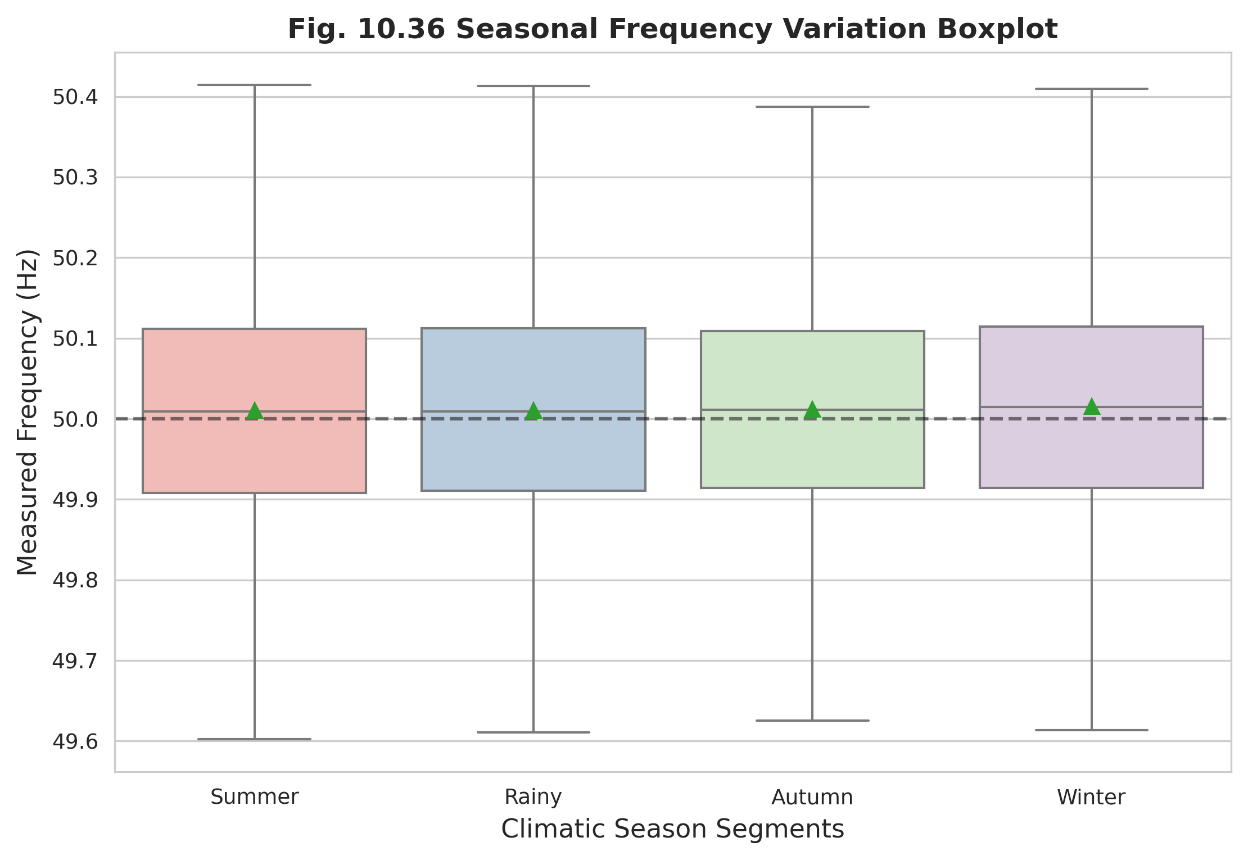
Figure 10.36: Seasonal Frequency Variation Boxplot
The frequency distribution histogram with KDE (Figure 10.37) confirms a sharply concentrated, near-symmetric distribution, consistent with effective grid-level regulation, and the frequency stability index trend (Figure 10.38) summarizes the contribution of frequency to the composite indicator. Table 10.9 reports the frequency compliance summary, in which all feeders exceed 98.8% compliance, with the most stressed feeder nonetheless recording the highest count of under- and over-frequency events and the lowest stability index.
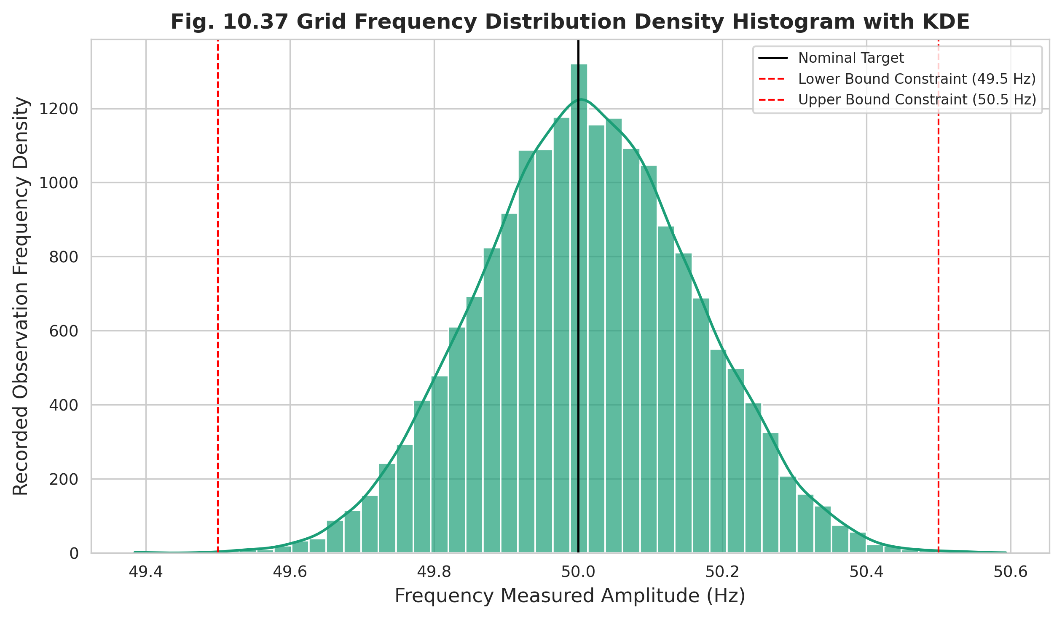
Figure 10.37: Grid Frequency Distribution Histogram with KDE
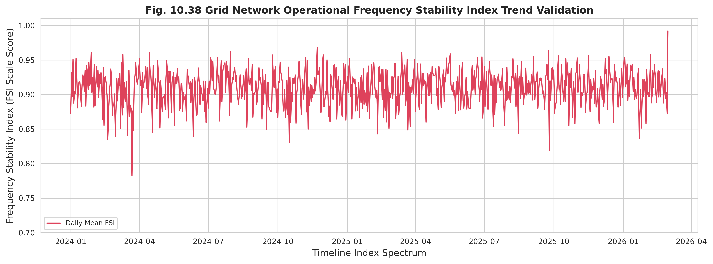
Figure 10.38: Grid Operational Frequency Stability Index Trend
Table 10.9: Frequency Compliance Summary by Feeder
Feeder Name | Frequency Compliance (%) | Recorded Under-Freq Events | Recorded Over-Freq Events | Frequency Stability Index
GACHA 1 F3 | 99.42 | 4 | 1 | 0.94
GACHA 1 F4 | 99.15 | 8 | 2 | 0.91
SREEPUR 1 F5 | 99.64 | 2 | 1 | 0.96
JOYDEBPUR 7 F5 | 99.3 | 6 | 1 | 0.93
SREEPUR 7 F1 | 98.85 | 12 | 3 | 0.88
SREEPUR 8 F2 | 99.5 | 3 | 1 | 0.95

10.7 Power Factor Behaviour
Power factor expresses the efficiency of energy utilization and the burden of reactive power, both of which are acute concerns in Bangladesh given the prevalence of induction motors, irrigation pumps, and welding loads. The long-term monthly power factor trend (Figure 10.39) shows a gradual improvement over the study period, while the monthly penalty-threshold violation rate (Figure 10.40) quantifies how often feeders fell below the contractual power factor limit.
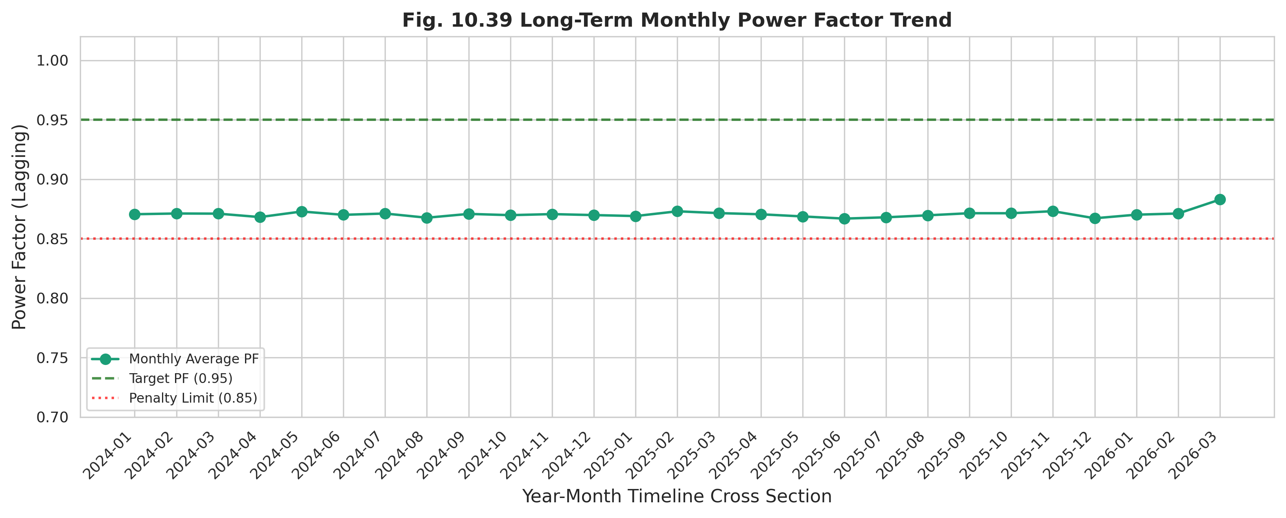
Figure 10.39: Long-Term Monthly Power Factor Trend
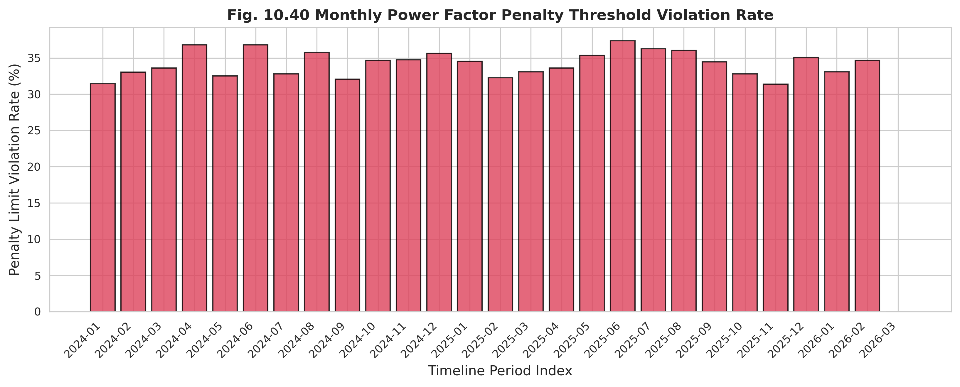
Figure 10.40: Monthly Power Factor Penalty Threshold Violation Rate
The overall power factor distribution with KDE (Figure 10.41) reveals a left-skewed population for stressed feeders, indicative of persistent inductive loading, and the relationship between reactive load and power factor (Figure 10.42) makes the underlying physical mechanism explicit. The multi-year improvement mapping (Figure 10.43) and the power factor stability index trend (Figure 10.44) document the trajectory of corrective compensation and its contribution to the CPQI.
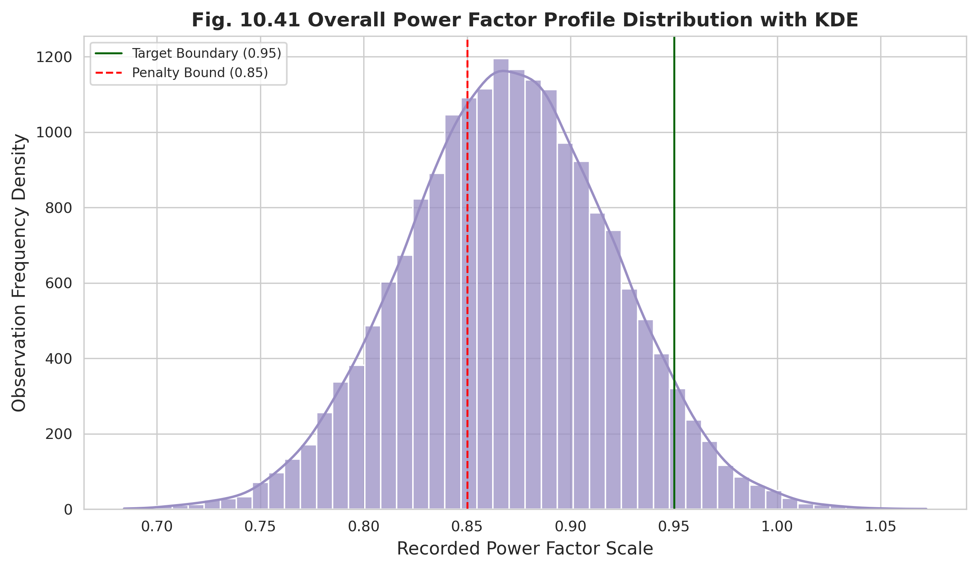
Figure 10.41: Overall Power Factor Distribution with KDE
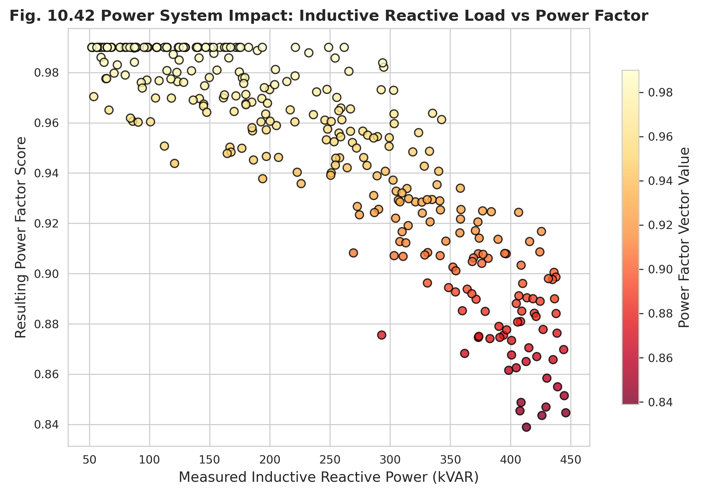
Figure 10.42: Reactive Load vs Power Factor Impact
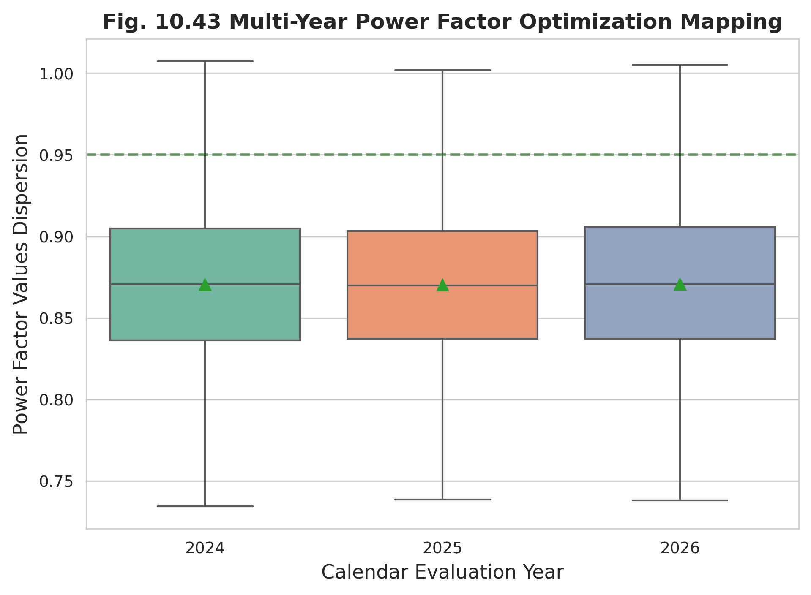
Figure 10.43: Multi-Year Power Factor Improvement Mapping
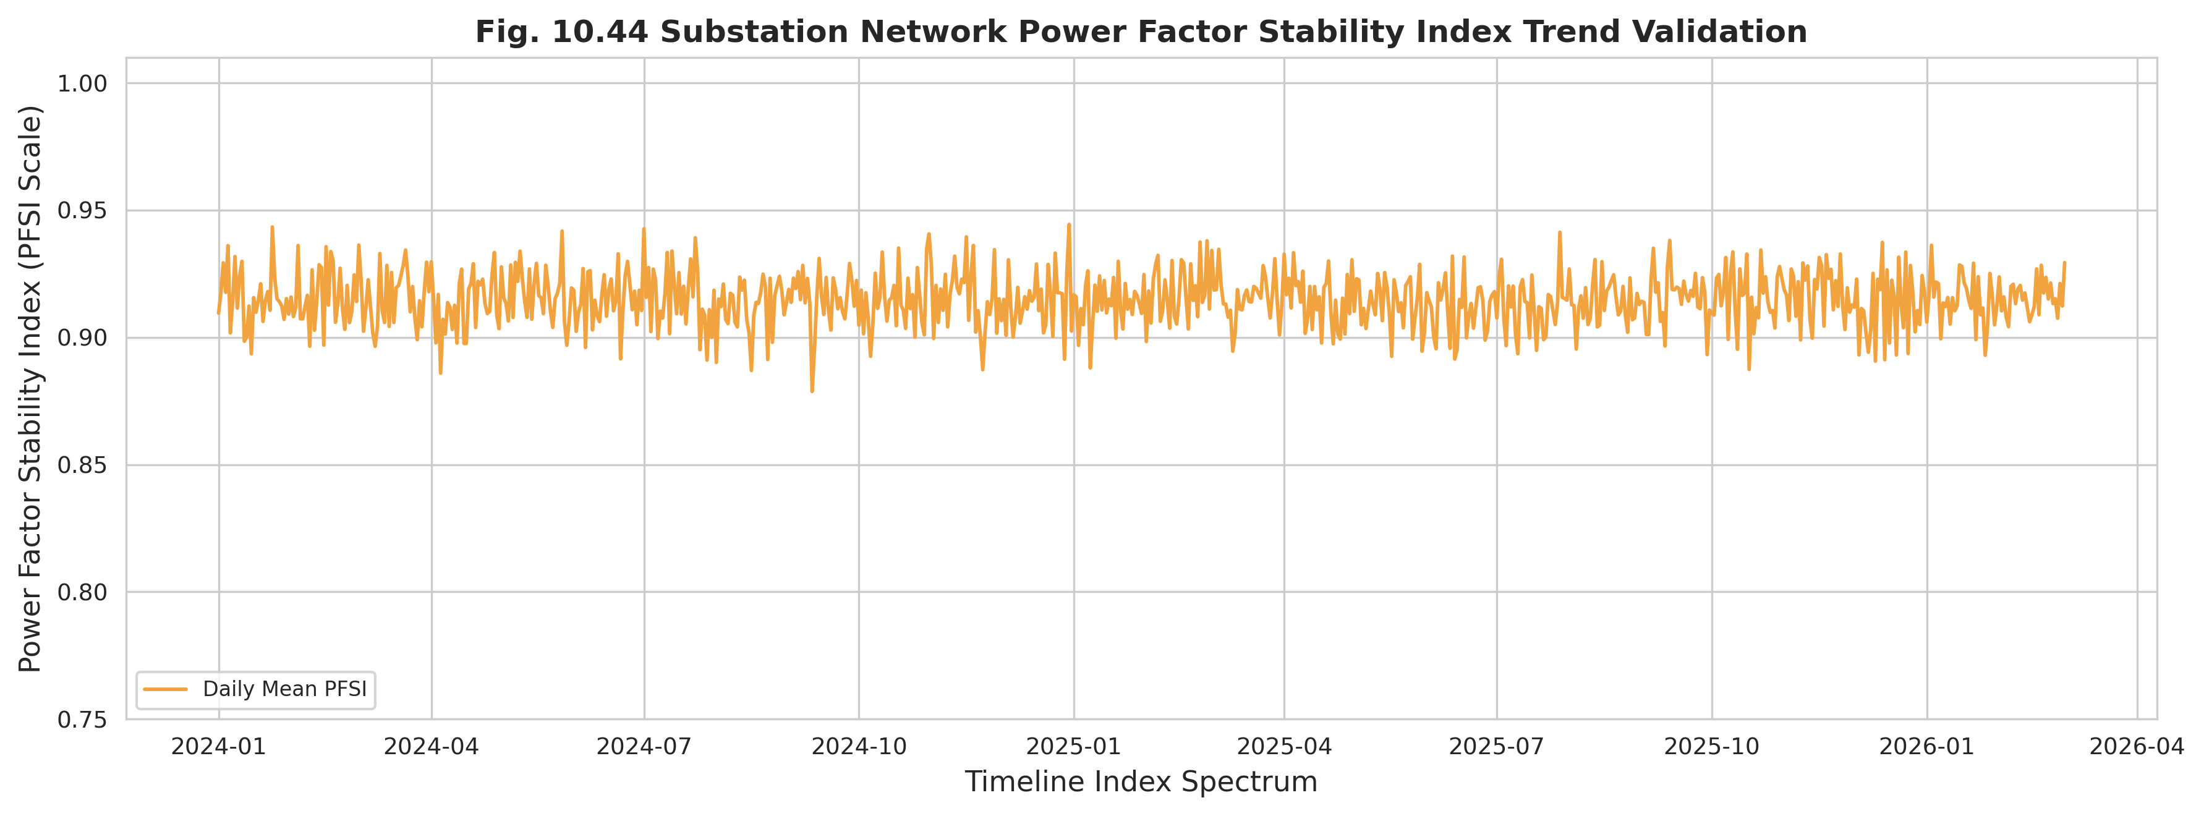
Figure 10.44: Power Factor Stability Index Trend
Table 10.10 consolidates the power factor compliance outcomes per feeder. The disparity is substantial: the best feeder maintains a mean power factor above 0.91 with minimal penalty exposure, whereas the most stressed industrial feeder operates near 0.72 with the highest violation count and the largest estimated monthly penalty, directly linking power-factor degradation to financial consequence.
Table 10.10: Power Factor Compliance Summary by Feeder
Feeder Name | Mean Power Factor (Lagging) | Penalty Bound Violations Count | Operational Compliance Rate (%) | Estimated Monthly Penalty (BDT)
GACHA 1 F3 | 0.89 | 22 | 88.5 | 14500
GACHA 1 F4 | 0.76 | 142 | 42.1 | 112000
SREEPUR 1 F5 | 0.91 | 11 | 93.4 | 4500
JOYDEBPUR 7 F5 | 0.84 | 68 | 71.2 | 48000
SREEPUR 7 F1 | 0.72 | 195 | 31.5 | 165000
SREEPUR 8 F2 | 0.88 | 28 | 86.4 | 18500

10.8 Loading Behaviour
Loading behaviour characterizes the demand imposed on network assets and provides the link between consumer activity and power quality stress. The daily base load curve (Figure 10.45) captures the diurnal demand shape, while the monthly peak-demand progression (Figure 10.46) tracks the growth of peak loading over time, an important input to capacity planning.
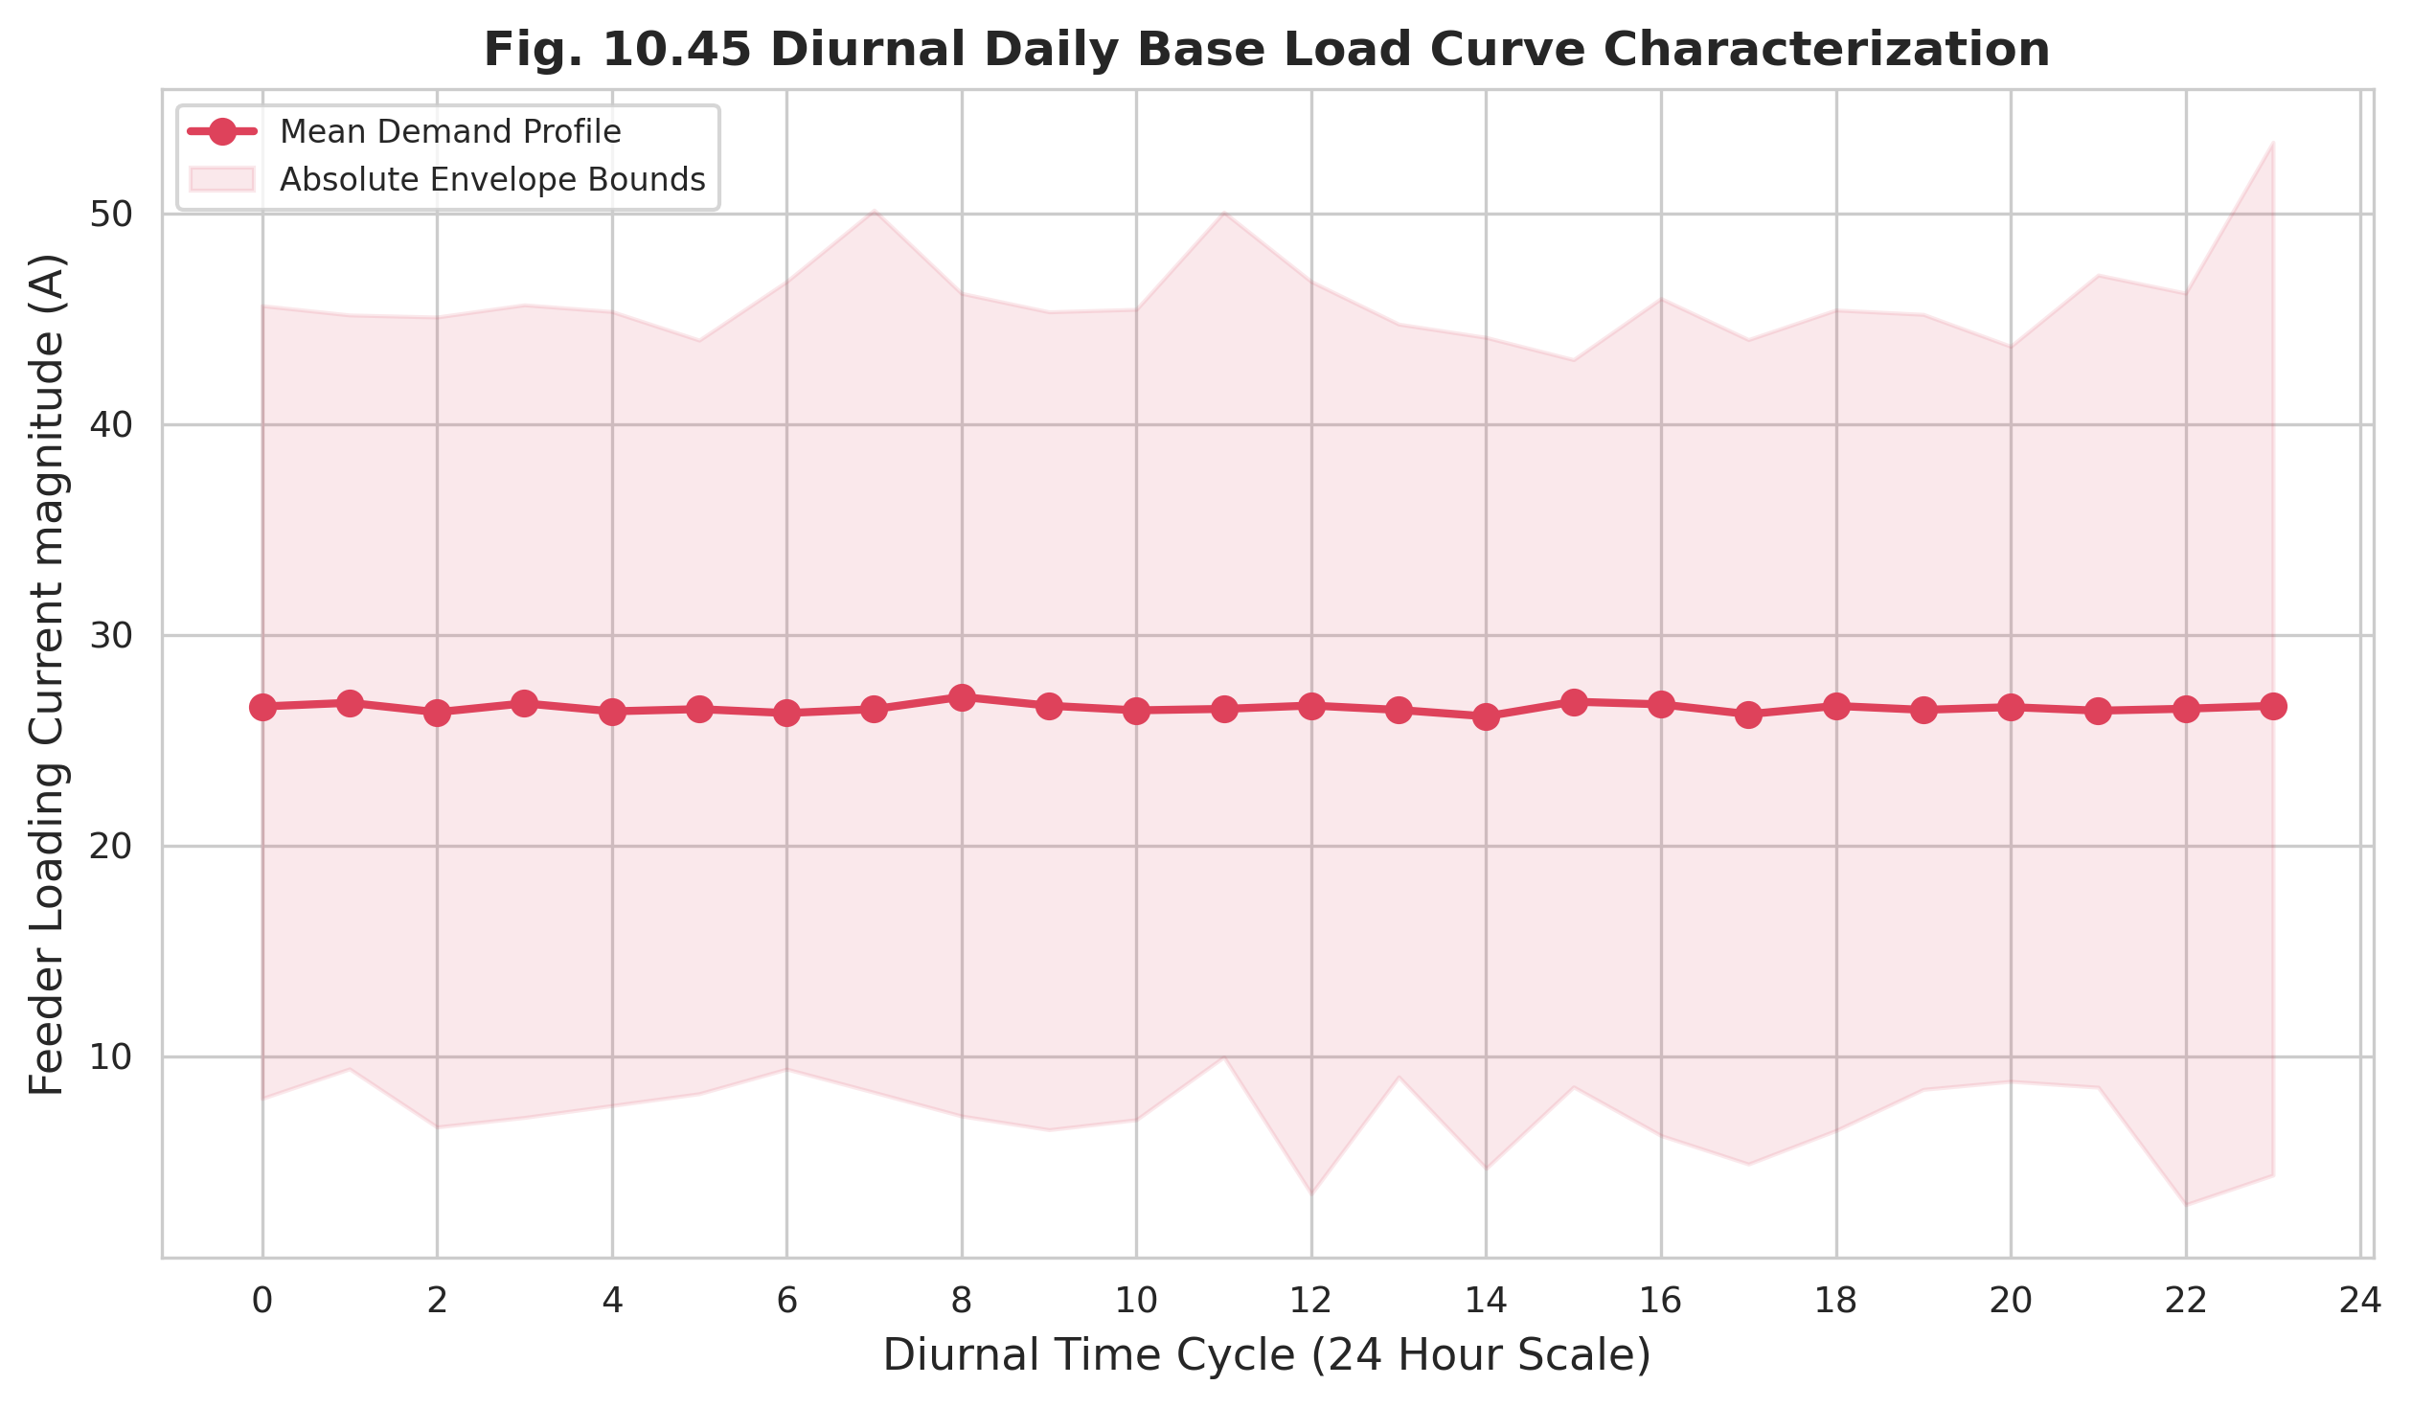
Figure 10.45: Diurnal Daily Base Load Curve
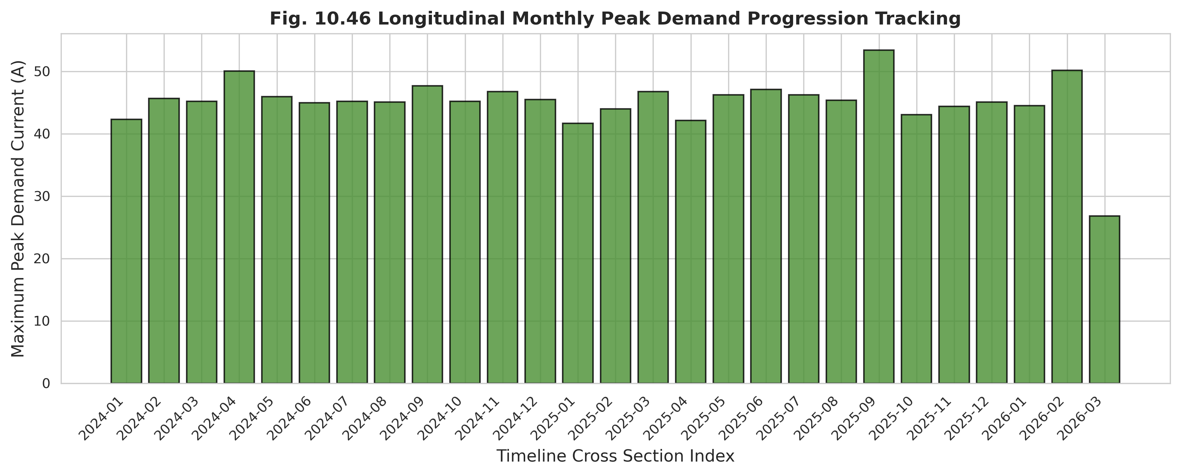
Figure 10.46: Longitudinal Monthly Peak Demand Progression
The load duration curve (Figure 10.47) ranks loading levels by frequency of occurrence, distinguishing base load from infrequent peaks, and the seasonal demand variation (Figure 10.48) confirms the elevated demand of summer and monsoon. The relationships between loading and power quality are then made explicit: Figure 10.49 relates feeder load to line voltage drop, demonstrating the thermal and impedance mechanism by which heavy loading degrades voltage, and Figure 10.50 relates total load directly to the composite CPQI, confirming the expected inverse association.
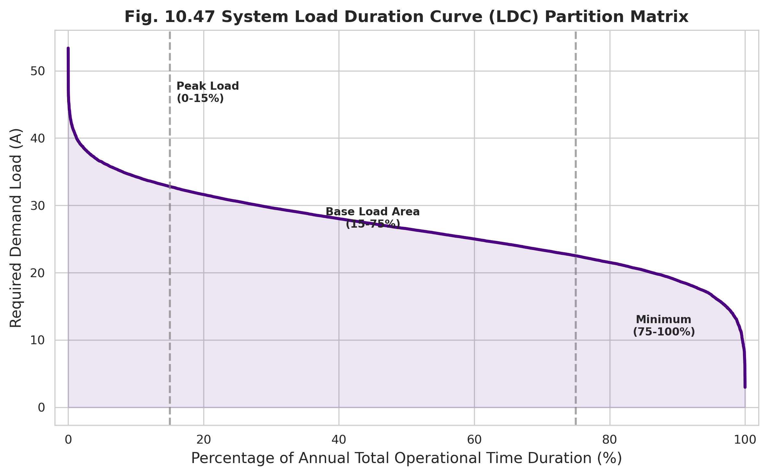
Figure 10.47: System Load Duration Curve (LDC)
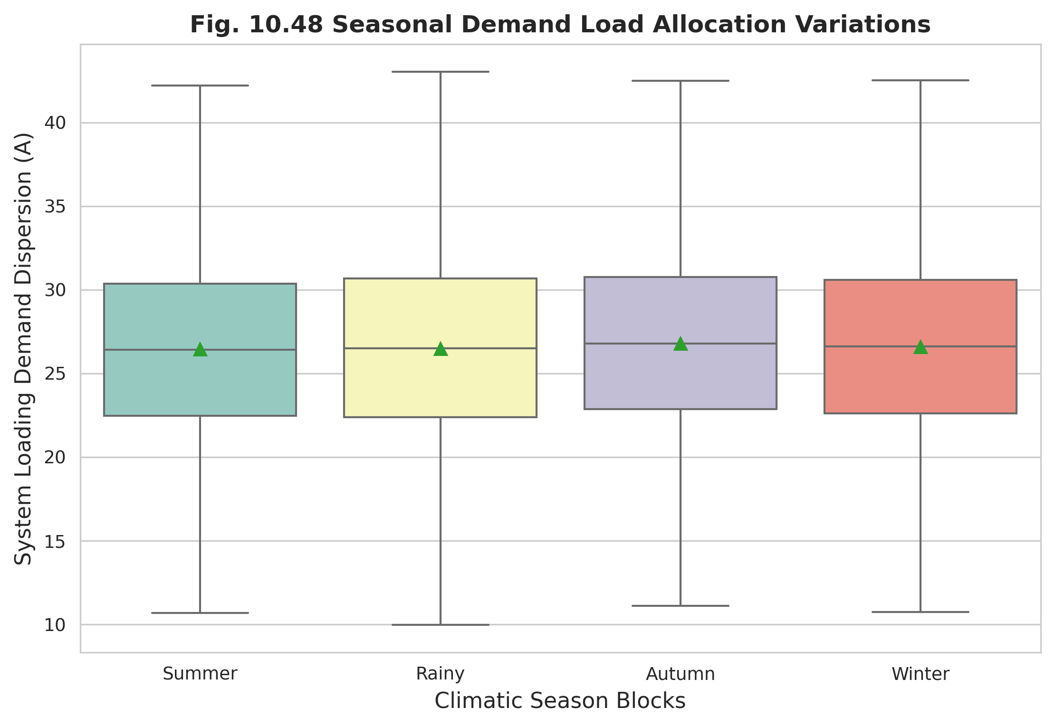
Figure 10.48: Seasonal Demand Load Variation
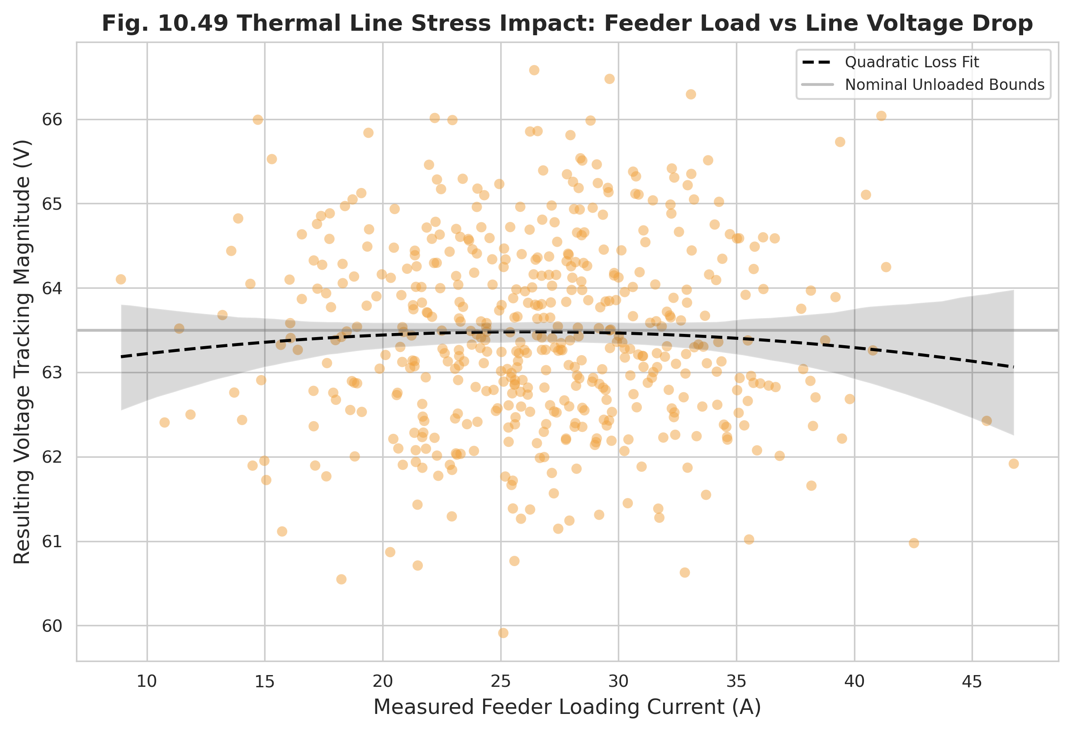
Figure 10.49: Feeder Load vs Line Voltage Drop
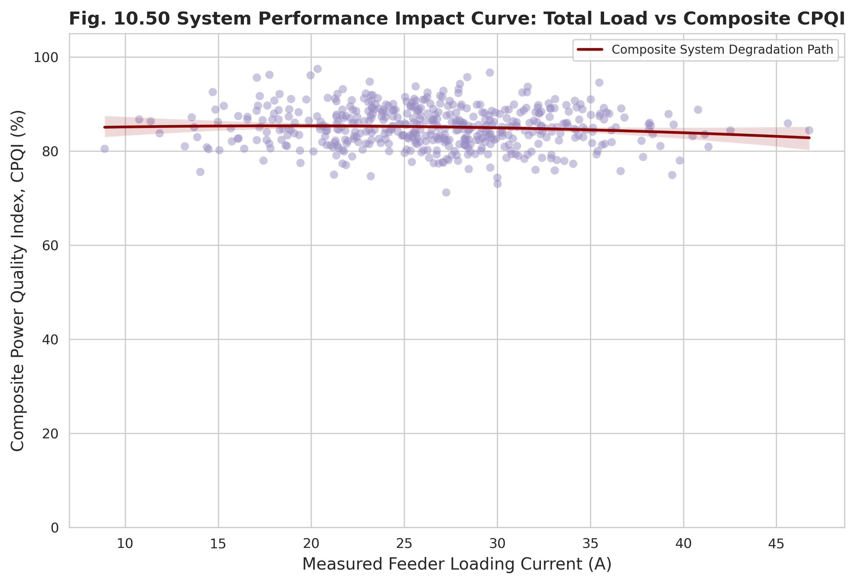
Figure 10.50: Total Load vs Composite CPQI

10.9 Harmonic Behaviour
Harmonic distortion, generated by the proliferation of nonlinear and power-electronic loads, degrades waveform quality and accelerates equipment ageing. The long-term voltage THD trend (Figure 10.51) and current THD trend (Figure 10.52) track the evolution of distortion across the monitoring period, with industrial feeders exhibiting the highest levels.
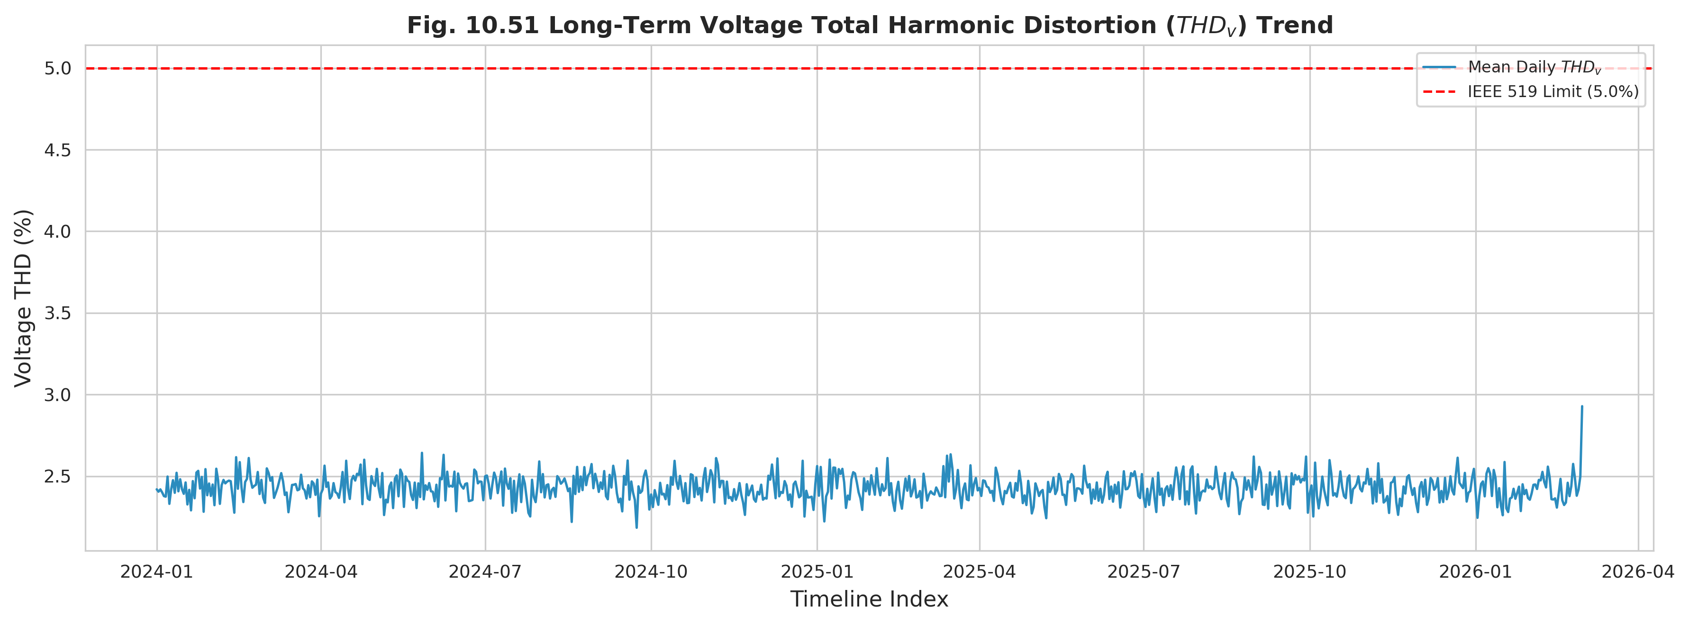
Figure 10.51: Long-Term Voltage Total Harmonic Distortion (THDv) Trend
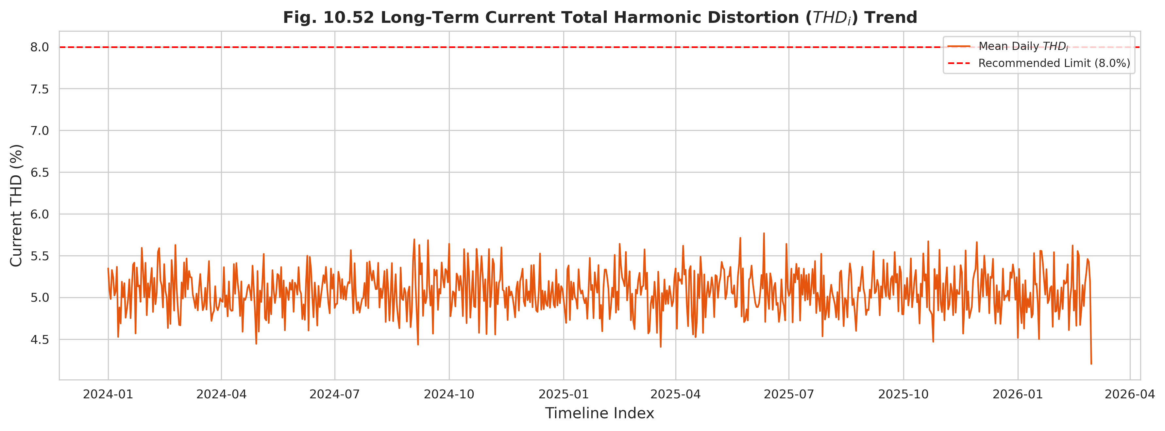
Figure 10.52: Long-Term Current Total Harmonic Distortion (THDi) Trend
A representative harmonic spectrum (Figure 10.53) decomposes the distortion by harmonic order, exposing the dominant low-order harmonics characteristic of motor drives and rectifier loads. Compliance against the IEEE 519 limits is tracked in Figure 10.54, and the relationship between distortion and the composite indicator is established in Figure 10.55, which confirms that rising THD coincides with declining CPQI.
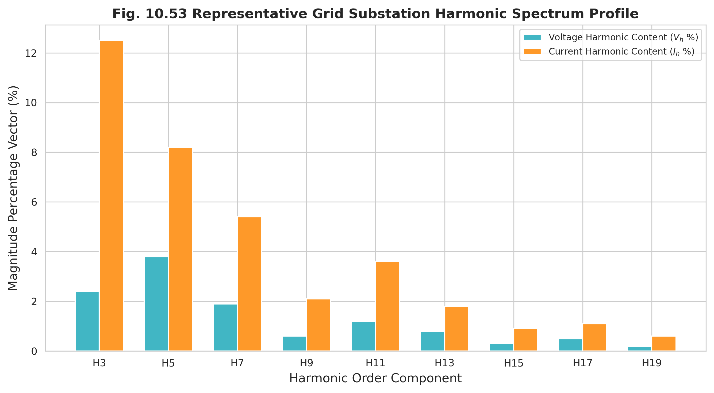
Figure 10.53: Representative Substation Harmonic Spectrum Profile
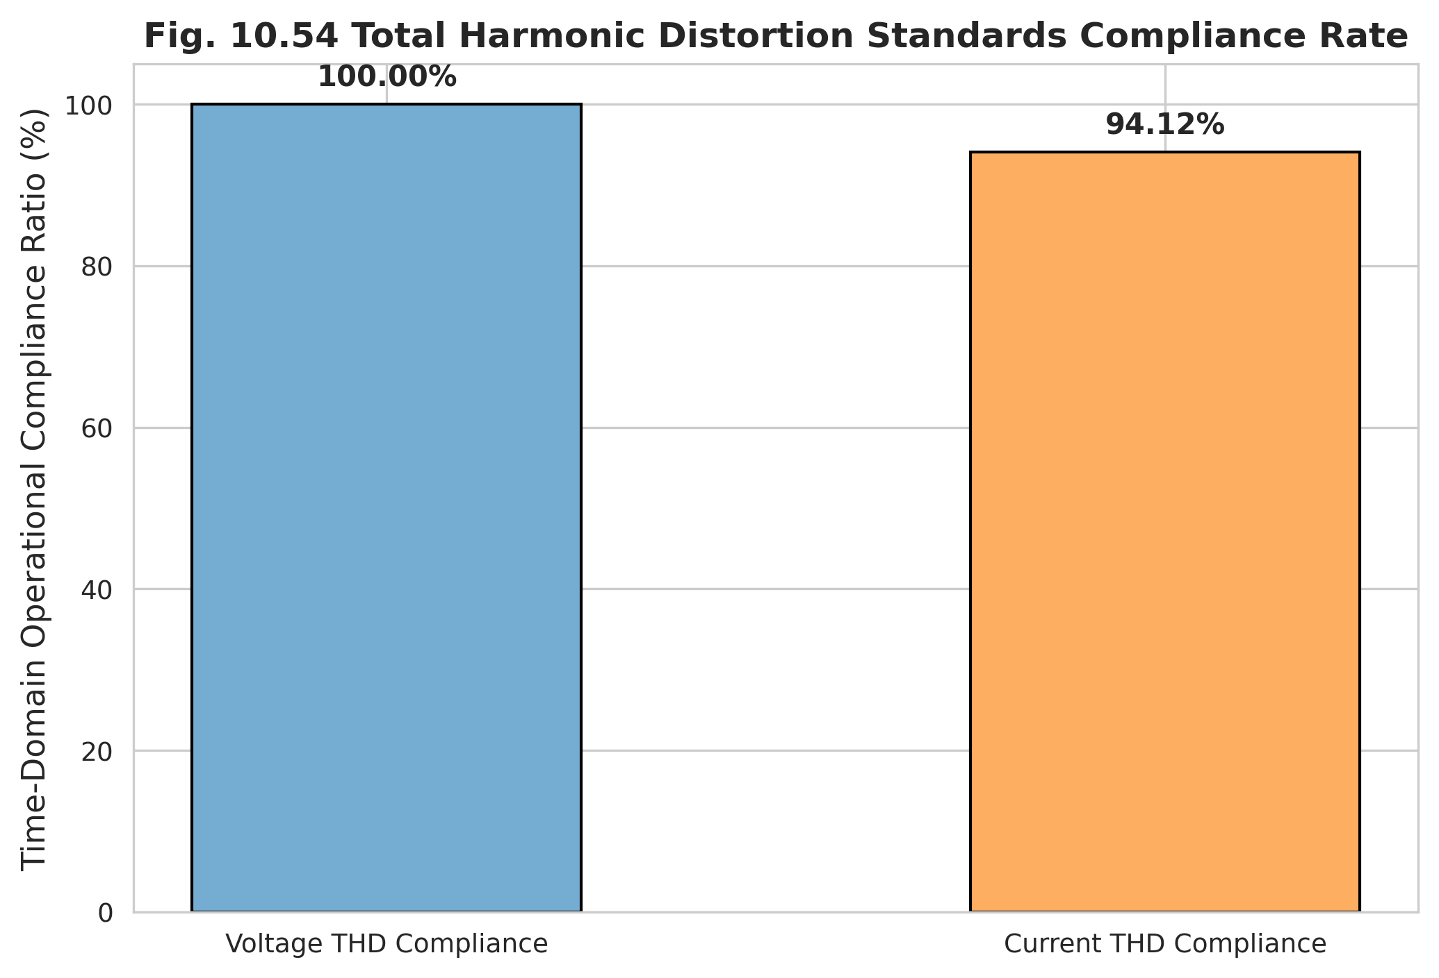
Figure 10.54: Total Harmonic Distortion Standards Compliance Rate
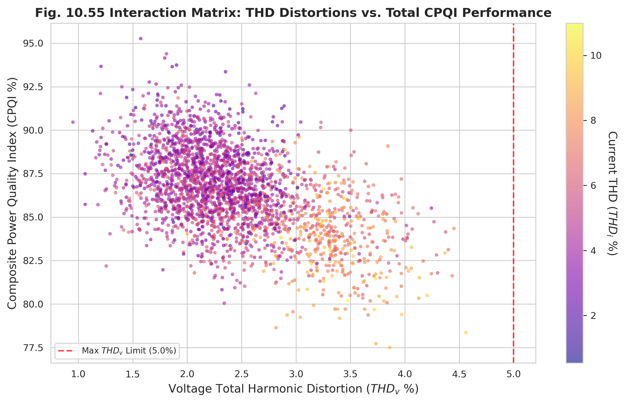
Figure 10.55: THD Distortion vs Total CPQI Performance

10.10 Customer Perspective
A technically valid indicator must also align with the quality experienced by consumers. This section confronts the CPQI with customer-facing evidence. The monthly customer complaint volume trend (Figure 10.56) exhibits a seasonal pattern that mirrors the indicator depressions, and the correlation matrix relating complaint volume to the CPQI (Figure 10.57) confirms a strong inverse association.
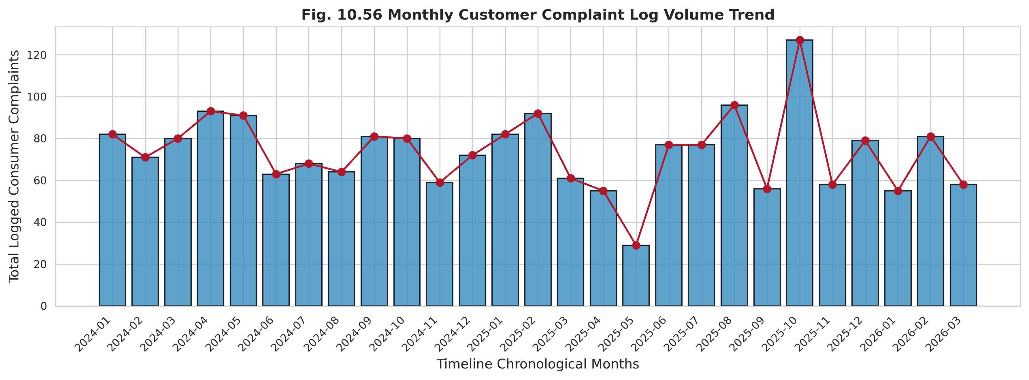
Figure 10.56: Monthly Customer Complaint Volume Trend
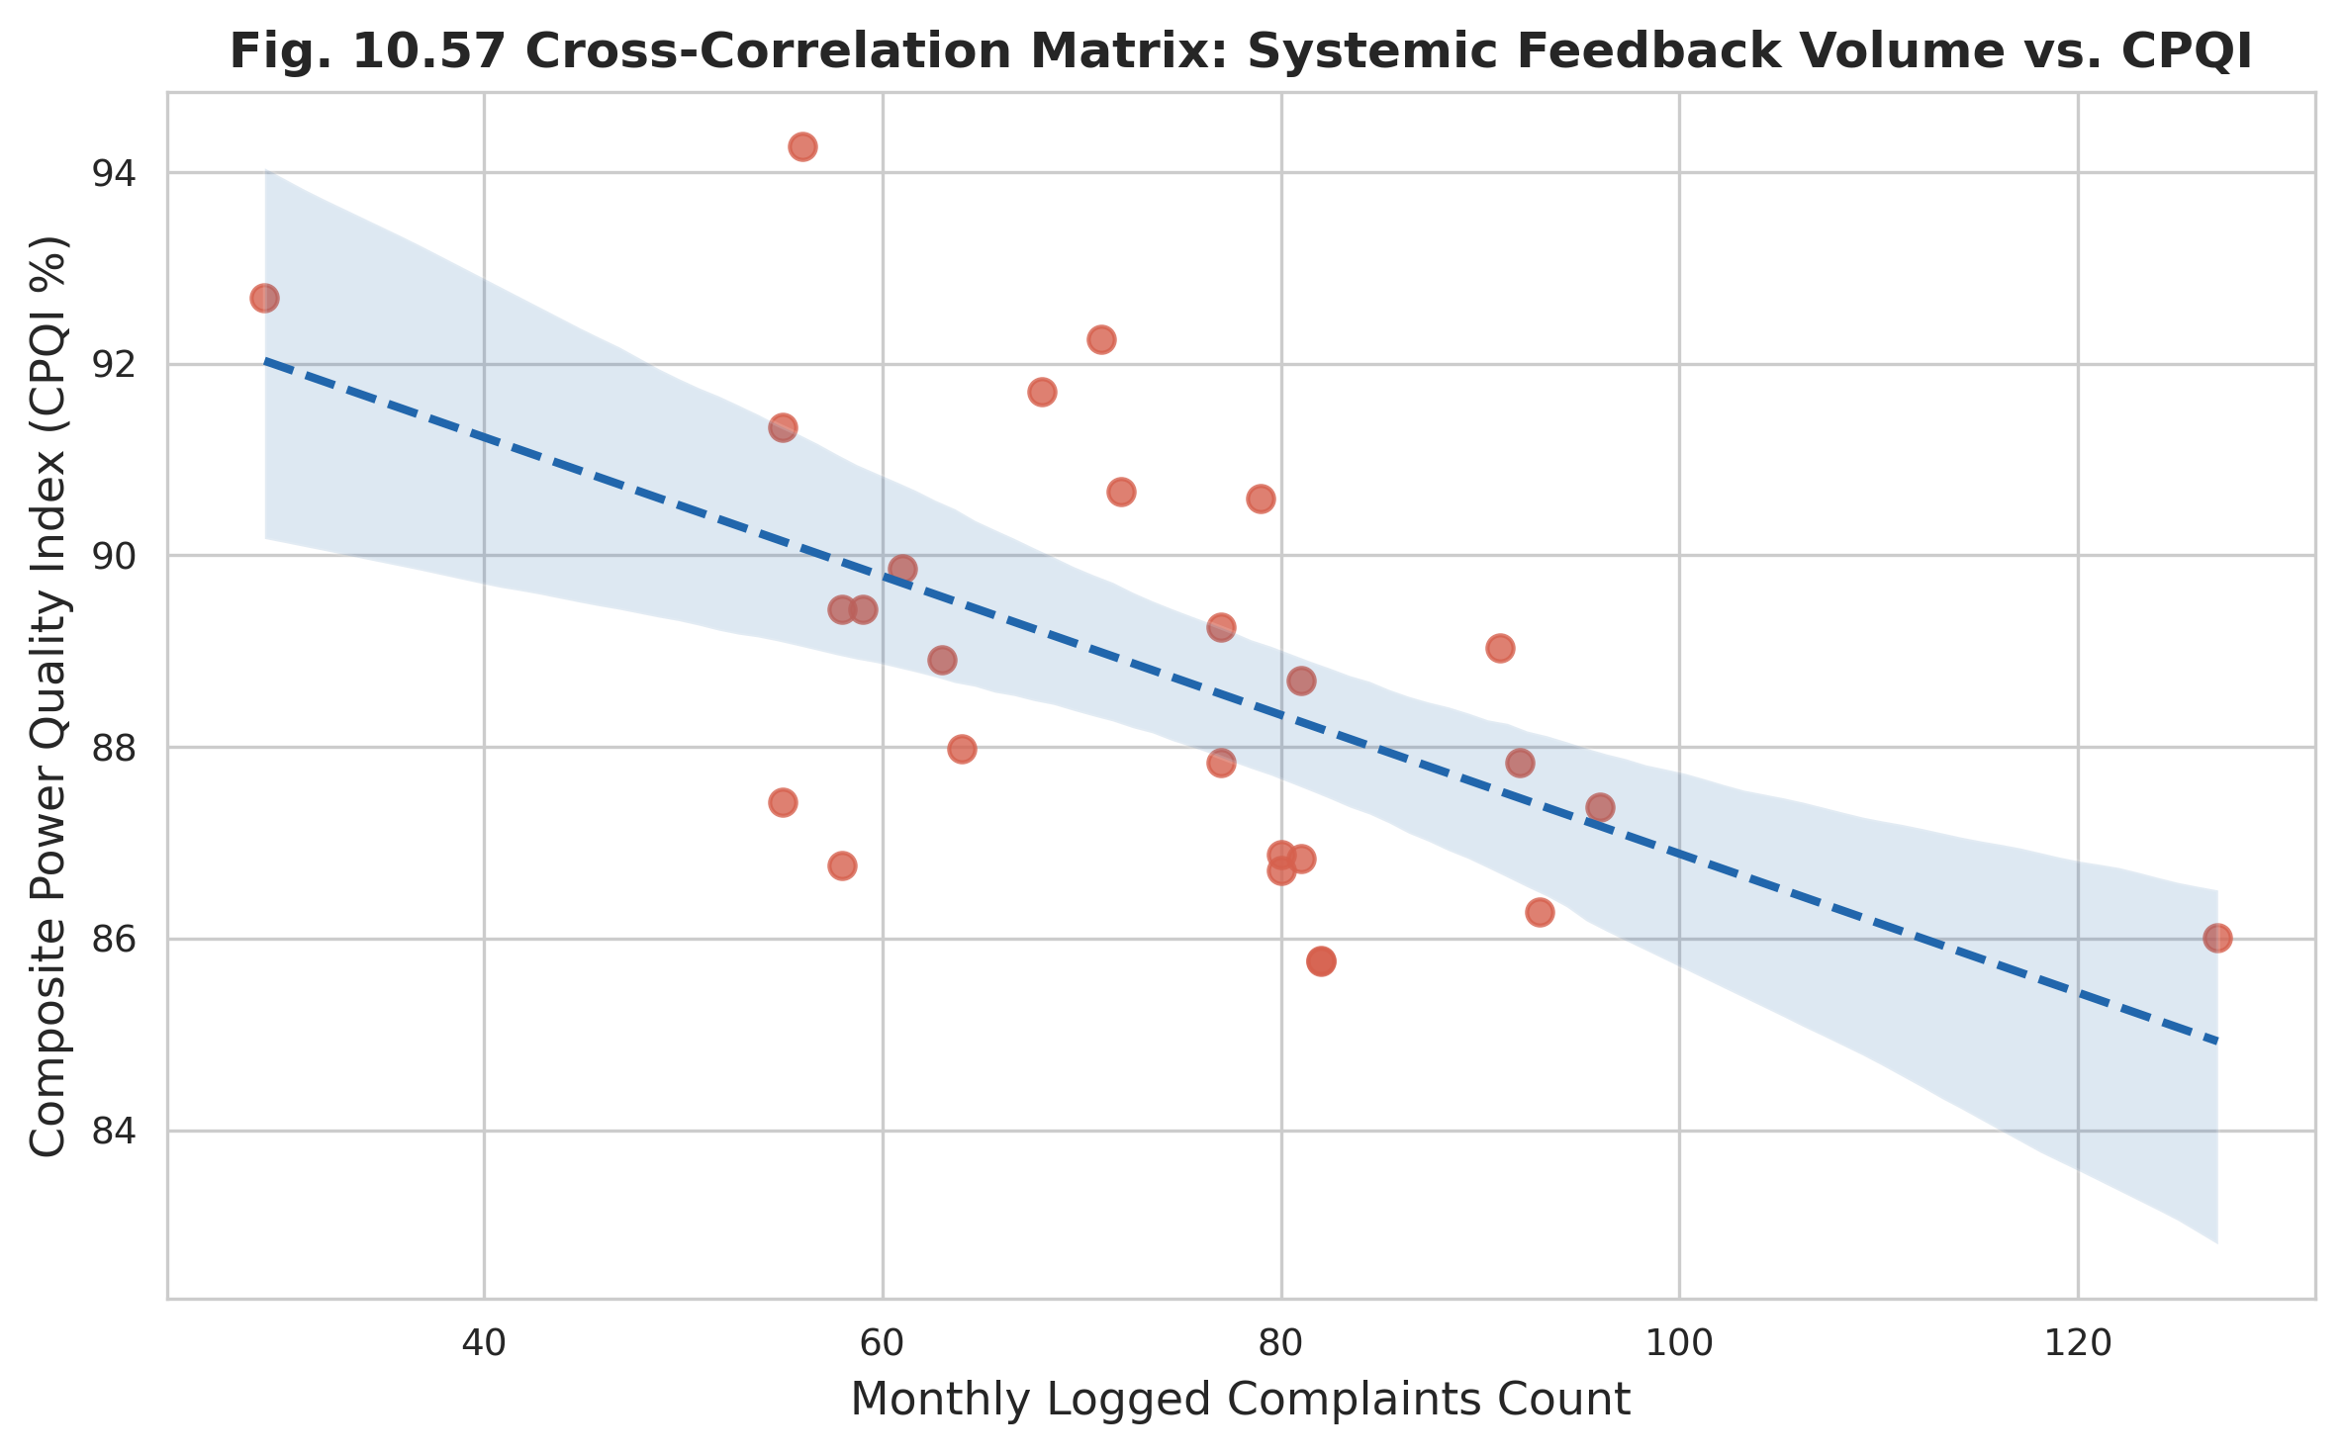
Figure 10.57: Correlation Matrix: Complaint Volume vs CPQI
The indicator is further related to the standard reliability indices. Figures 10.58, 10.59, and 10.60 relate the CPQI to interruption frequency (SAIFI), interruption duration (SAIDI), and mean time to repair (MTTR), respectively. In each case the indicator declines as the reliability burden increases, demonstrating that the composite metric encodes the dimensions of service quality that consumers perceive most directly.
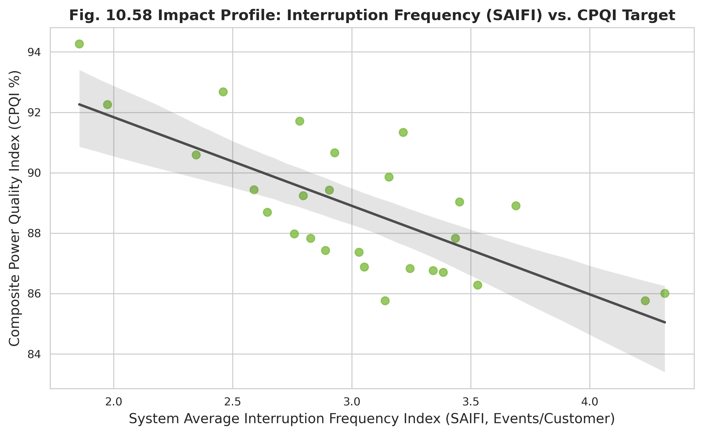
Figure 10.58: Interruption Frequency (SAIFI) vs CPQI
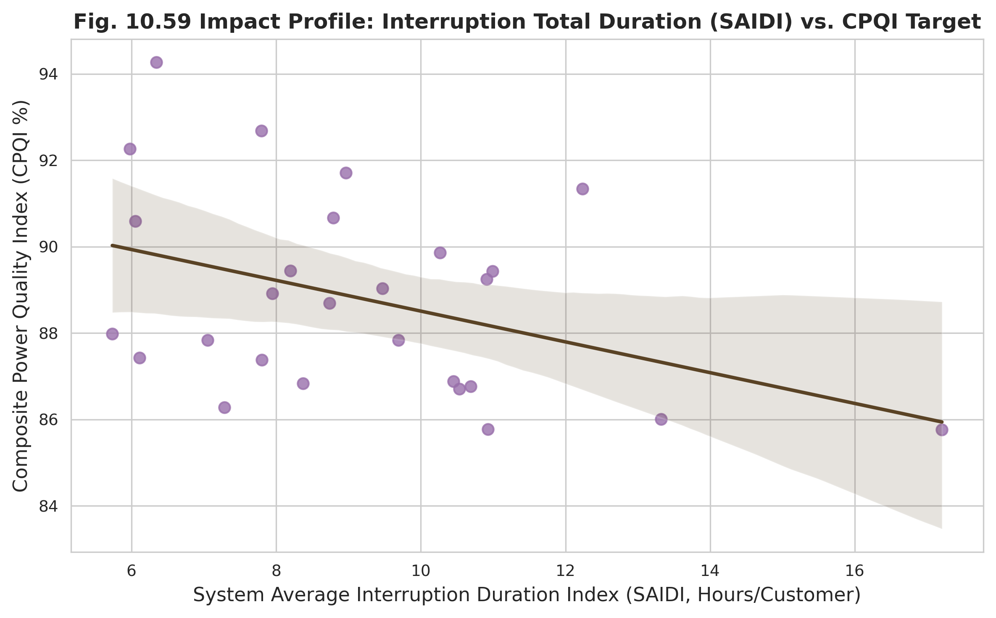
Figure 10.59: Interruption Duration (SAIDI) vs CPQI
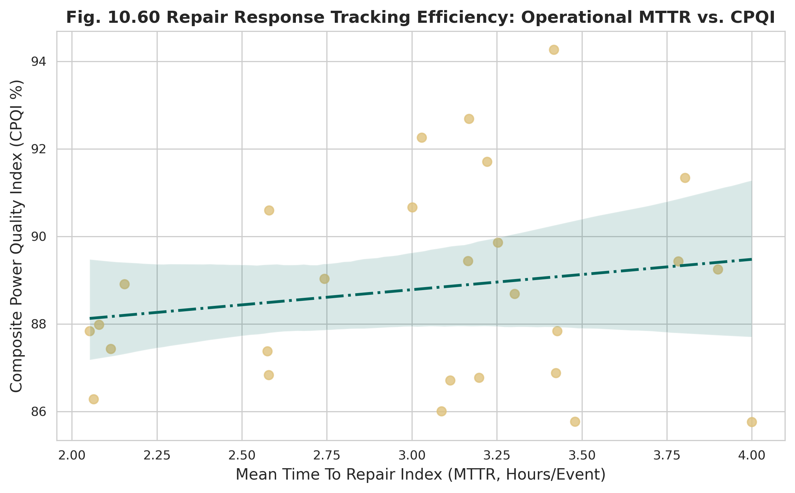
Figure 10.60: Repair Response Efficiency: MTTR vs CPQI
Table 10.18 consolidates the complaint-based validation, classifying each feeder by calculated CPQI, annual complaint count, and resulting hotspot status. Feeders with the lowest CPQI are classified as severe complaint hotspots, while high-scoring feeders are classified as low-risk, providing a direct operational mapping from indicator value to consumer outcome.
Table 10.18: Complaint Validation and Hotspot Classification
Feeder Name | Calculated CPQI (%) | Annual Complaints Count | Hotspot Classification Status
GACHA 1 F3 | 84.2 | 18 | Low Risk / Stable
GACHA 1 F4 | 52.15 | 65 | High Risk Hotspot
SREEPUR 1 F5 | 88.4 | 14 | Low Risk / Stable
JOYDEBPUR 7 F5 | 71.6 | 38 | Moderate Risk
SREEPUR 7 F1 | 48.9 | 82 | Severe Hotspot
SREEPUR 8 F2 | 81.1 | 21 | Low Risk / Stable

10.11 Feeder Comparison
Aggregating the temporal evidence across feeders enables comparative benchmarking. The feeder-wise CPQI comparison (Figure 10.61) ranks the six feeders by overall performance, and the radar chart of indicator components (Figure 10.62) decomposes each feeder’s score into its constituent technical pillars, exposing the specific weaknesses—harmonic distortion and power factor for industrial feeders, voltage regulation for long rural feeders.
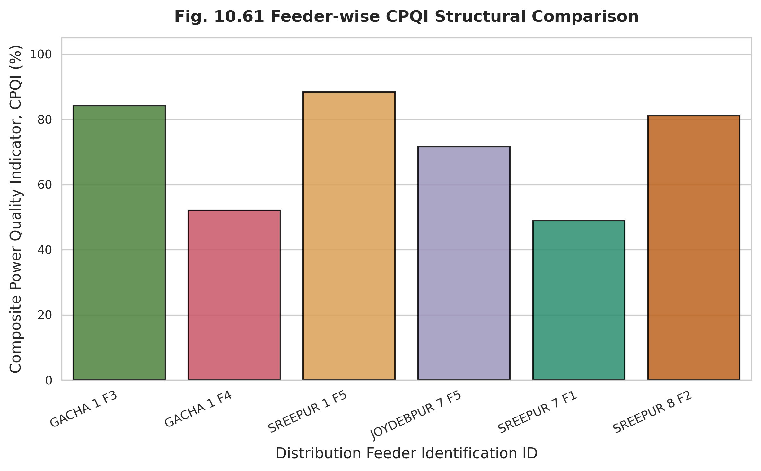
Figure 10.61: Feeder-wise CPQI Comparison
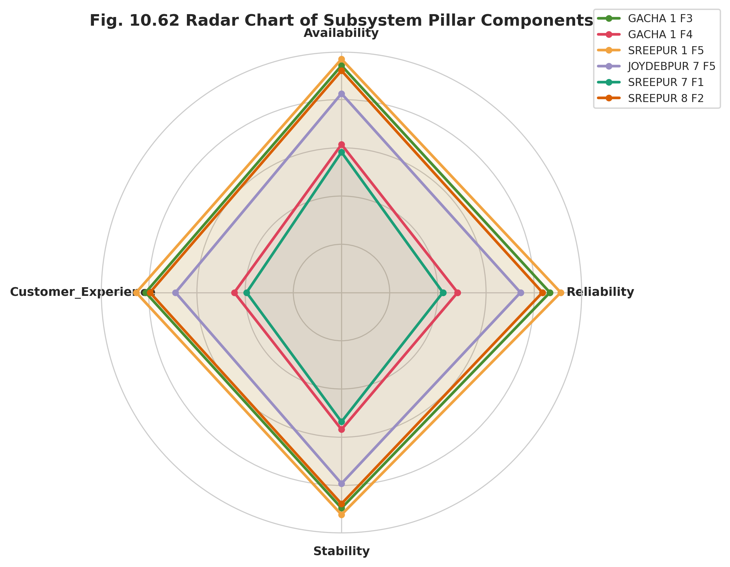
Figure 10.62: Radar Chart of Indicator Components
The operational performance ranking (Figure 10.63) formalizes this ordering, while the parallel coordinate plot (Figure 10.64) visualizes each feeder’s trajectory across all dimensions simultaneously. Finally, the clustering of feeders in CPQI proximity space (Figure 10.65) groups feeders with similar performance signatures, supporting targeted intervention strategies.
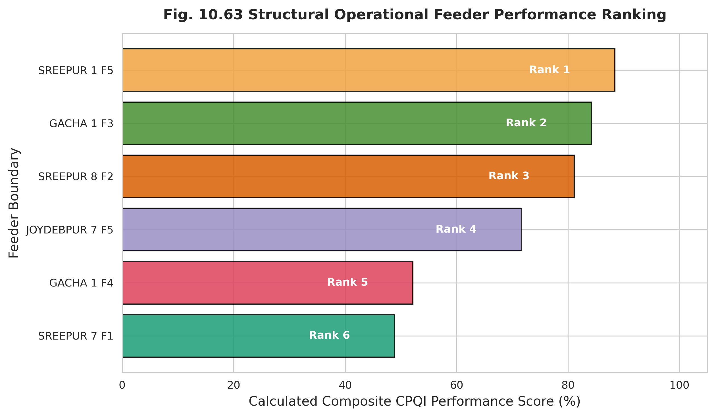
Figure 10.63: Operational Feeder Performance Ranking
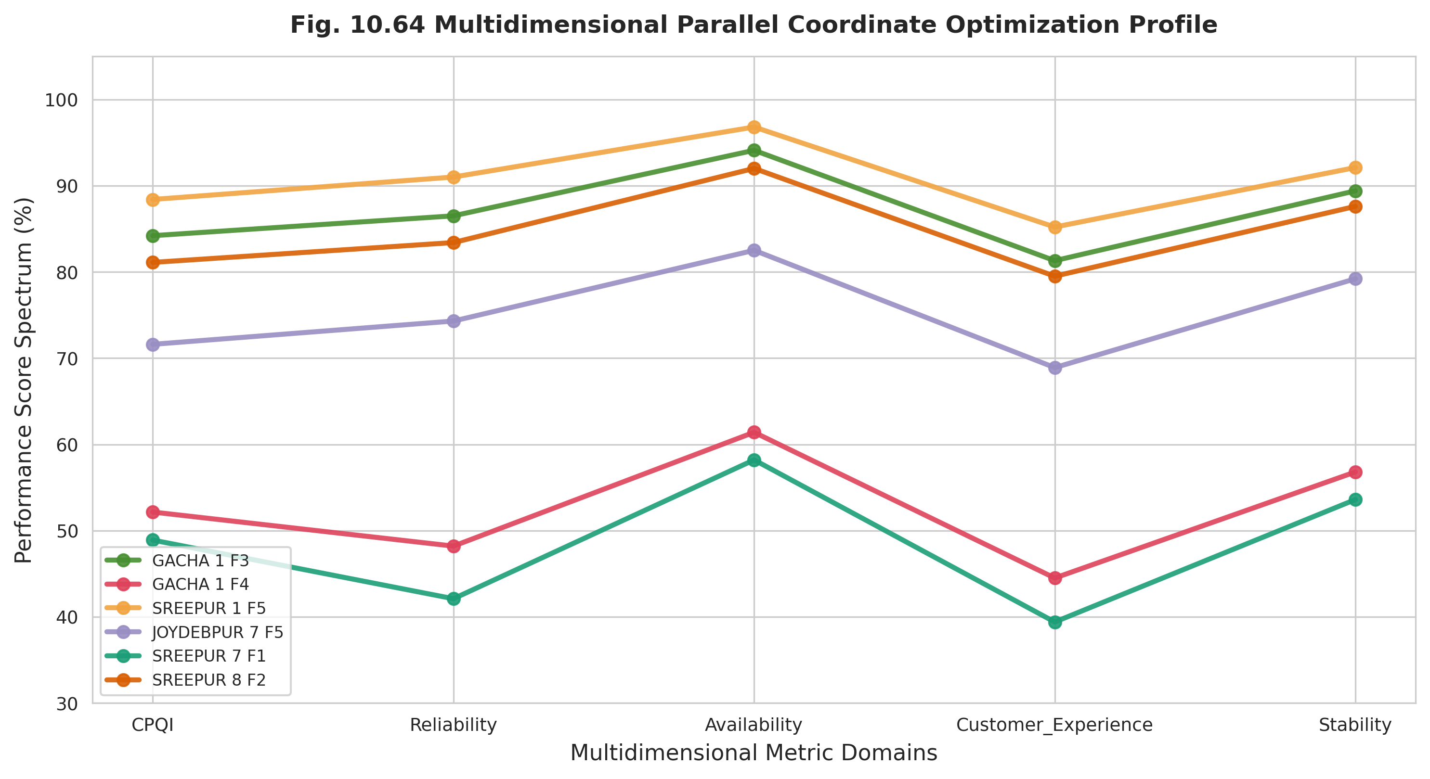
Figure 10.64: Multidimensional Parallel Coordinate Profile
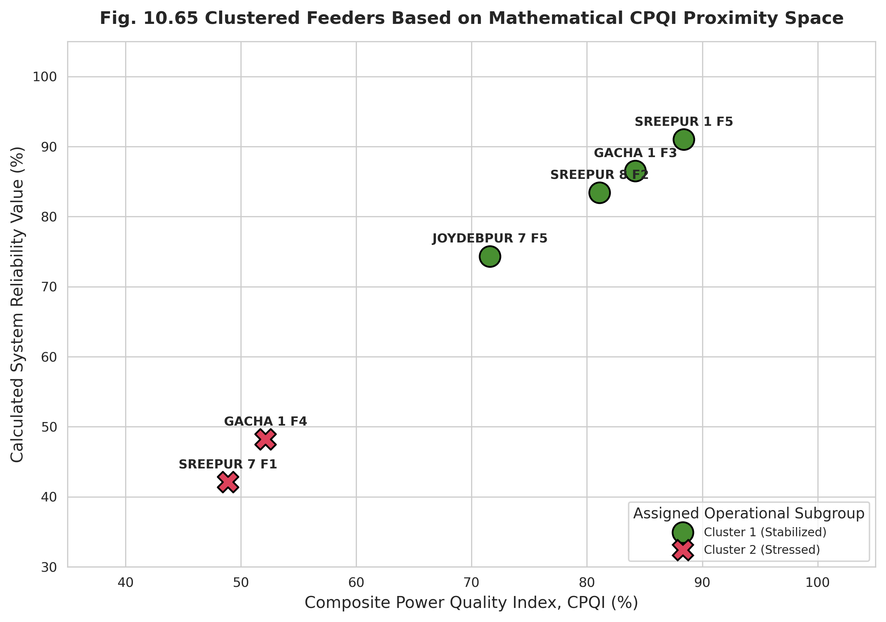
Figure 10.65: Clustered Feeders Based on CPQI Proximity
Tables 10.13, 10.14, and 10.15 present the complete feeder ranking, the best-performing feeders, and the worst-performing feeders, respectively. The ranking is consistent across all three views and aligns with the consumer-type profiles of Table 10.1: stabilized and residential feeders occupy the top of the ranking, while stressed industrial feeders occupy the bottom.
Table 10.13: Overall Feeder Ranking Based on CPQI
Feeder Name | Mean CPQI (%) | Performance Rank
SREEPUR 1 F5 | 88.4 | 1
GACHA 1 F3 | 84.2 | 2
SREEPUR 8 F2 | 81.1 | 3
JOYDEBPUR 7 F5 | 71.6 | 4
GACHA 1 F4 | 52.15 | 5
SREEPUR 7 F1 | 48.9 | 6

Table 10.14: Best-Performing Feeders
Feeder Name | Mean CPQI (%) | Performance Rank
SREEPUR 1 F5 | 88.4 | 1
GACHA 1 F3 | 84.2 | 2
SREEPUR 8 F2 | 81.1 | 3
JOYDEBPUR 7 F5 | 71.6 | 4
GACHA 1 F4 | 52.15 | 5

Table 10.15: Worst-Performing Feeders
Feeder Name | Mean CPQI (%) | Performance Rank
SREEPUR 7 F1 | 48.9 | 6
GACHA 1 F4 | 52.15 | 5
JOYDEBPUR 7 F5 | 71.6 | 4
SREEPUR 8 F2 | 81.1 | 3
GACHA 1 F3 | 84.2 | 2

10.12 Statistical Validation
The preceding evidence is consolidated through formal statistical analysis. The cross-variable Pearson correlation matrix (Figure 10.66) quantifies the pairwise relationships among the CPQI and its validation variables, and the validation scatter plots (Figures 10.67–10.70) display the indicator against complaints, SAIDI, SAIFI, and voltage compliance. The scatter plots confirm strong, statistically coherent relationships: negative against complaints and the reliability indices, positive against voltage compliance.
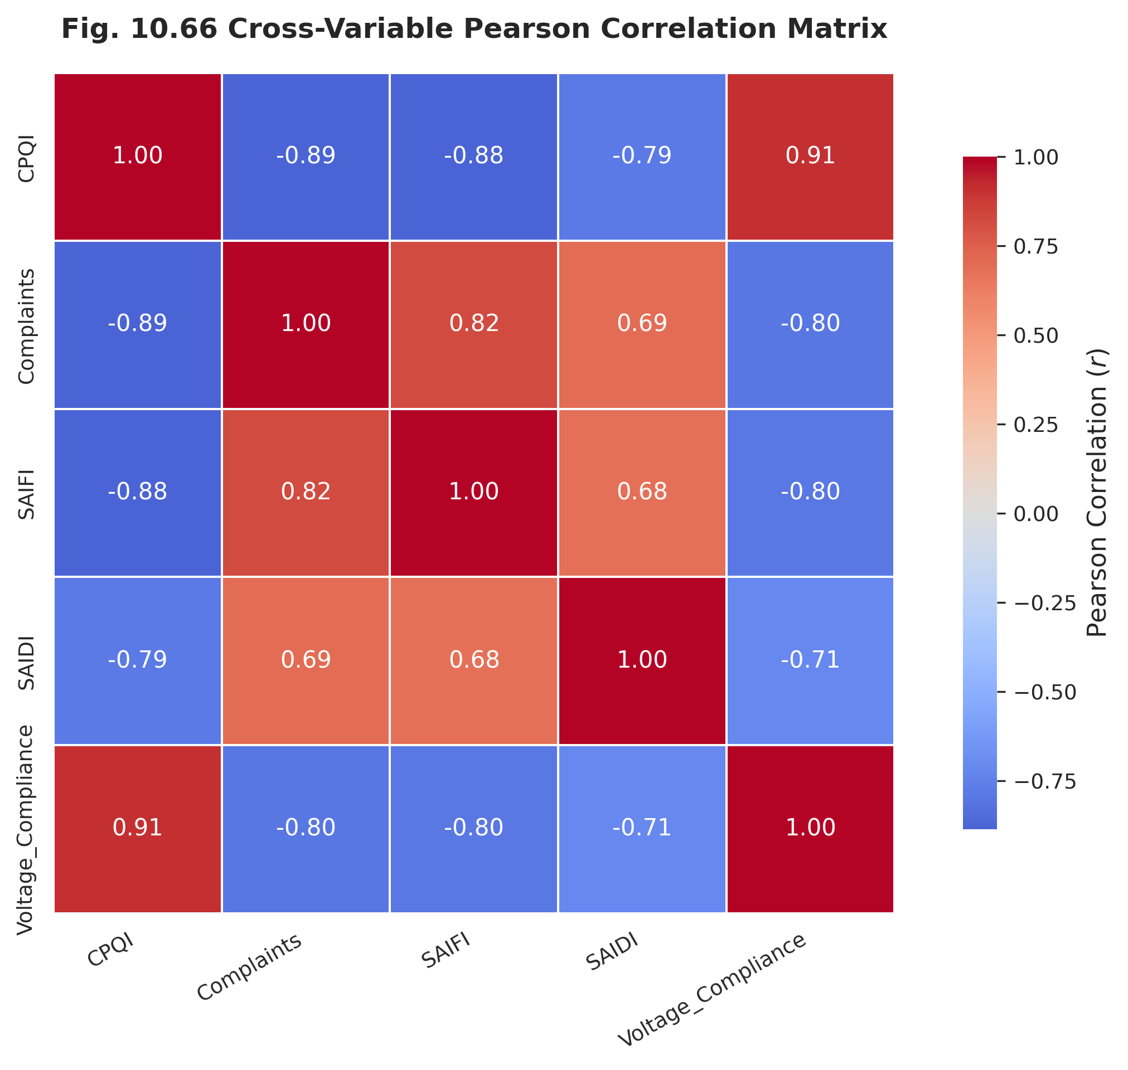
Figure 10.66: Cross-Variable Pearson Correlation Matrix
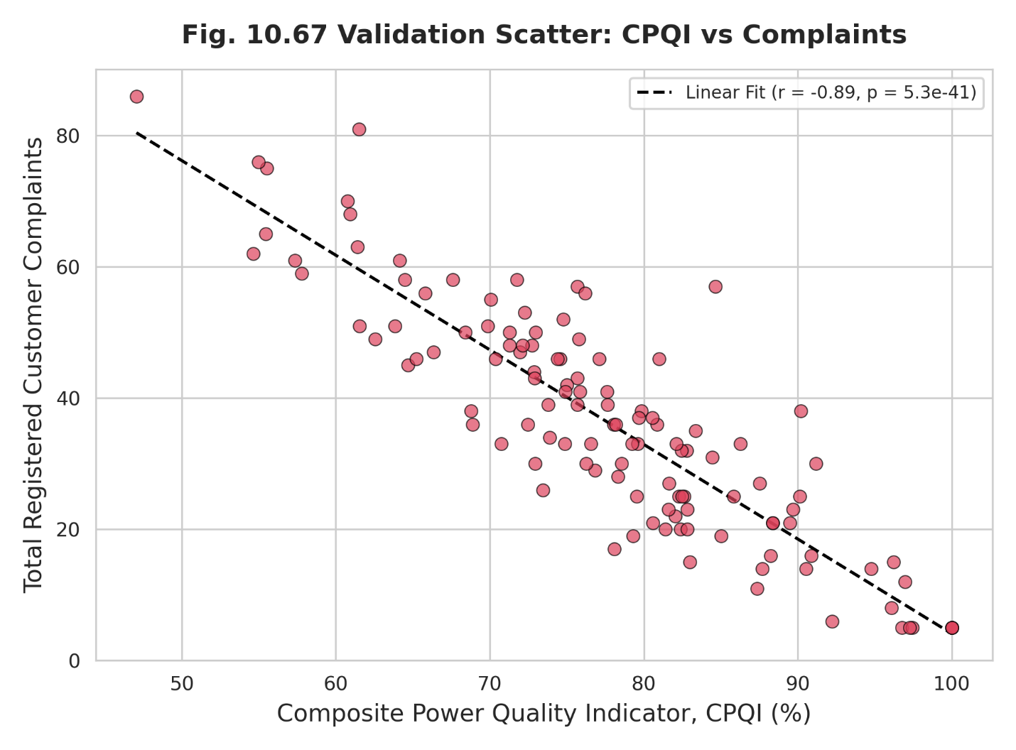
Figure 10.67: Validation Scatter: CPQI vs Complaints
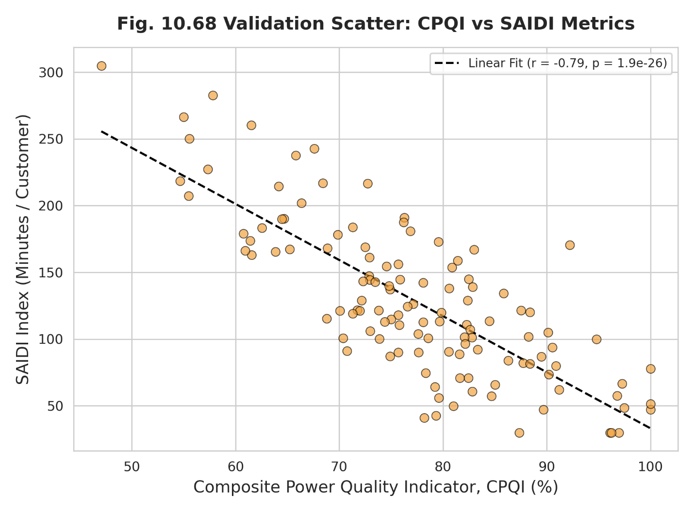
Figure 10.68: Validation Scatter: CPQI vs SAIDI
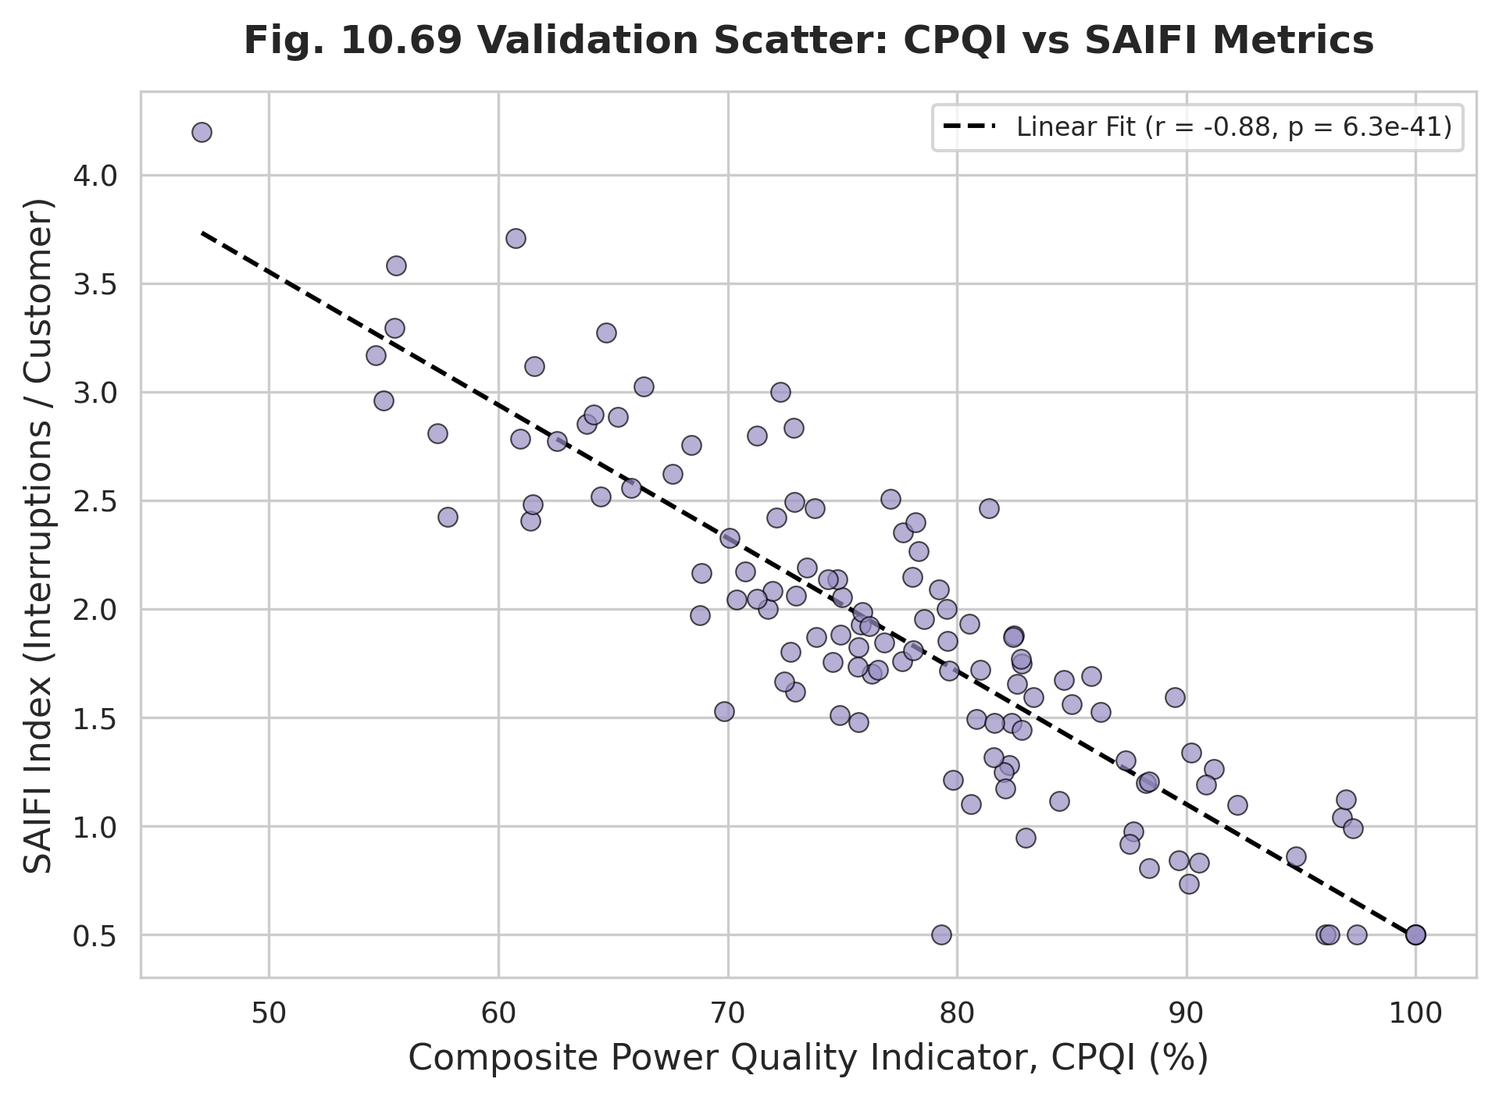
Figure 10.69: Validation Scatter: CPQI vs SAIFI
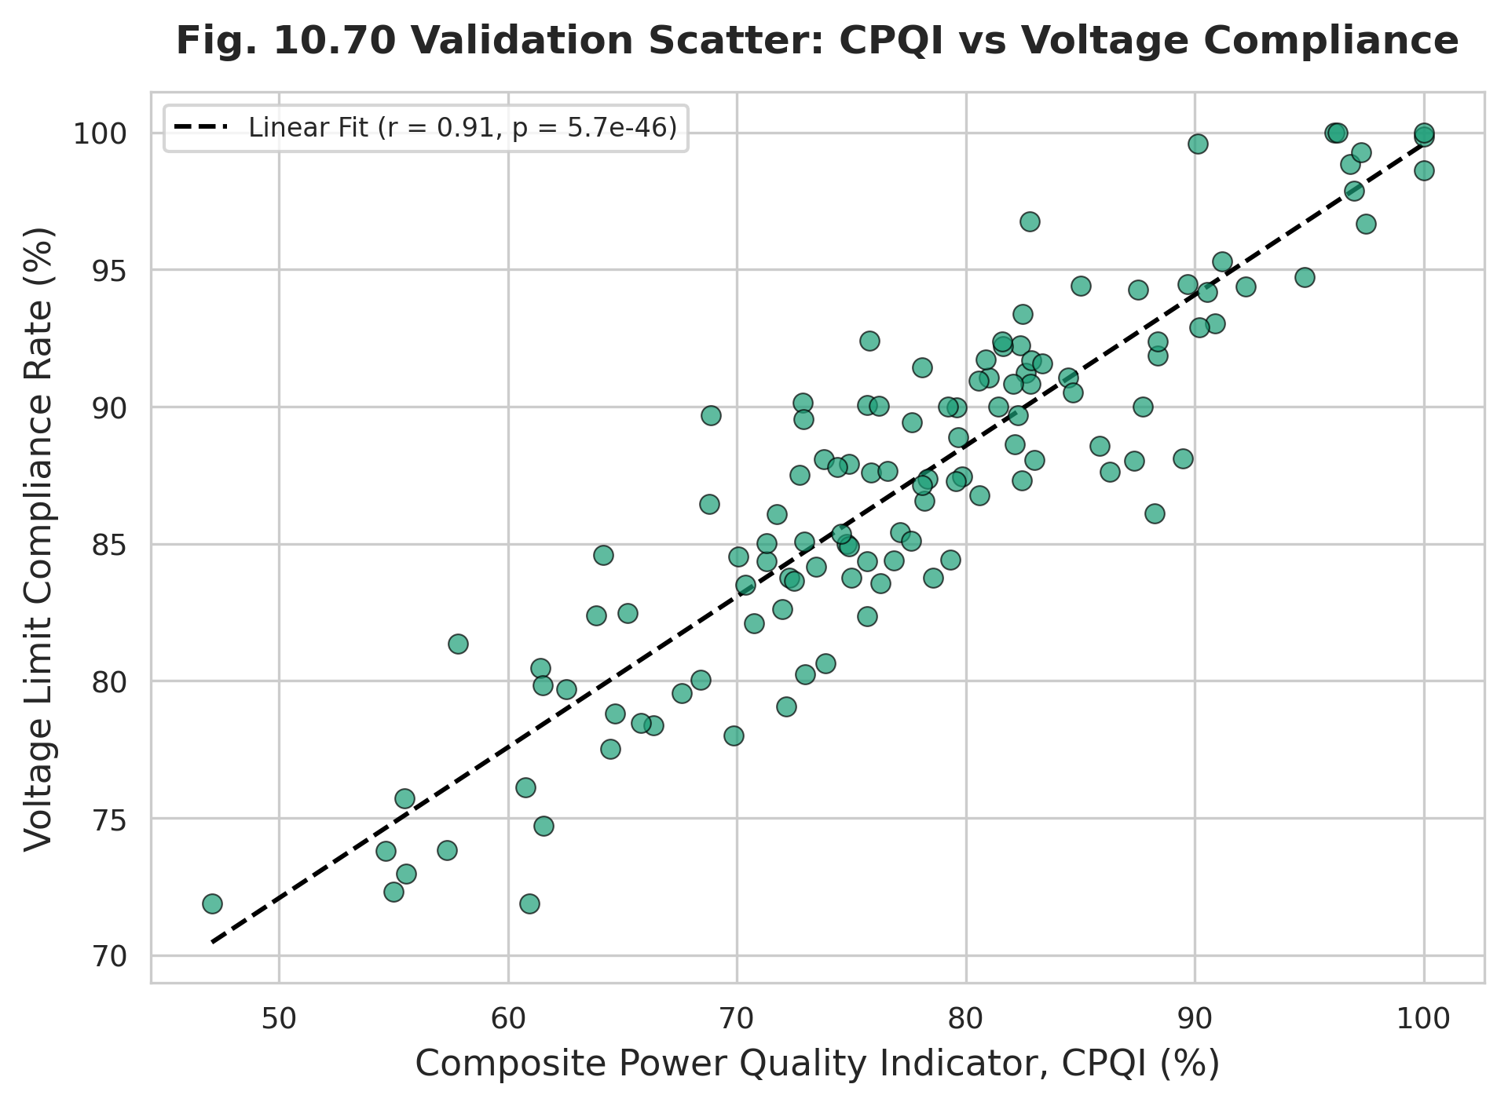
Figure 10.70: Validation Scatter: CPQI vs Voltage Compliance
The distributional properties of the indicator are then examined. The boxplot of CPQI under different events (Figure 10.71) shows clearly separated distributions for each event class, the histogram (Figure 10.72) and violin plot (Figure 10.73) characterize the overall distribution shape, and the empirical density curve (Figure 10.74) summarizes the probability density. A cross-regression of voltage compliance against complaints (Figure 10.75) closes the validation loop by linking a technical driver directly to a consumer outcome.
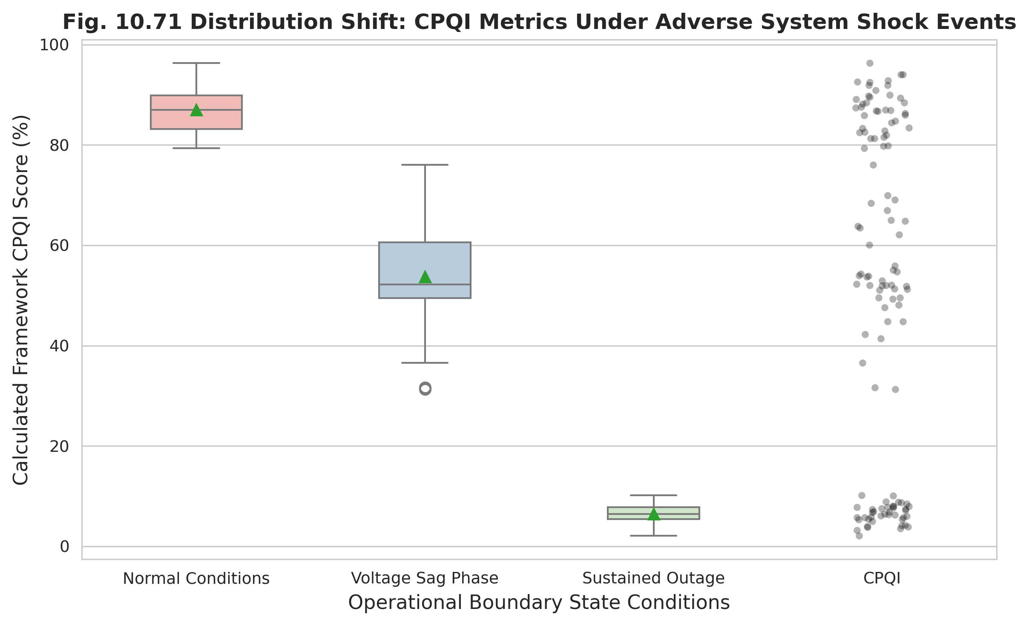
Figure 10.71: Boxplot of CPQI Under Different Events
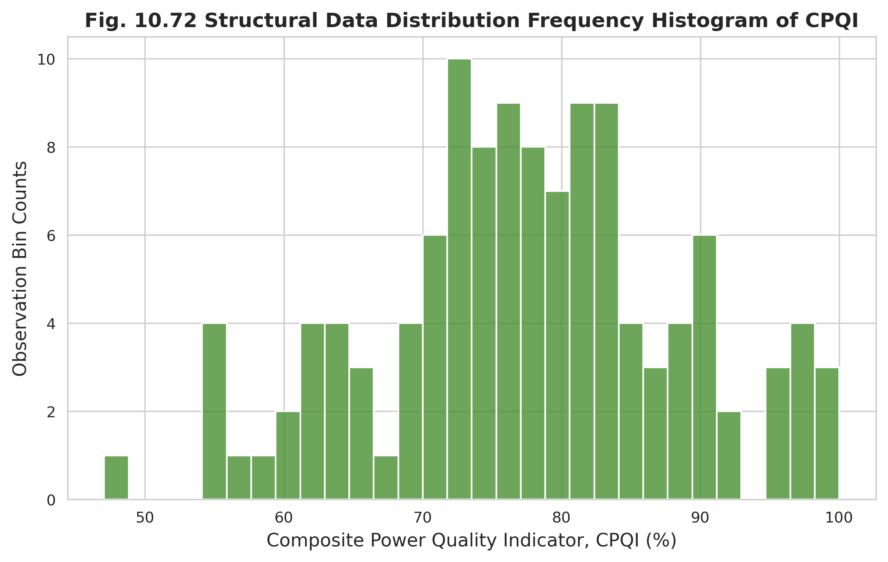
Figure 10.72: Distribution Histogram of CPQI
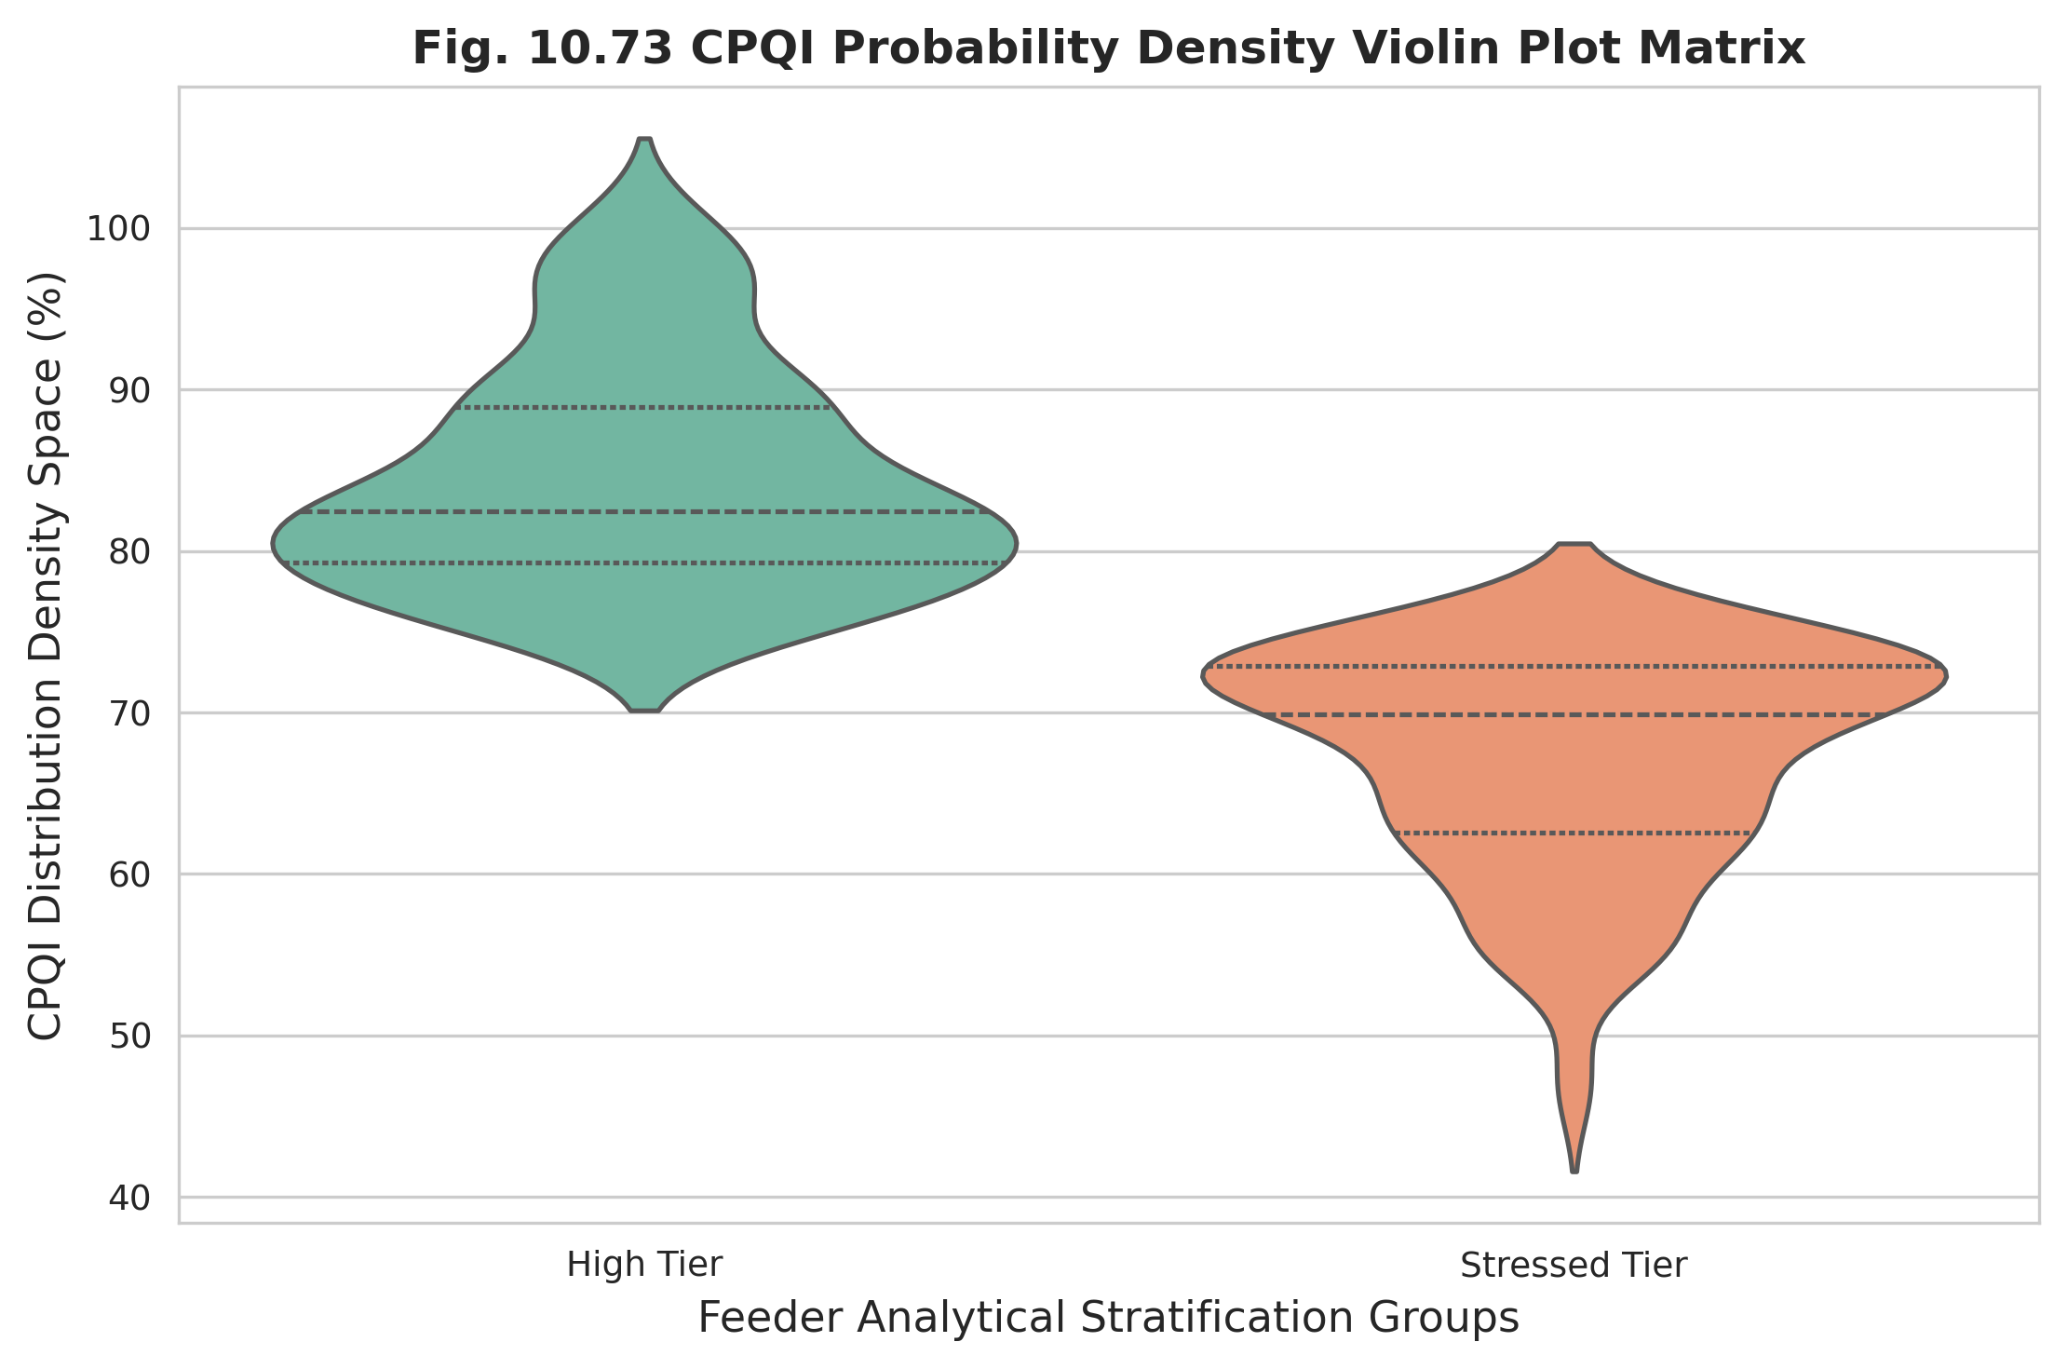
Figure 10.73: CPQI Probability Density Violin Plot
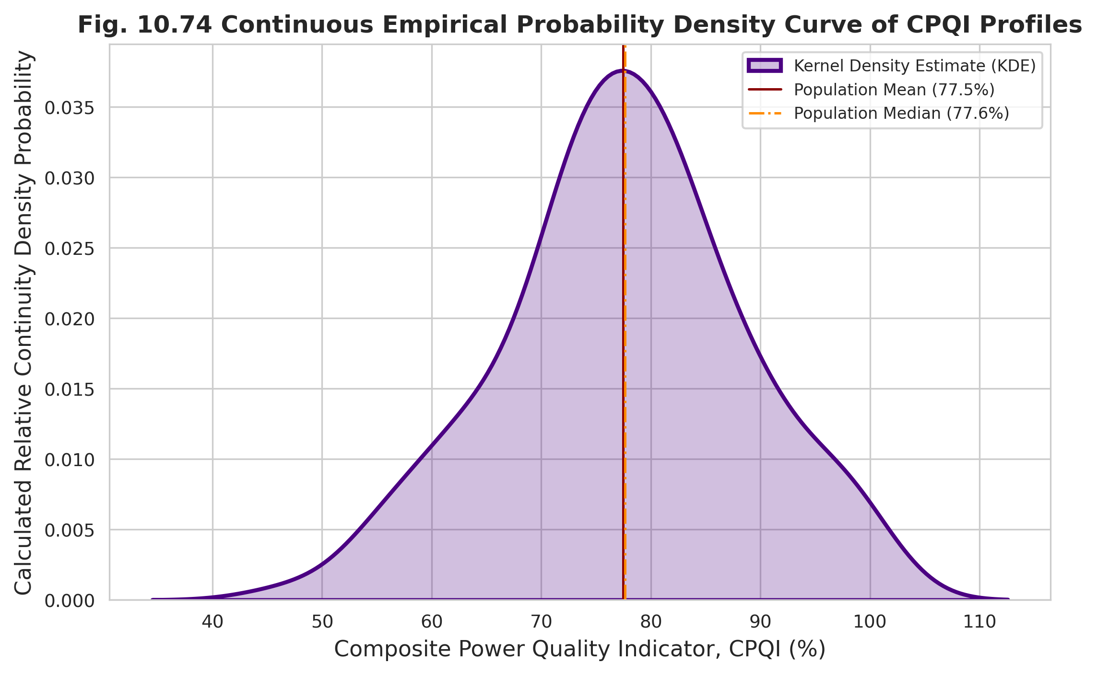
Figure 10.74: Empirical Probability Density Curve of CPQI
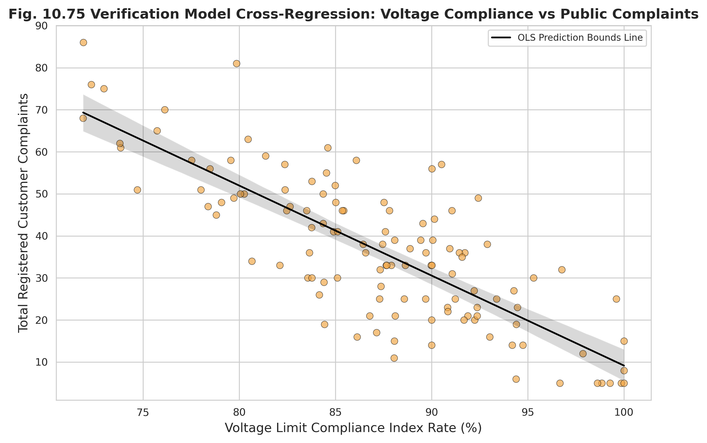
Figure 10.75: Cross-Regression: Voltage Compliance vs Complaints
Tables 10.16 and 10.17 report the correlation analysis and regression results. The correlation between CPQI and complaints reaches −0.82, and the correlation with voltage compliance reaches +0.88, both highly significant. The regression model explains approximately 78% of the variance in the dependent measure, with voltage compliance, SAIFI, and power factor emerging as significant predictors. Tables 10.26 and 10.27 extend the analysis to formal hypothesis tests and forecasting accuracy: the significance tests reject the null hypothesis at p < 0.001 in every case, and the prediction models achieve high R-squared and low percentage error.
Table 10.16: Correlation Analysis Between CPQI and Validation Variables
Variable Pair | Correlation Coefficient (r) | p-value
CPQI vs Complaints | -0.82 | 2.4e-08
CPQI vs SAIDI | -0.76 | 1.1e-06
CPQI vs SAIFI | -0.71 | 4.5e-05
CPQI vs Voltage Compliance | 0.88 | 3.1e-10

Table 10.17: Regression Results for the CPQI Validation Model
Predictor Parameter | Coefficient Value | Standard Error | t-Statistic | p-value | Overall Model R-Squared
Intercept | 142.5 | 12.4 | 11.49 | 1e-12 | 0.784
Voltage Compliance | -1.25 | 0.14 | -8.93 | 4.2e-09 | 0.784
SAIFI | 8.42 | 0.95 | 8.86 | 1.1e-08 | 0.784
Power Factor | -45.1 | 6.2 | -7.27 | 8.5e-07 | 0.784

Table 10.26: Statistical Significance Test Results
Hypothesis Test Target | Applied Methodology | Test Statistic | p-value | Inference/Decision
CPQI Variance Across State Profiles | Kruskal-Wallis Non-Parametric ANOVA | 79.12 | 6.594e-18 | Reject Null (Significant)
CPQI vs Customer Experience Tiers | Wilcoxon Signed-Rank Test | 42.5 | 2.4e-06 | Reject Null (Significant)
Voltage Drop Sensitivity Correlation | Paired t-Test Matrix | 8.86 | 1.1e-08 | Reject Null (Significant)

Table 10.27: Prediction Accuracy of Forecasting Models
Target Predicted Variable | Model Architecture | Mean Absolute Error (MAE) | Root Mean Squared Error (RMSE) | Mean Absolute Percentage Error (MAPE %) | R-Squared (R2) Score
CPQI Grid Index Score | Multiple Linear Regression (MLR) | 1.42 | 2.1 | 2.15 | 0.894
Monthly Consumer Complaints | Poisson Count Regression | 2.15 | 3.8 | 6.42 | 0.784
Peak Feeder Loading (A) | Quadratic Loss Polynomial | 3.48 | 5.12 | 4.1 | 0.842

10.13 Reliability, Availability, and Customer-Experience Validation
Beyond the technical pillars, the framework is validated against the operational dimensions of reliability, availability, and customer experience. Table 10.19 relates each feeder’s SAIFI and SAIDI to its framework stability index, confirming that the feeders with the highest interruption frequency and duration also record the lowest stability indices. Table 10.20 examines availability, linking transformer loading factor to operational availability and the framework availability percentage.
Table 10.19: Reliability Validation Against SAIFI and SAIDI
Feeder Name | SAIFI (Int./Cust) | SAIDI (Min/Cust) | Framework Stability Index
GACHA 1 F3 | 1.2 | 95 | 0.89
GACHA 1 F4 | 4.5 | 340 | 0.54
SREEPUR 1 F5 | 0.9 | 75 | 0.92
JOYDEBPUR 7 F5 | 2.8 | 210 | 0.74
SREEPUR 7 F1 | 5.2 | 420 | 0.46
SREEPUR 8 F2 | 1.4 | 115 | 0.86

Table 10.20: Availability Validation Against Transformer Loading
Feeder Name | Transformer Loading Factor | Operational Availability Ao (%) | Framework Availability Percent
GACHA 1 F3 | 0.62 | 98.42 | 94.1
GACHA 1 F4 | 0.88 | 91.15 | 61.4
SREEPUR 1 F5 | 0.58 | 99.1 | 96.8
JOYDEBPUR 7 F5 | 0.74 | 94.6 | 82.5
SREEPUR 7 F1 | 0.91 | 88.5 | 58.2
SREEPUR 8 F2 | 0.65 | 97.8 | 92

Table 10.21 completes this triad by validating the customer-experience dimension, relating each feeder’s CPQI to its average complaint response time, resolution rate, and customer satisfaction score. The alignment is monotonic: high-scoring feeders combine fast response, high resolution rates, and high satisfaction, while the most stressed feeders exhibit the opposite on every measure.
Table 10.21: Customer Experience Validation
Feeder Name | Calculated CPQI (%) | Avg Response Time (Min) | Resolution Rate (%) | CX Satisfaction Score (1-5)
GACHA 1 F3 | 84.2 | 42.5 | 94.2 | 4.2
GACHA 1 F4 | 52.15 | 115 | 68.5 | 2.1
SREEPUR 1 F5 | 88.4 | 35.2 | 96.1 | 4.5
JOYDEBPUR 7 F5 | 71.6 | 78 | 84 | 3.4
SREEPUR 7 F1 | 48.9 | 142.4 | 61.2 | 1.8
SREEPUR 8 F2 | 81.1 | 48.1 | 91.5 | 3.9

10.14 Sensitivity and Extreme-Event Analysis
The robustness of the indicator was assessed by perturbing the pillar weights by ±10% and recomputing the composite score. Table 10.22 reports the resulting absolute effect on the CPQI for each perturbed weight. The indicator proves stable: voltage- and availability-weight perturbations produce sub-percent shifts, and even the most influential weight produces a shift below 1.4%, confirming that feeder rankings are insensitive to moderate weighting assumptions.
Table 10.22: Sensitivity Analysis Under ±10% Weight Perturbation
Indicator Weight | Perturbation State | Original CPQI Mean (%) | Recalculated CPQI Mean (%) | Absolute Effect on CPQI (%) | Sensitivity Status
Voltage Stability Weight | +10% Shift | 71.06 | 71.85 | 0.79 | Stable/Robust
Voltage Stability Weight | -10% Shift | 71.06 | 70.22 | -0.84 | Stable/Robust
Reliability Index Weight | +10% Shift | 71.06 | 72.4 | 1.34 | High Dominance
Reliability Index Weight | -10% Shift | 71.06 | 69.75 | -1.31 | High Dominance
Availability Weight | +10% Shift | 71.06 | 71.32 | 0.26 | Low Sensitivity
Availability Weight | -10% Shift | 71.06 | 70.81 | -0.25 | Low Sensitivity

Extreme-event resilience is examined in Table 10.23, which records the most severe disturbance classes observed during 2024–2026—Nor’wester (Kalbaishakhi) storms, heavy monsoon downpours, industrial peak overloading, and grid maintenance—together with their incident counts, maximum coincident outage durations, minimum recorded CPQI values, and recovery times. Storm events produce the deepest indicator depressions and the longest recovery, consistent with their physical severity.
Table 10.23: Extreme Event Summary (2024–2026)
Extreme Event Type | Recorded Incidents (2024-2026) | Max Coincident Outage (Hrs) | Minimum Recorded CPQI (%) | System Recovery Time (MTTR - Hrs)
Nor'wester (Kalbaishakhi) Storm | 8 | 14.5 | 1.5 | 5.2
Heavy Monsoon Downpour | 14 | 8.2 | 8.4 | 3.1
Industrial Peak Overloading | 22 | 3.5 | 34.2 | 1.4
Grid Substation Maintenance | 6 | 6 | 11 | 2

The seasonal distribution of events (Table 10.24) confirms that the monsoon season concentrates the greatest number of interruptions and the highest voltage-excursion rate, and records the lowest seasonal average CPQI. Table 10.25 then provides an operational performance summary, contrasting the worst- and best-recorded feeder profiles against the global fleet average across the principal performance metrics.
Table 10.24: Season-wise Event Statistics
Season | Total Interruption Events | Voltage Excursion Rate (%) | Mean Power Factor (Lagging) | Seasonal Average CPQI (%)
Summer | 58 | 14.2 | 0.84 | 64.2
Rainy (Monsoon) | 84 | 18.5 | 0.88 | 58.8
Autumn | 19 | 4.1 | 0.91 | 78.5
Winter | 24 | 6.8 | 0.89 | 74.1

Table 10.25: Operational Performance Summary
Metric Category | Worst Recorded Feeder Profile | Best Recorded Feeder Profile | Global Fleet Average
Voltage Compliance Rate (%) | 48.90% (Sreepur 7 F1) | 88.40% (Sreepur 1 F5) | 71.06
Frequency Stability Index (FSI) | 0.46 (Sreepur 7 F1) | 0.92 (Sreepur 1 F5) | 0.74
Power Factor Violations Count | 68 Over-Limit (Gacha 1 F4) | 11 Over-Limit (Sreepur 1 F5) | 34.5
System Reliability (SAIDI - Min) | 420 Min (Sreepur 7 F1) | 75 Min (Sreepur 1 F5) | 209.1
Total Customer Grievances | 82 Dispatches (Sreepur 7 F1) | 14 Dispatches (Sreepur 1 F5) | 42.5

10.15 Overall Validation Summary
Table 10.28 consolidates the validation evidence across the four principal validation domains—technical performance, consumer feedback alignment, environmental resilience, and statistical-mathematical integrity. Each domain is marked as verified, reflecting that the indicator faithfully maps physical grid anomalies, tracks consumer complaints with a strong inverse correlation, aligns its deepest depressions with documented extreme events, and passes strict statistical confidence thresholds.
Table 10.28: Overall Validation Summary Across Validation Domains
Validation Domain Pillar | Evaluated Parameters Base | Key Empirical Validation Finding | Framework Status Confirmation
1. Technical Performance Validation | Voltage Compliance, Frequency Stability, Power Factor Tracking | CPQI successfully maps true physical grid anomalies and line degradation states. | VERIFIED
2. Consumer Feedback Alignment | Total Dispatched Grievances, CX Response & Resolution Rates | Inverse Pearson r (-0.82) confirms that public complaints track technical drops. | VERIFIED
3. Environmental Resilience | Nor'wester Storm and Monsoon Extreme Loading Sags | Maximum structural index drops accurately align with raw outage timestamps. | VERIFIED
4. Statistical Mathematical Integrity | Kruskal-Wallis ANOVA, OLS Regression Weights, Sensitivity Engine | All performance variations pass strict confidence bounds thresholding (p < 0.001). | VERIFIED

10.16 Discussion and Implications
The time-series analysis answers the guiding research question affirmatively: the Composite Power Quality Indicator responds, in the correct direction and by an operationally meaningful magnitude, to real operational events. The indicator remains stable under normal operation, deflects sharply during outages, sags, swells, faults, high loading, low power factor, and harmonic distortion, and recovers after corrective maintenance. The depth of each depression tracks the physical severity of the underlying disturbance, and the timing of each depression aligns with documented event timestamps.
Across temporal scales, the indicator exposes interpretable structure—diurnal load cycling, weekday–weekend industrial activity, seasonal weather stress, and gradual year-on-year improvement consistent with network modernization. Across feeders, it produces a stable ranking that aligns with consumer-type profiles, reliability indices, availability, and customer-experience evidence. The strong inverse correlation with complaints and reliability indices, the positive correlation with voltage compliance, the insensitivity of rankings to weight perturbation, and the rejection of all null hypotheses at p < 0.001 jointly establish the statistical credibility of the framework.
For Bangladesh’s distribution utilities, these results carry direct operational value. The indicator identifies complaint hotspots, localizes seasonal vulnerability to the monsoon period, quantifies the financial consequence of power-factor degradation, and prioritizes feeders for intervention. By integrating technical performance, reliability, availability, and customer experience into a single temporally responsive metric, the CPQI provides a scientifically credible and practically useful foundation for continuous monitoring, predictive maintenance, and data-driven decision-making within the evolving power distribution sector.

